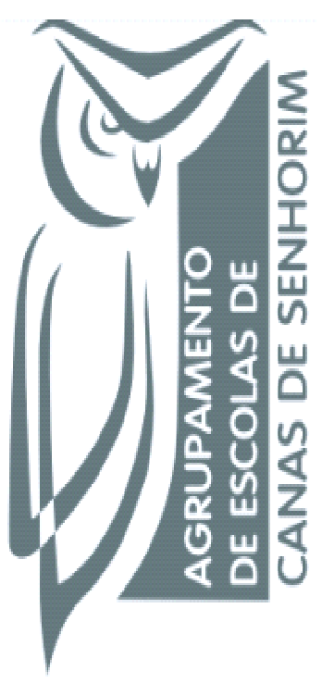
Managing for @ School of Success

Curricular organization projects

Principals are the Curriculum decision-makers: for our country.

Branston Junior Academy – United Kingdom
Gemeente 's-Hertogenbosch - The Netherlands
I Spoleczne Liceum Ogolnoksztalcace im Unii Europejskiej w Zamosciu – Poland
Istituto Omicomprensivo "Ridolfi- Zimarino" – Italy
Confederacion Espanola de Centros de Ensenanza Asociacion C.E.C.E. – Spain
EduFor Schools - Portugal

This project has been funded with support from the European Commission.
This publication reflects the views only of the author, and the Commission cannot be held responsible for any use which may be made of the information contained therein.

This work is licensed under a Creative Commons Attribution-NonCommercial 4.0 International License.

