
Managing for @ School of Success

Curricular organization projects

Index:
Canas de Senhorim Group of Schools 2
Branston Junior Academy – United Kingdom 9
Vila Nova de Paiva Group of Schools 21
Gemeente 's-Hertogenbosch - The Netherlands 21
I Spoleczne Liceum Ogolnoksztalcace im Unii Europejskiej w Zamosciu – Poland 36
Sátão Group of Schools 48
Istituto Omicomprensivo "Ridolfi- Zimarino" – Italy 48
Nelas Group of Schools 56
Confederacion Espanola de Centros de Ensenanza Asociacion C.E.C.E. – Spain 56
Penalva do Castelo Group of Schools 78
Mangualde Group of Schools 78

Canas de Senhorim Group of Schools
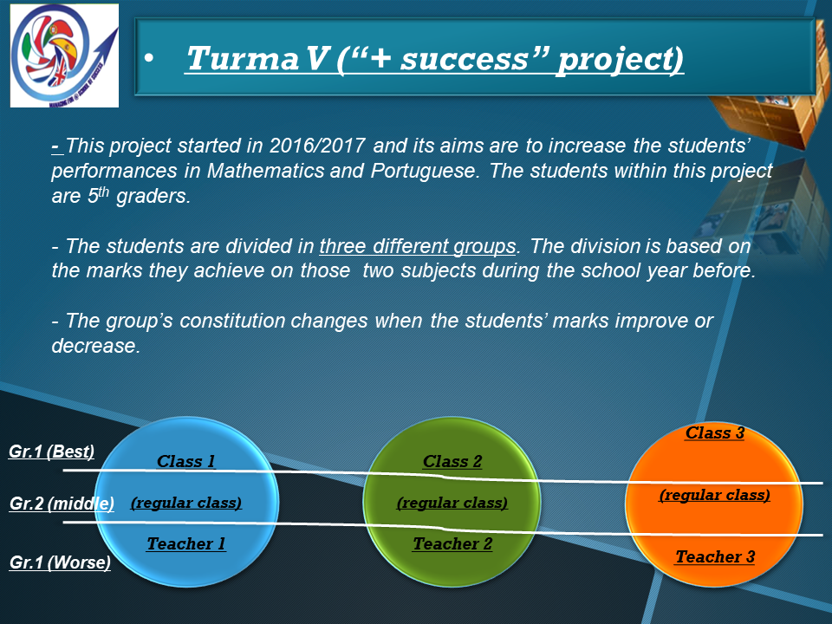
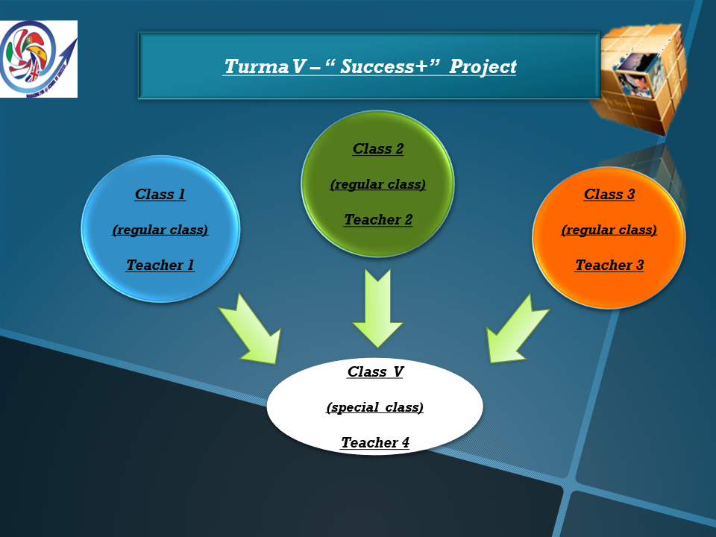
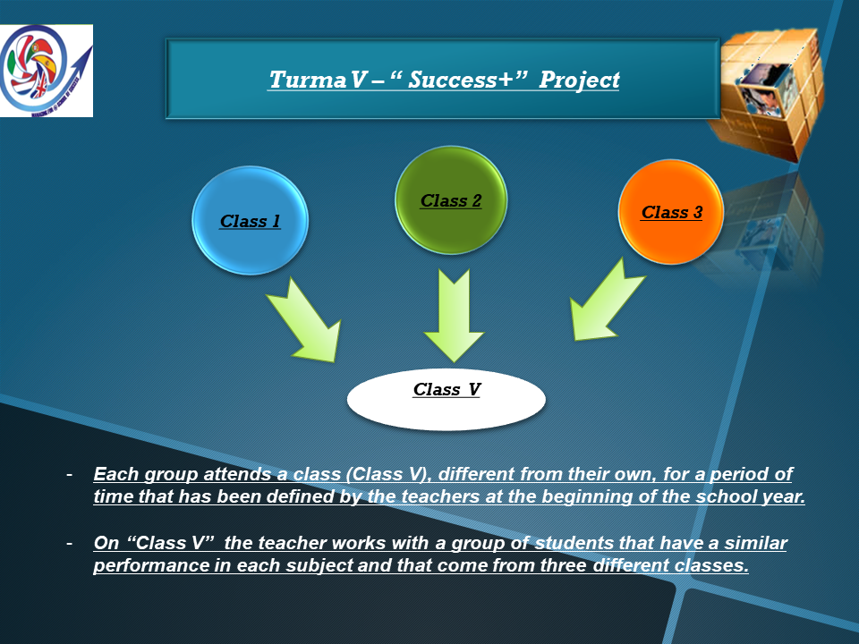
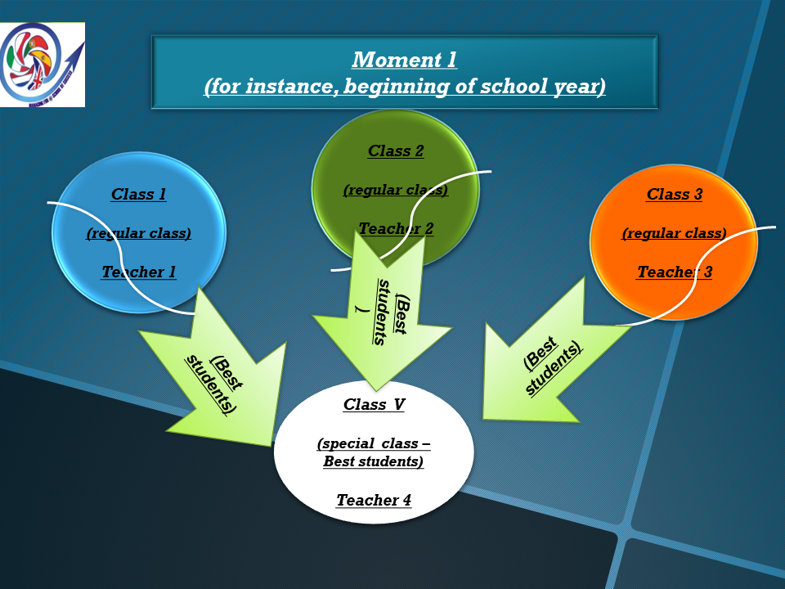
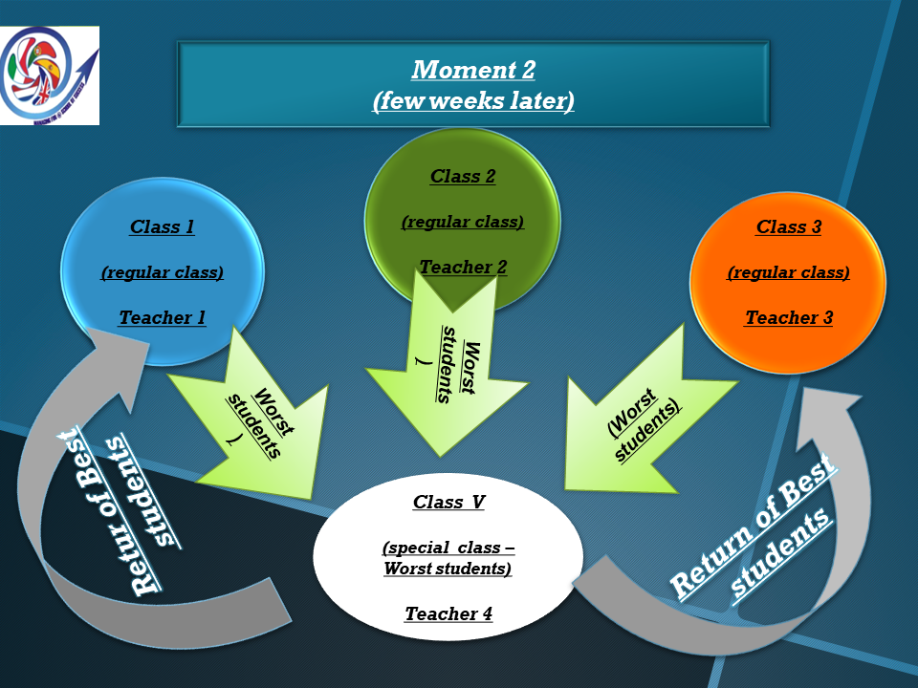
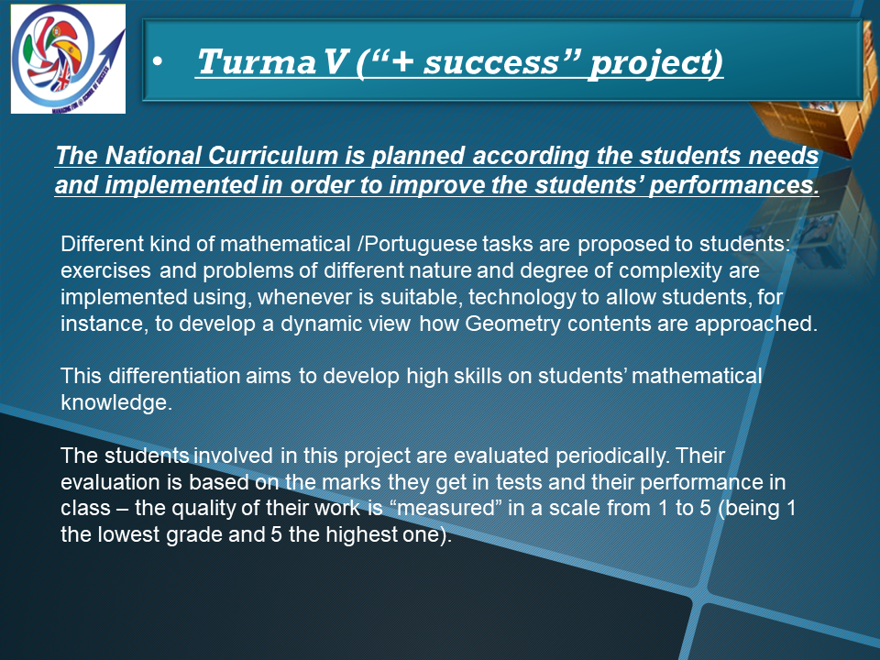
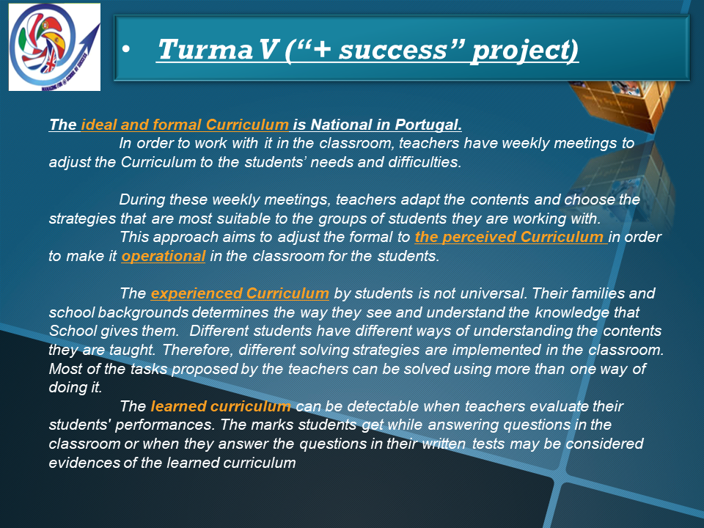
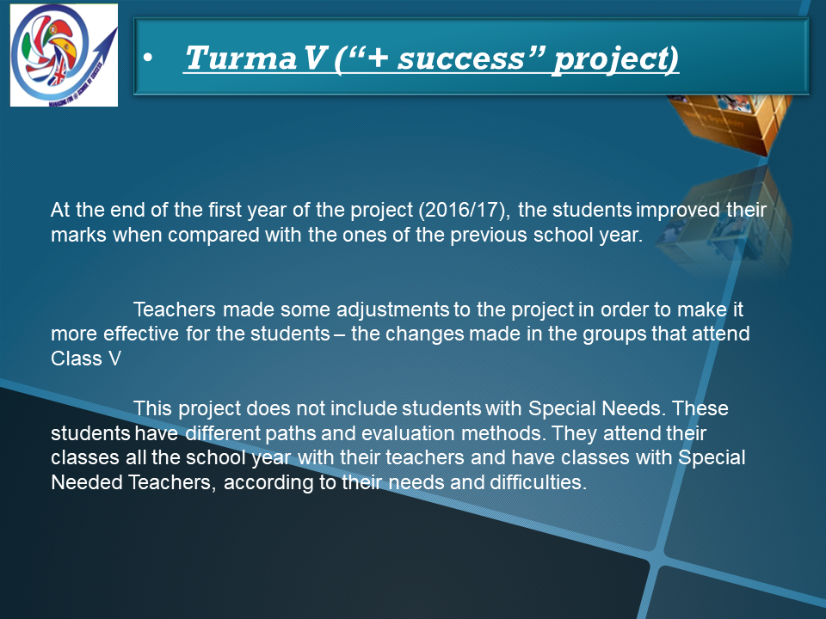
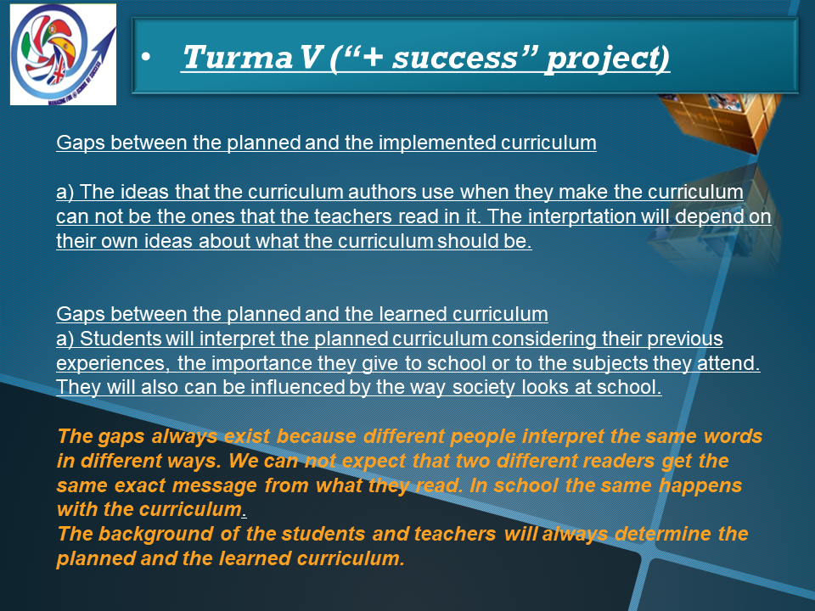
schoolsucess.edufor.eu

The Principals are the Curriculum decision makers: as you know, in the Training Event in Italy (November 2017) and in the UK (March 2018) the theme is the Curriculum. Let's start preparing our Training Event in Italy.

Activity: MIND THE GAP / OVERCOME THE GAP
Goals:
• Become aware of the gaps between Planned Curriculum, Implemented Curriculum and Experienced Curriculum.
• Identify practices or guidelines that reduce gaps.
• Find effective ways to improve students’ achievement.

1st Part (to be held before the Training Event in Italy*)
Tasks:
1 – Select as an example a project of your school within the scope of the curriculum management that has been or is being implemented. The example can be a project from a class, a course or a subject.

Sucesso+ Project
This project started in 2016/2017 and its aims are to increase the students’ performances in Mathematics and Portuguese. The students within this project are 5th graders.
The students are divided in three different groups. The division is based on the marks they achieve on the two subjects during the school year.
The group’s constitution changes when the students’ marks improve or decrease.
Each group attends a class (Class V), different from their own, for a period of time that has been defined by the teachers at the beginning of the school year.
On Class V the teacher works with a group of students that have a similar performance in each subject and that come from three different classes.
The National Curriculum is planned according the students needs and implemented in order to improve the students’ performances.
Different kind of mathematical tasks are proposed to students: exercises and problems of different nature and degree of complexity are implemented using, whenever is suitable, technology to allow students, for instance, to develop a dynamic view how Geometry contents are approached.
This differentiation aims to develop high skills on students’ mathematical knowledge.
The students involved in this project are evaluated periodically. Their evaluation is based on the marks they get in tests and their performance in class – the quality of their work is “measured” in a scale from 1 to 5 (being 1 the lowest grade and 5 the highest one).

2 – Identify, in your example, the gaps between the Planned Curriculum, the Implemented Curriculum and the Experienced Curriculum, taking into account the scheme:
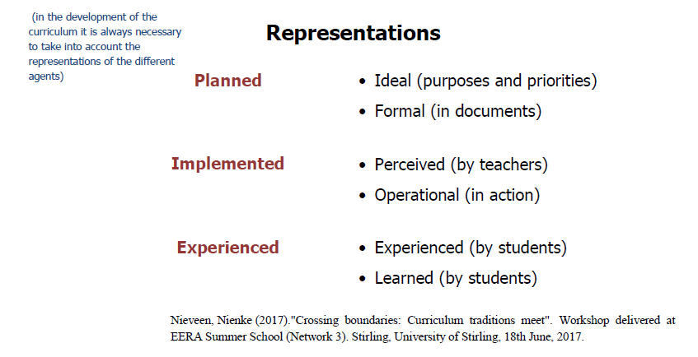

The ideal and formal Curriculum is National in Portugal.
In order to work with it in the classroom, teachers have weekly meetings to adjust the Curriculum to the students’ needs and difficulties.
During these weekly meetings, teachers adapt the contents and choose the strategies that are most suitable to the groups of students they are working with.
This approach aims to adjust the formal to the perceived Curriculum in order to make it operational in the classroom for the students.
The experienced Curriculum by students is not universal. Their families and school backgrounds determines the way they see and understand the knowledge that School gives them.
Different students have different ways of understanding the contents they are taught. Therefore, different solving strategies are implemented in the classroom. Most of the tasks proposed by the teachers can be solved using more than one way of doing it. In order to improve the students’ ability to solve problems, and become more autonomous on doing it as time goes by, the teachers make them aware of the vantages and disadvantages of the solving paths they choose. Although the aim is not to choose and use the “best” approach every time, teachers alert their students for the pros and cons of using approaches that will drive them away from the objectives that are supposed to be reached.

At the end of the first year of the project, the students improved their marks when compared with the ones of the previous school year.
Teachers made some adjustments to the project in order to make it more effective for the students – the changes made in the groups that attend Class V (in each of the three school periods of work the students of the different groups and classes attend Class V).
This project does not include students with Special Needs. These students have different paths and evaluation methods. They attend their classes all the school year with their teachers and have classes with Special Needed Teachers, according to their needs and difficulties.

N.B.: The way each participant identifies the gaps is of their own choice (ask, observe, collect evidence from different sources, etc.).
However, in the Presentation to the large group the participants should refer how they collected the information.

2nd Part (to be held during the Training Event in Italy)
Tasks:
A. Present to the large group (7 minutes at most) the first part of the activity;
B. Organize a table (in working groups) showing the differences in curricular management and the approach that each participant assigns: o To the documents of the formal curriculum;
o To the curriculum operationalised in the classroom by the teachers;
o To the curriculum perceived and learned by students.

N.B.: This moment of collaborative work in Italy will be complemented by two other moments: one to clarify curriculum concepts (taking into account the realities of the different countries) and the other to discuss the curriculum guidelines of each country, from given examples.

Branston Junior Academy – United Kingdom

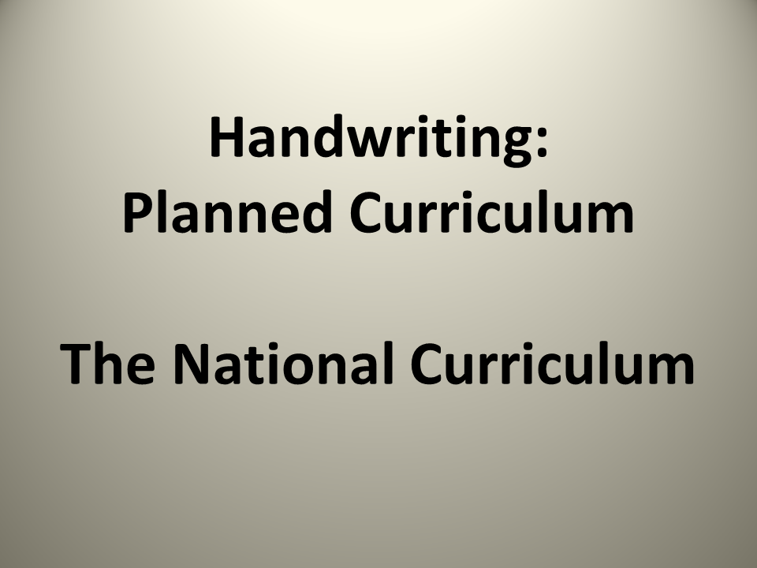
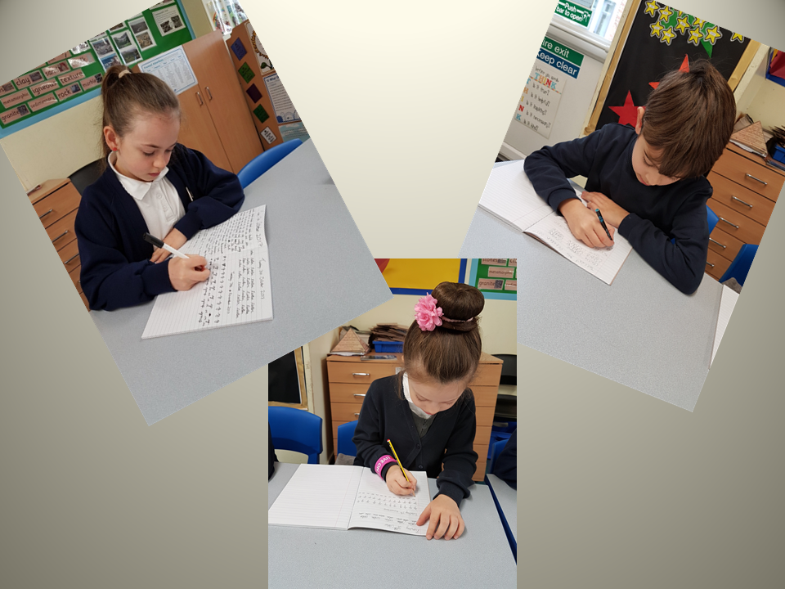
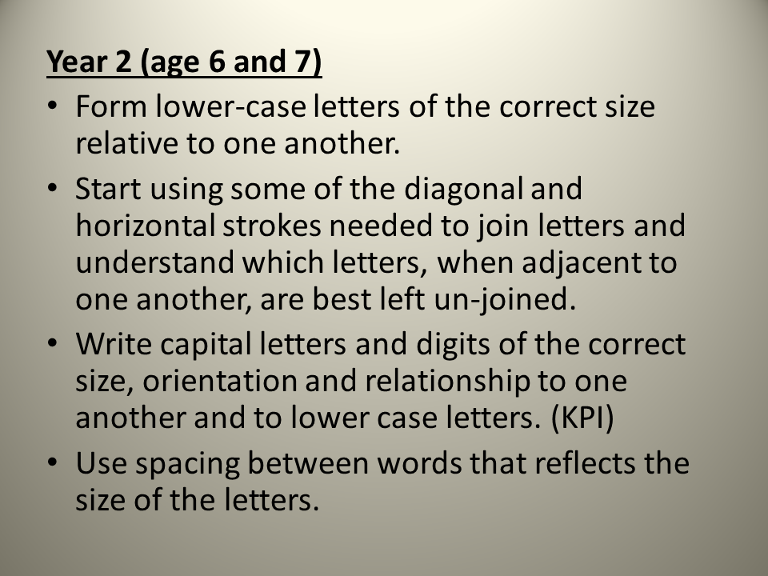
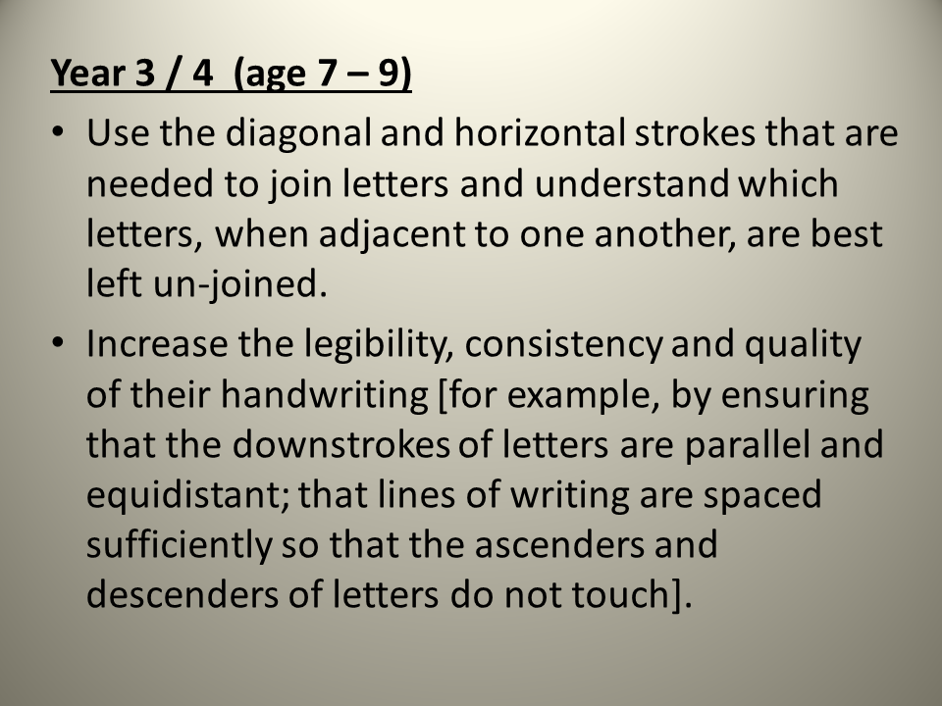
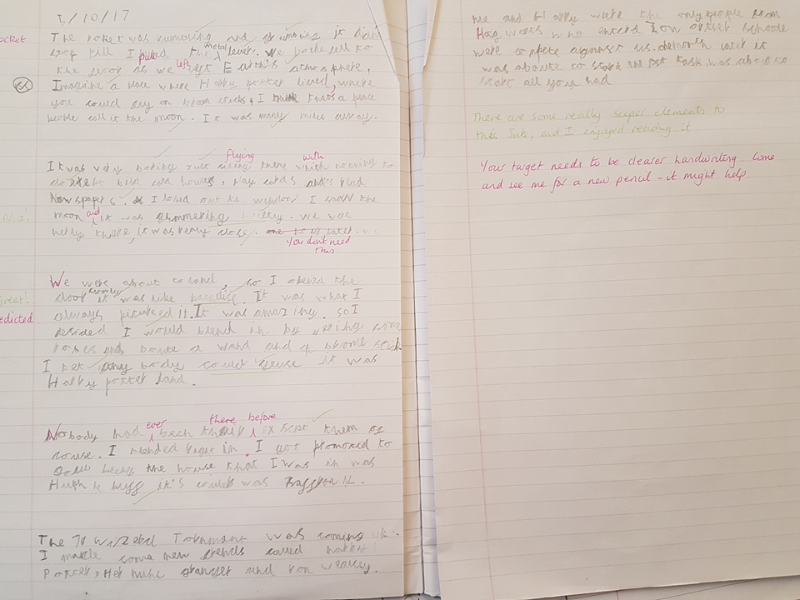
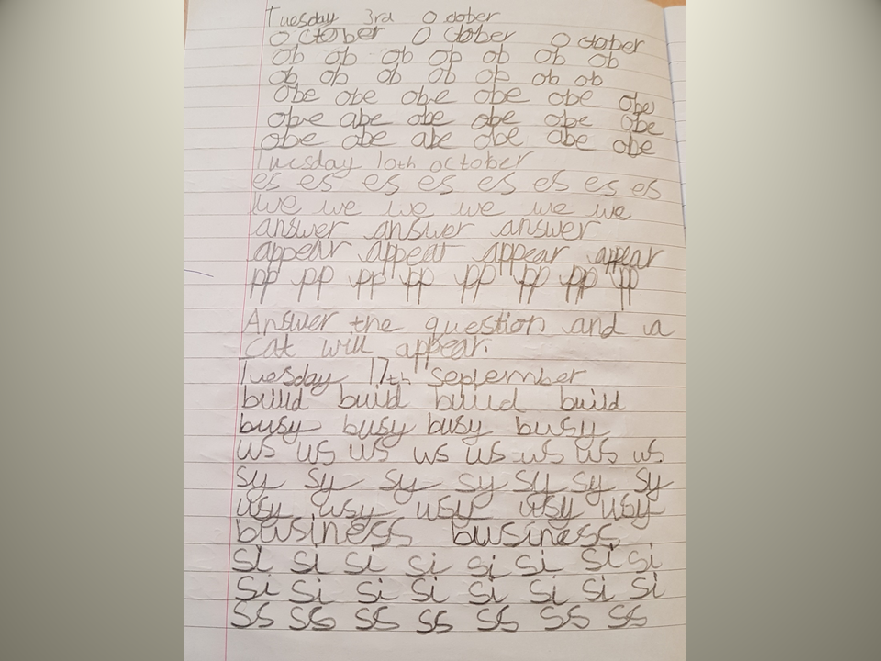
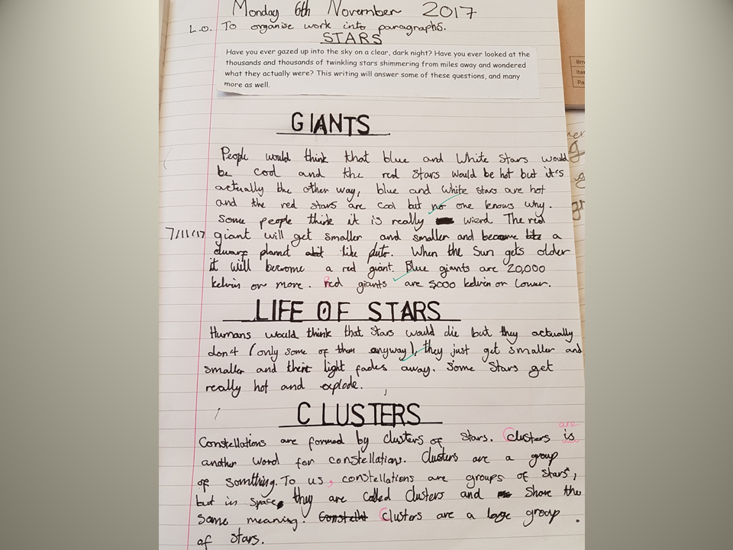
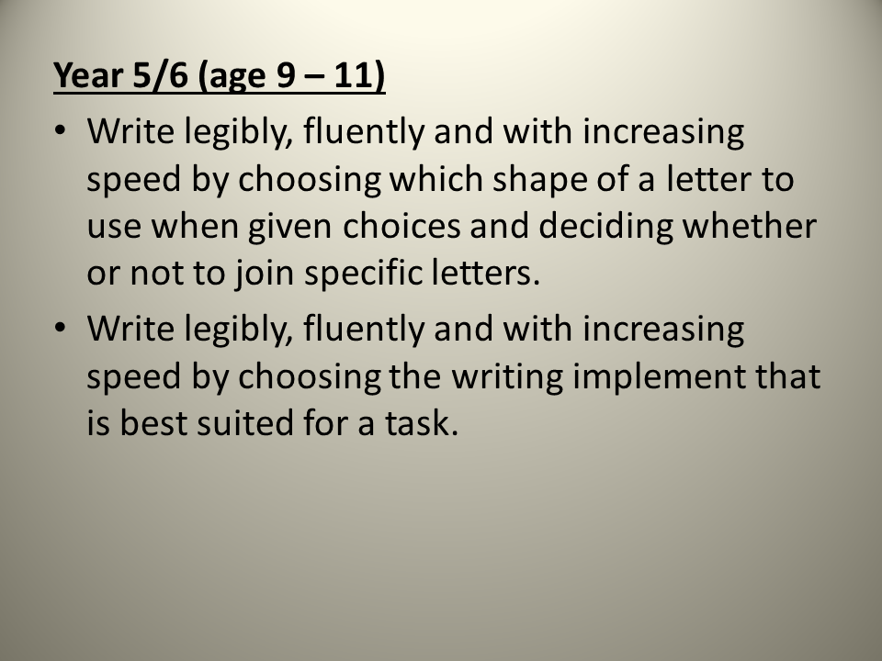
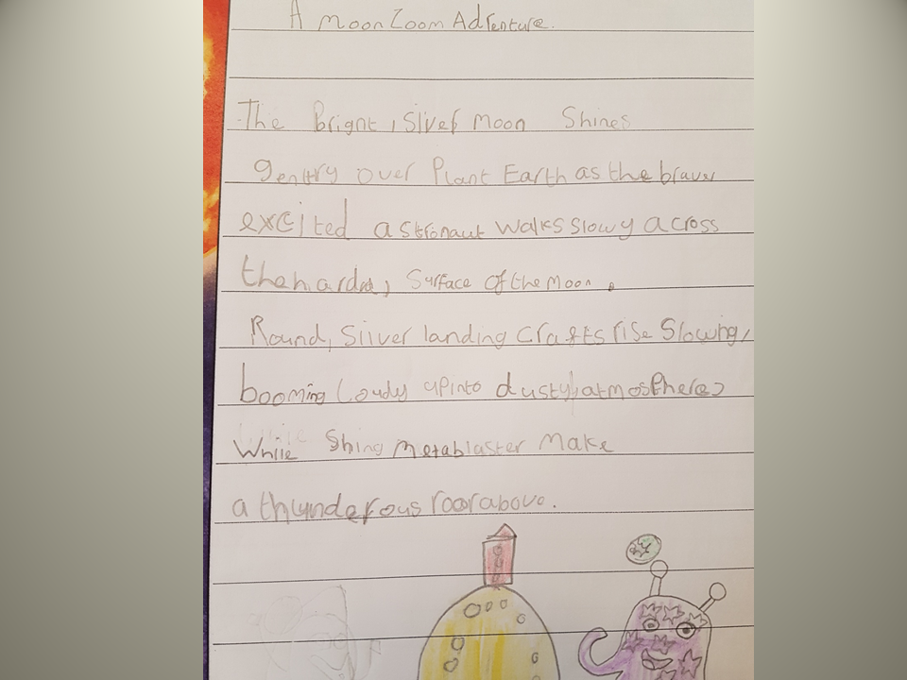
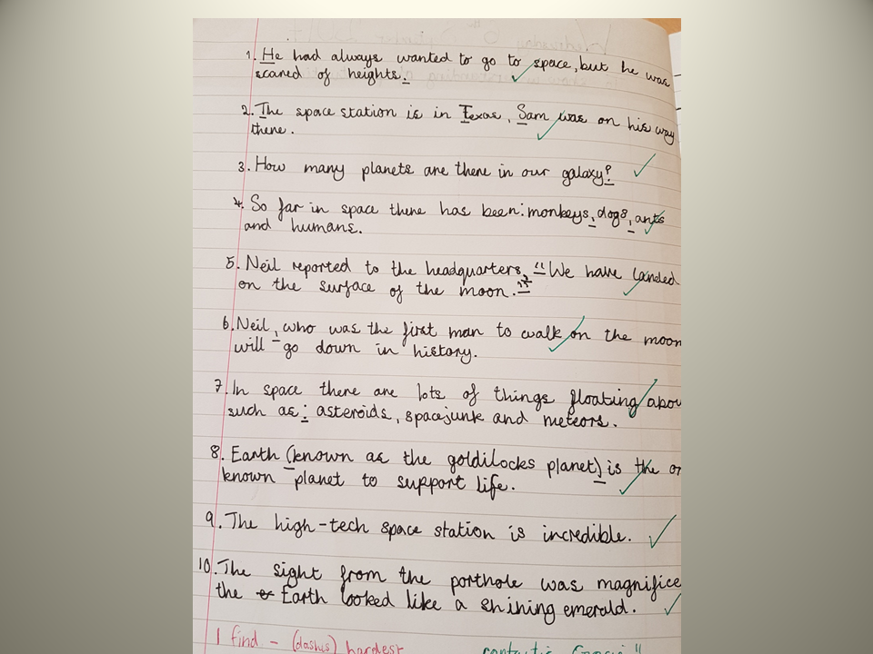
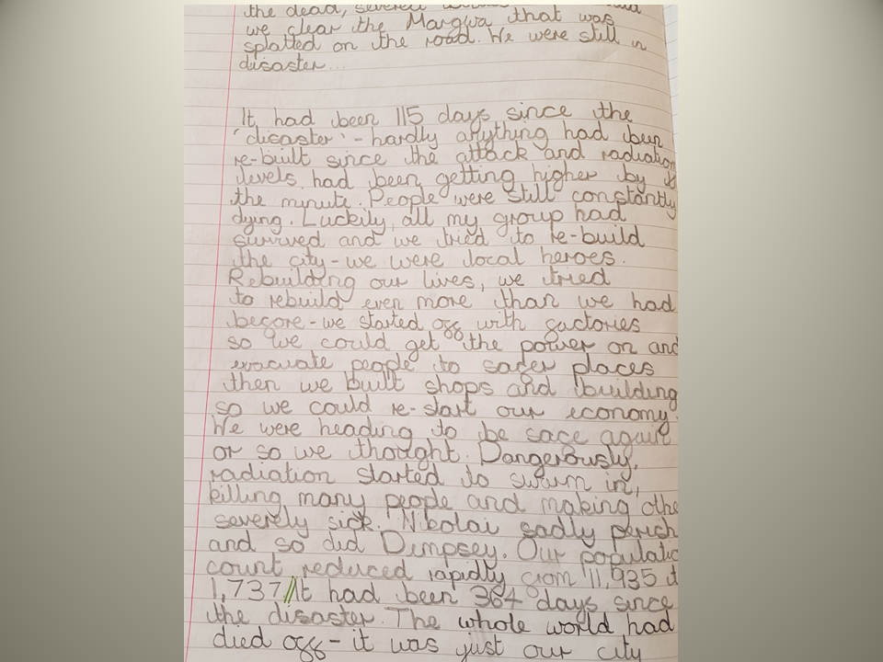
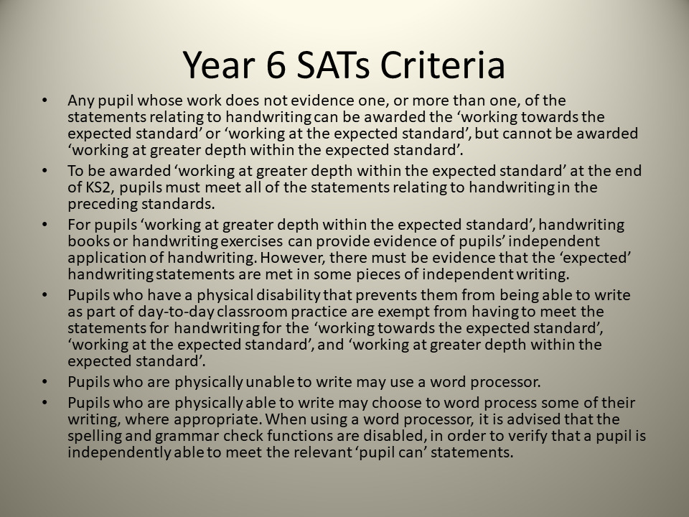
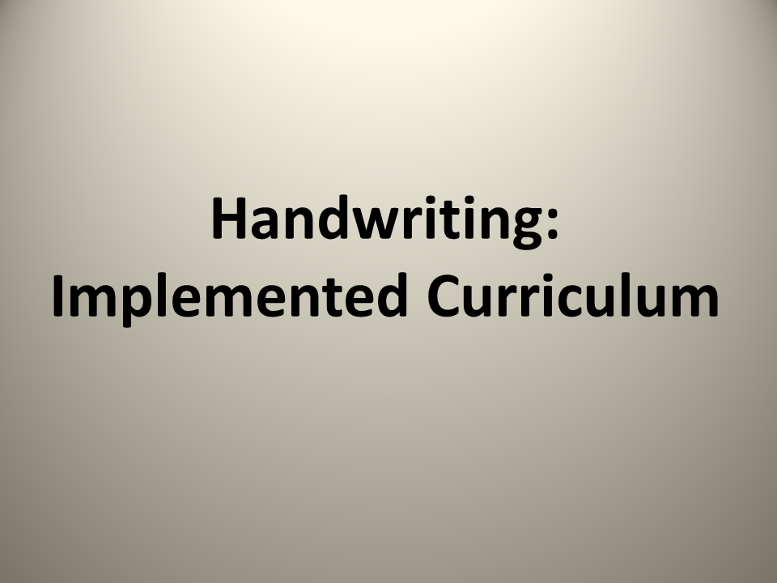
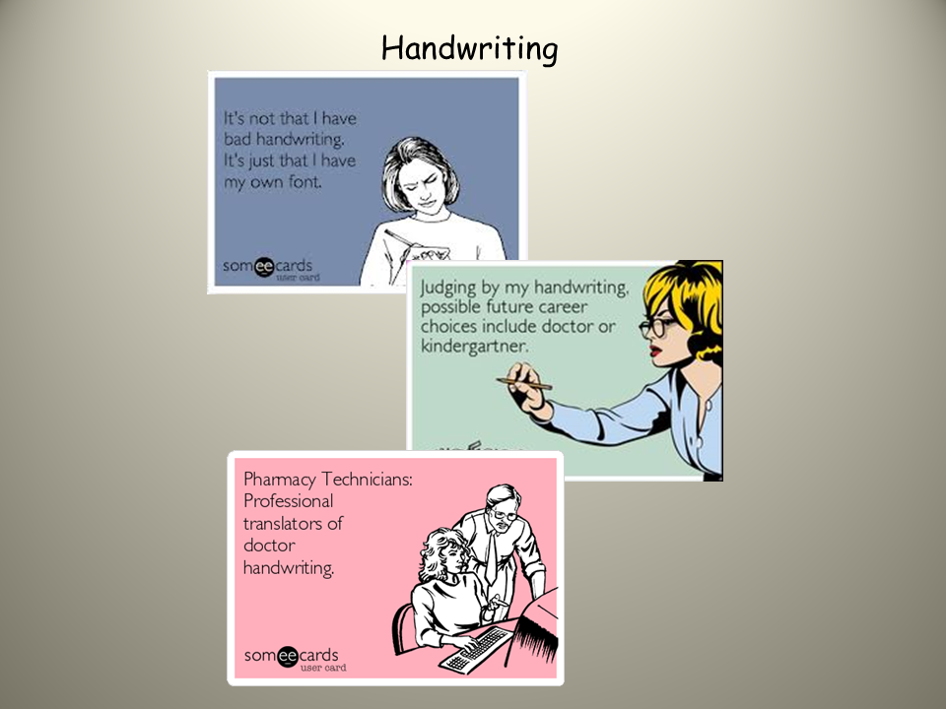
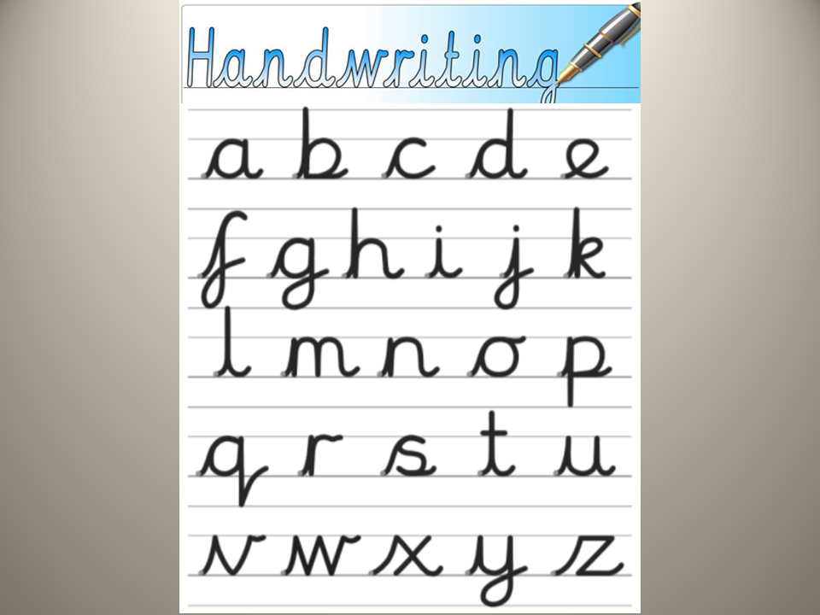
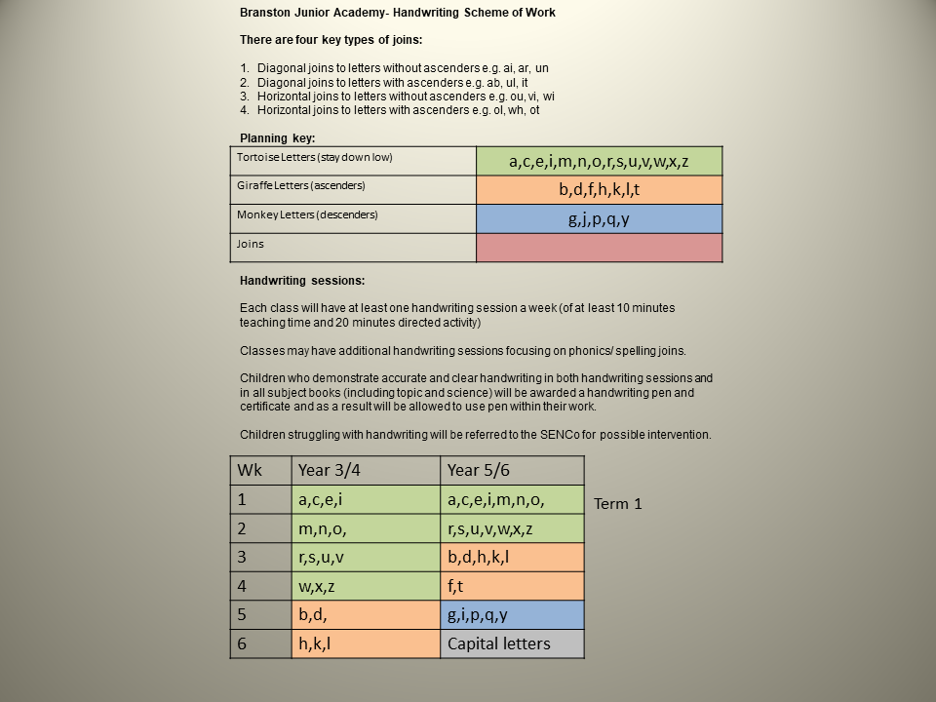
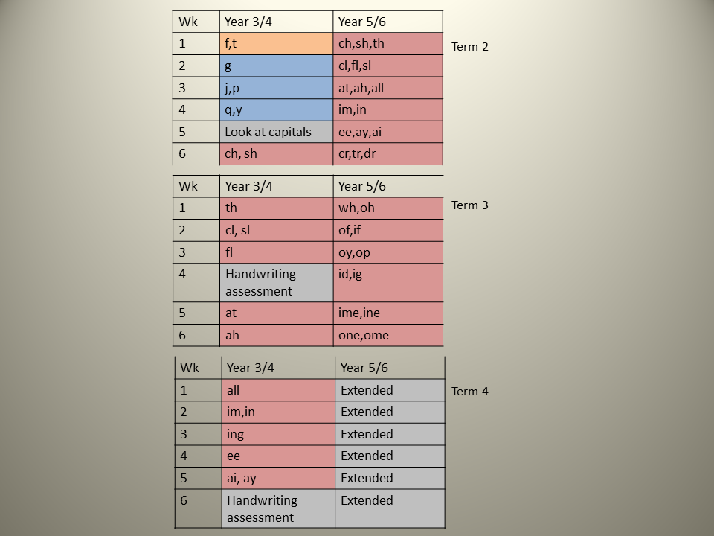
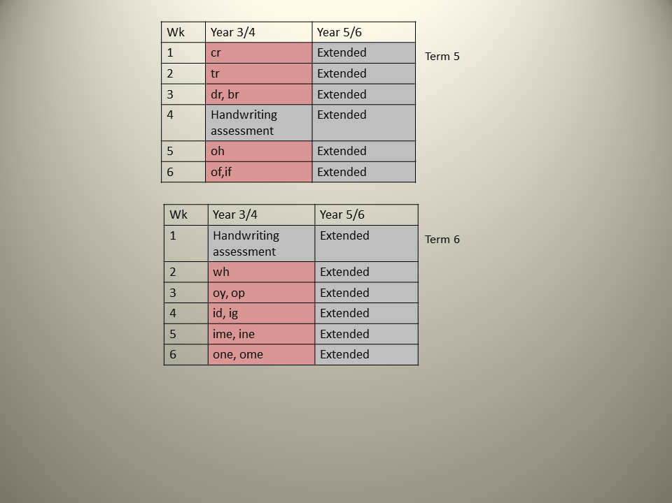
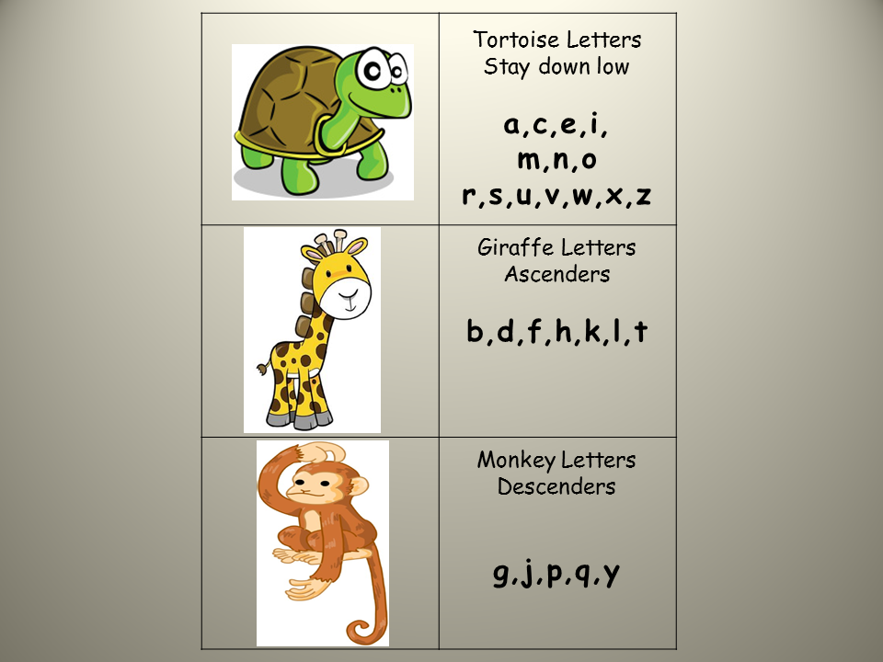
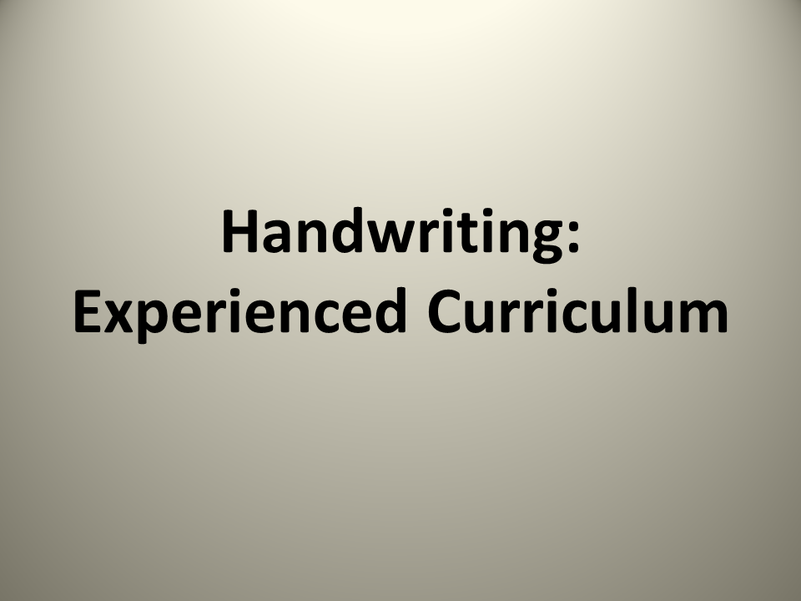
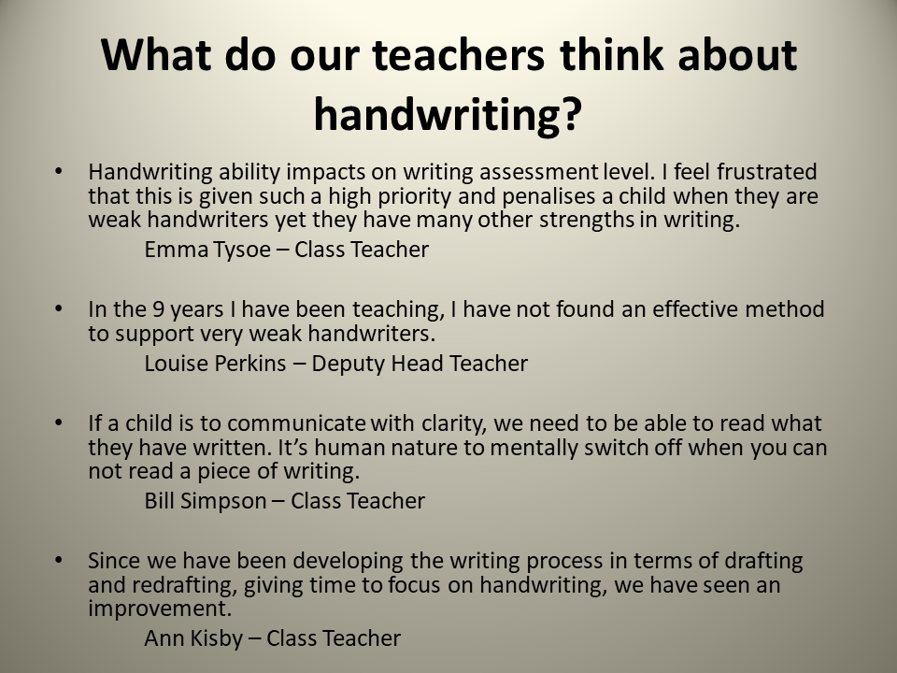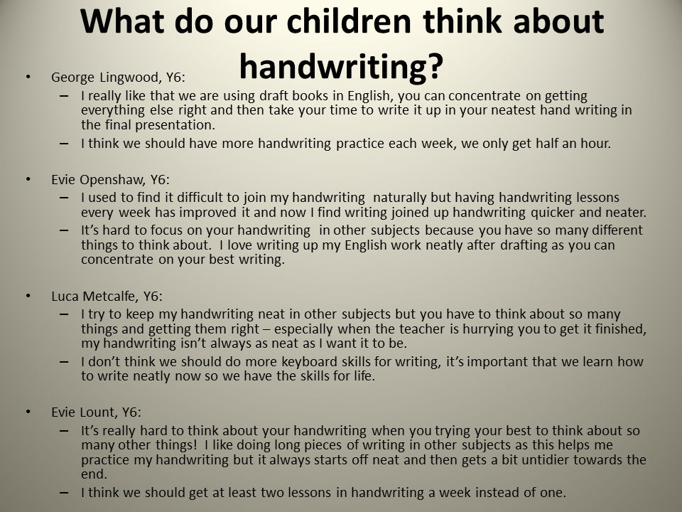

Vila Nova de Paiva Group of Schools

Gemeente 's-Hertogenbosch - The Netherlands
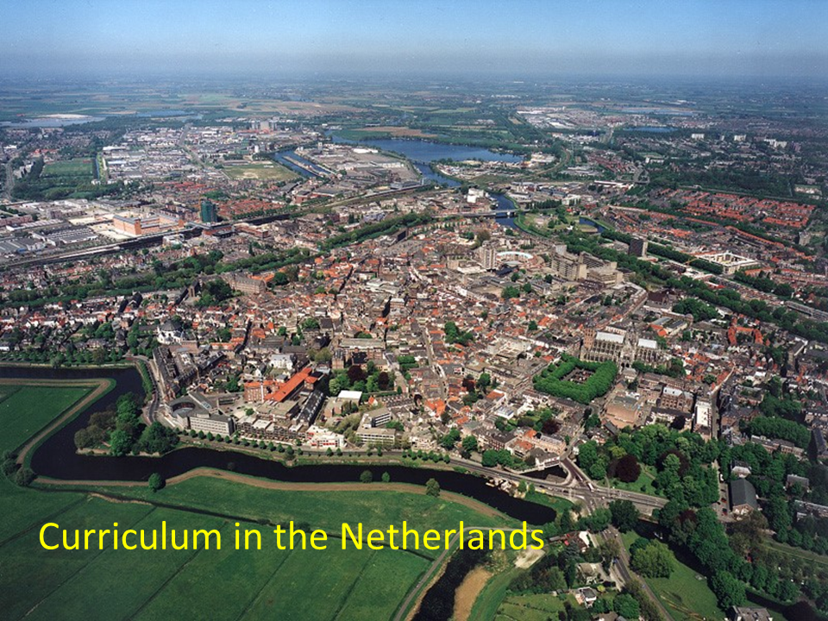
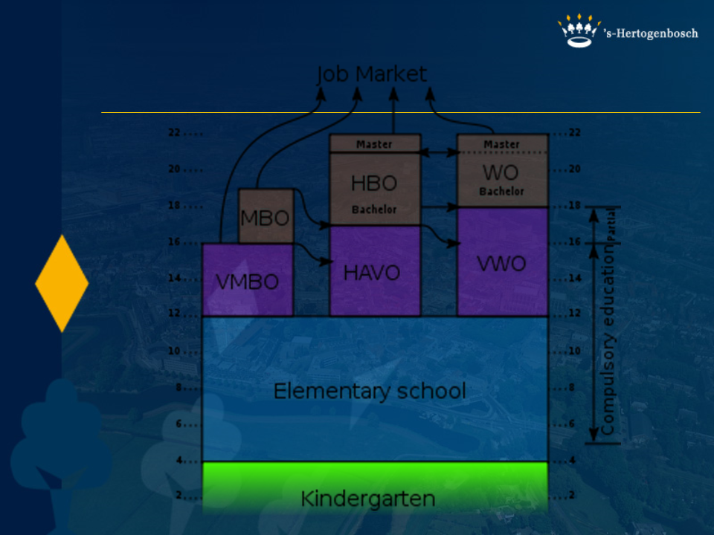
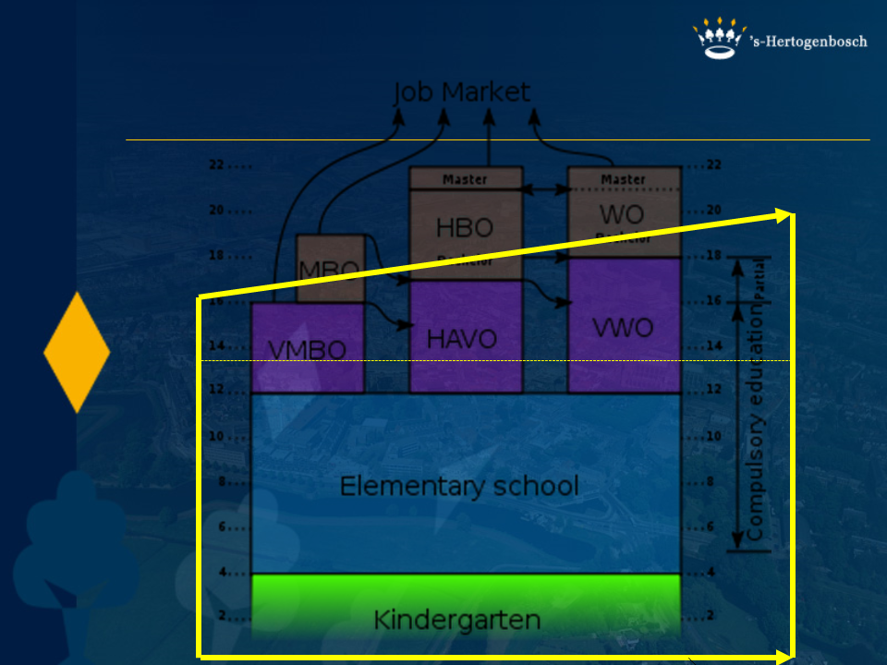
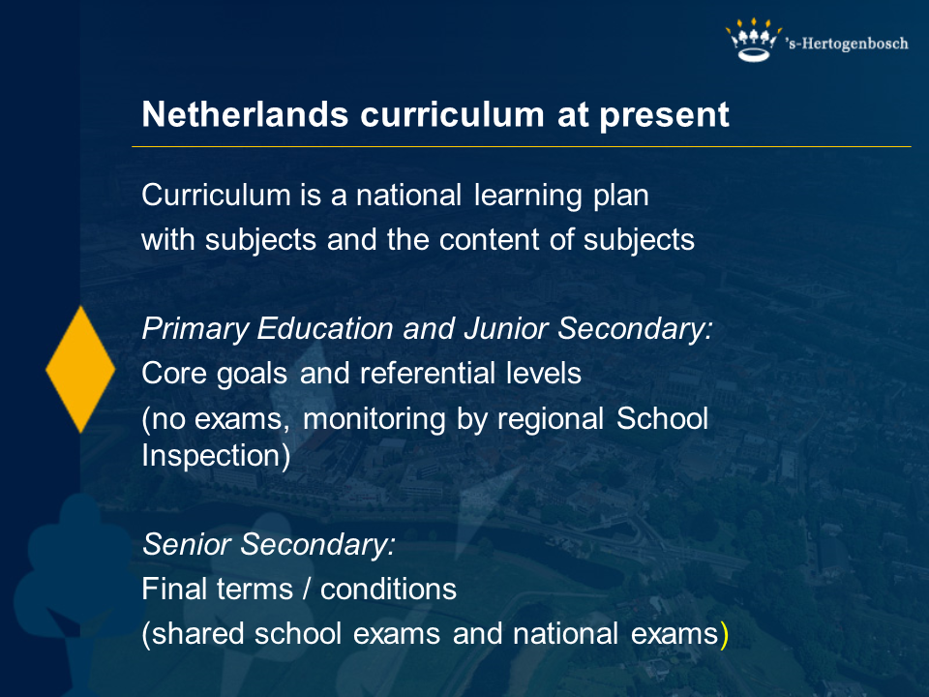
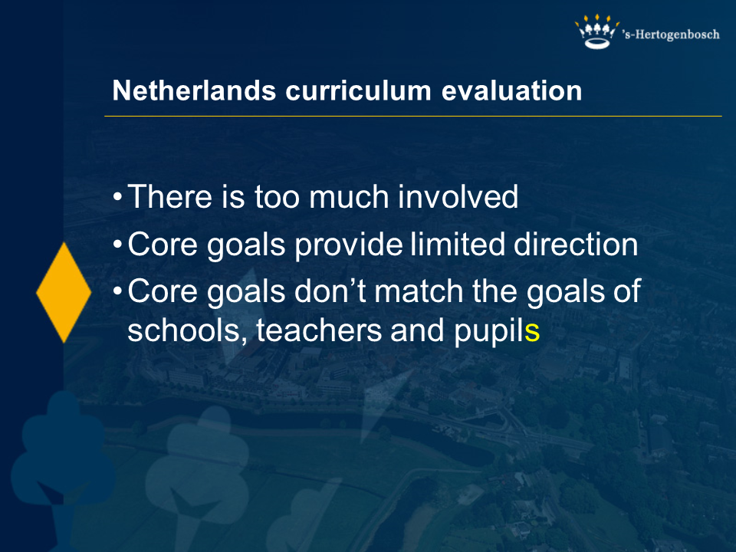
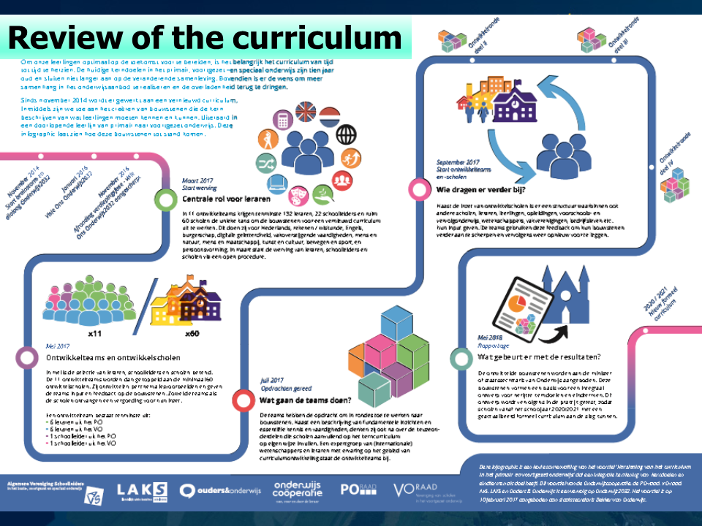
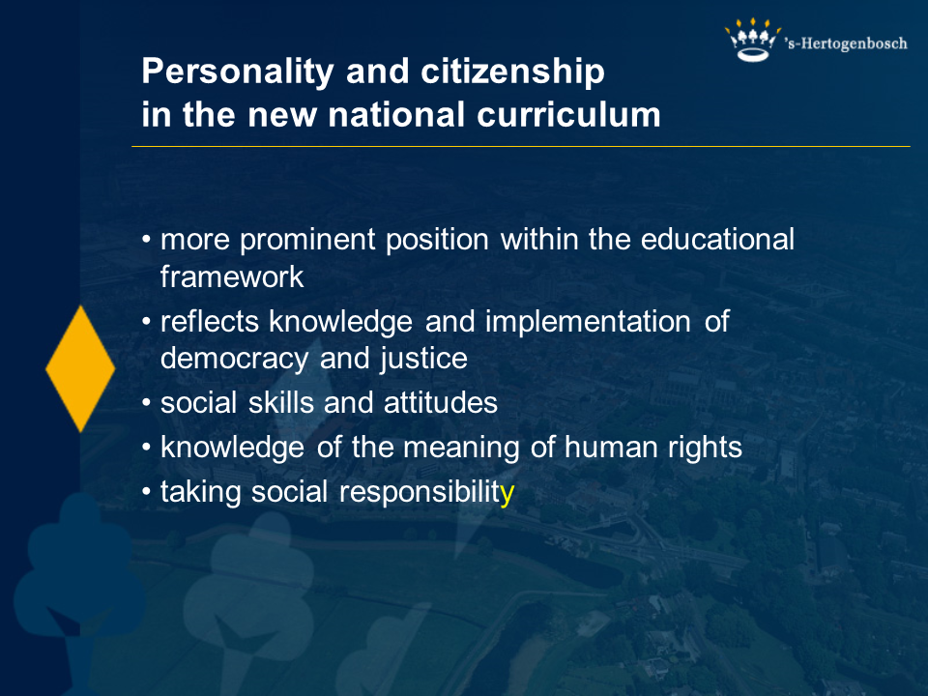
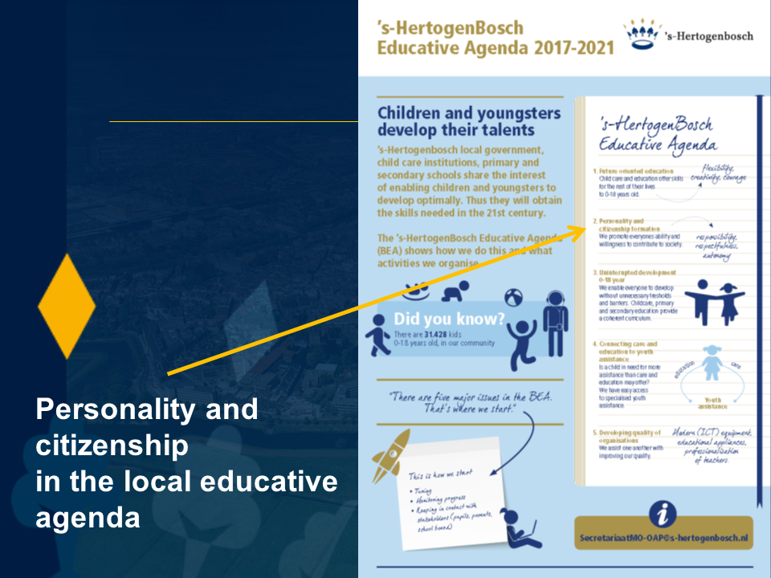
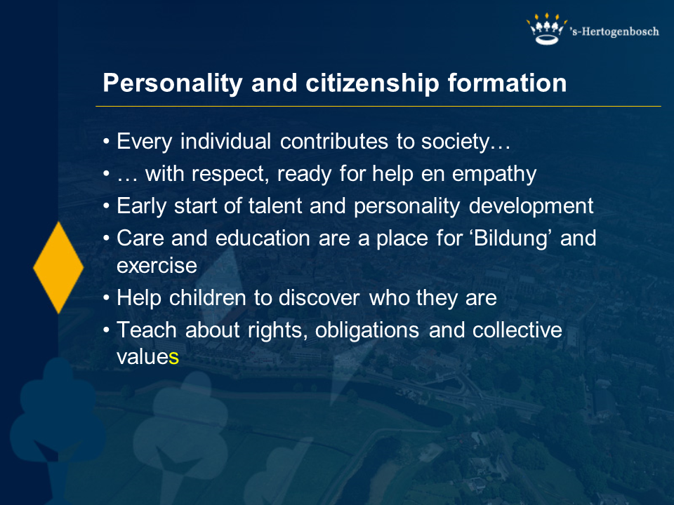
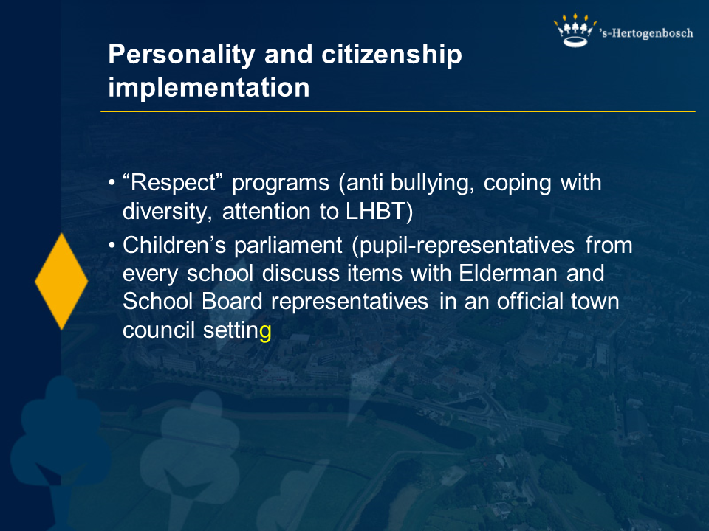
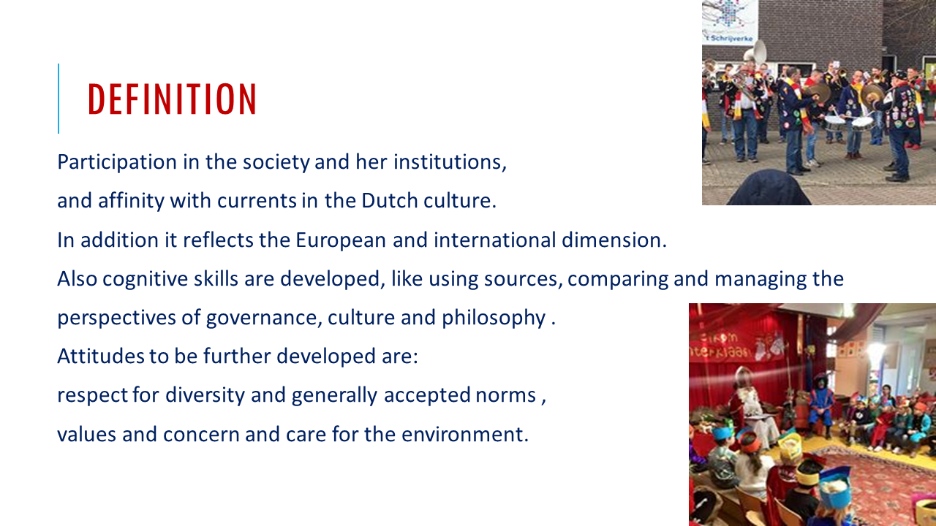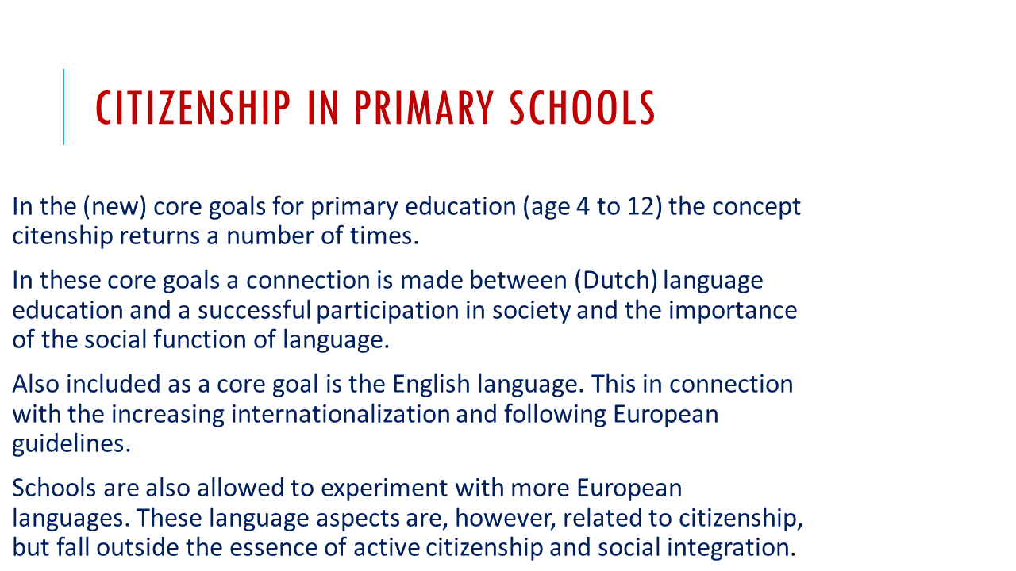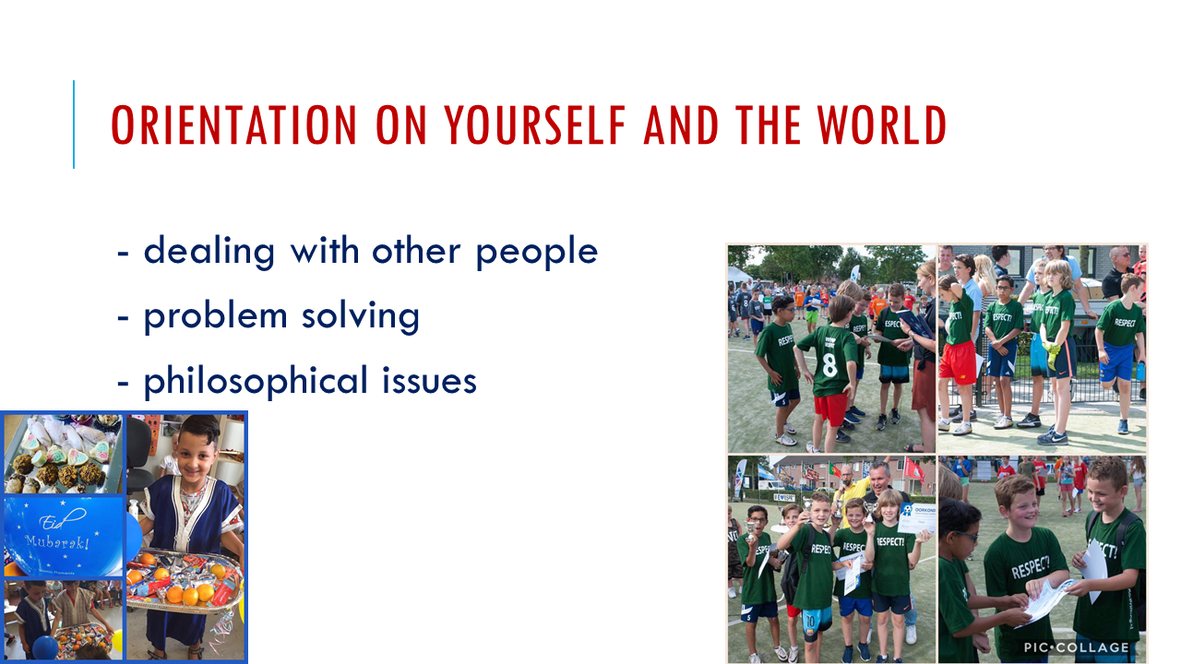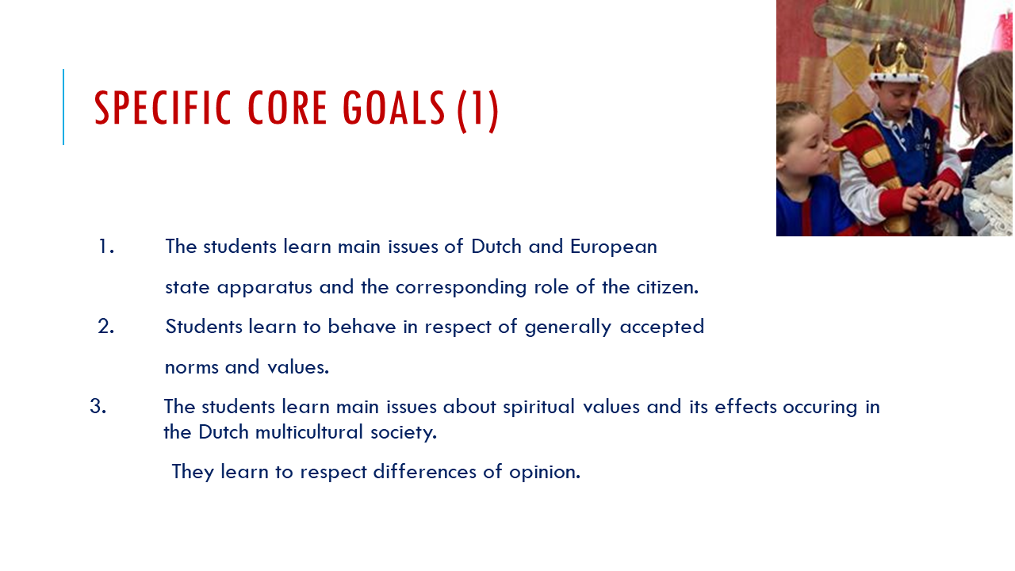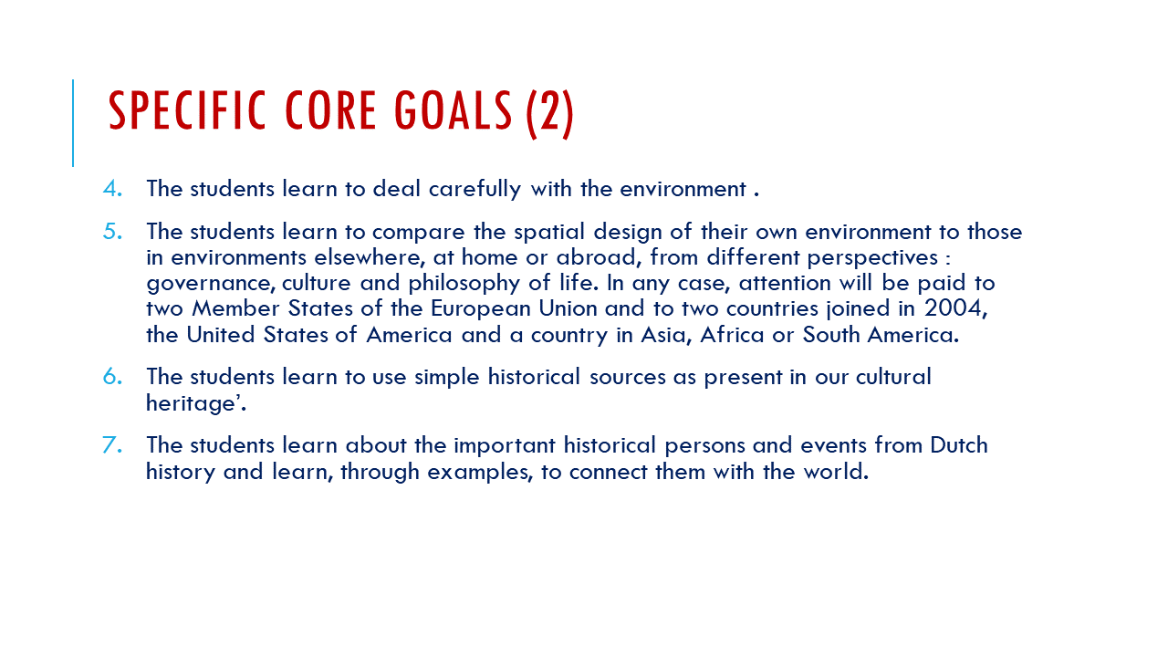
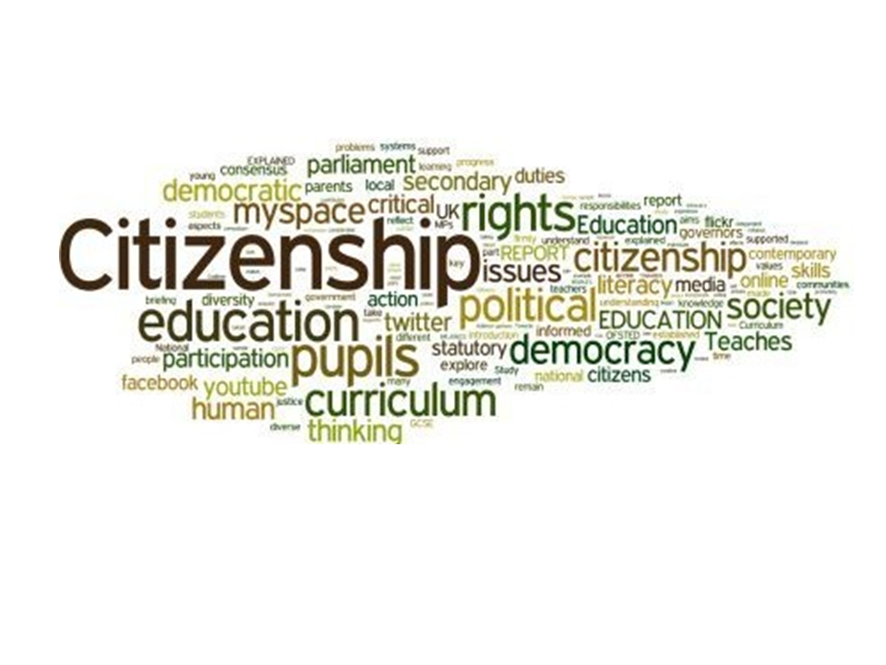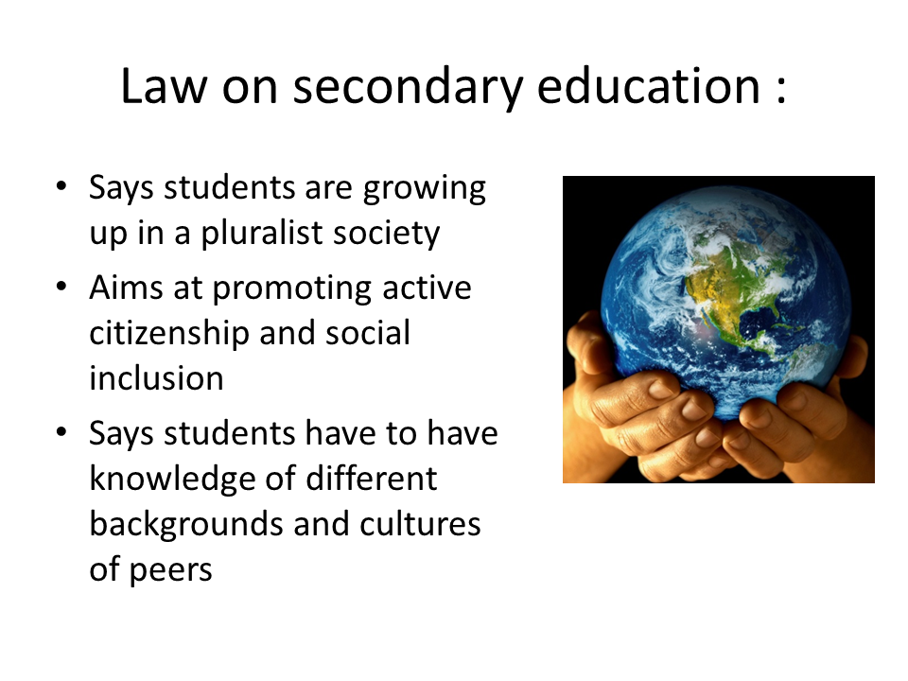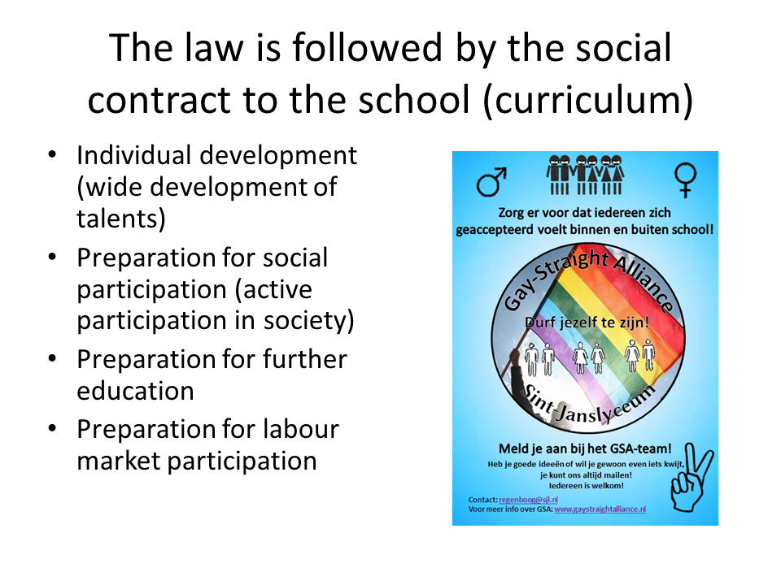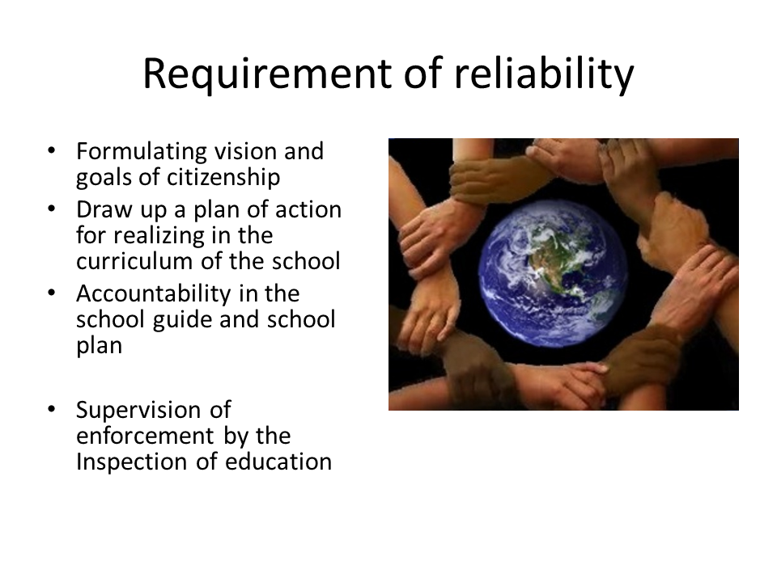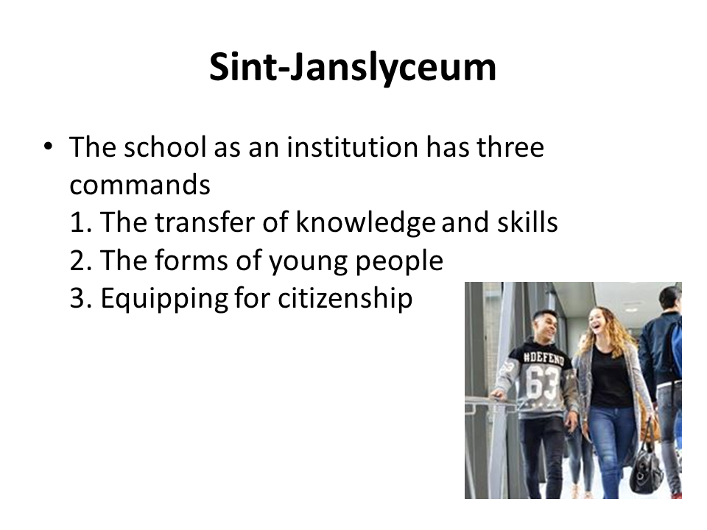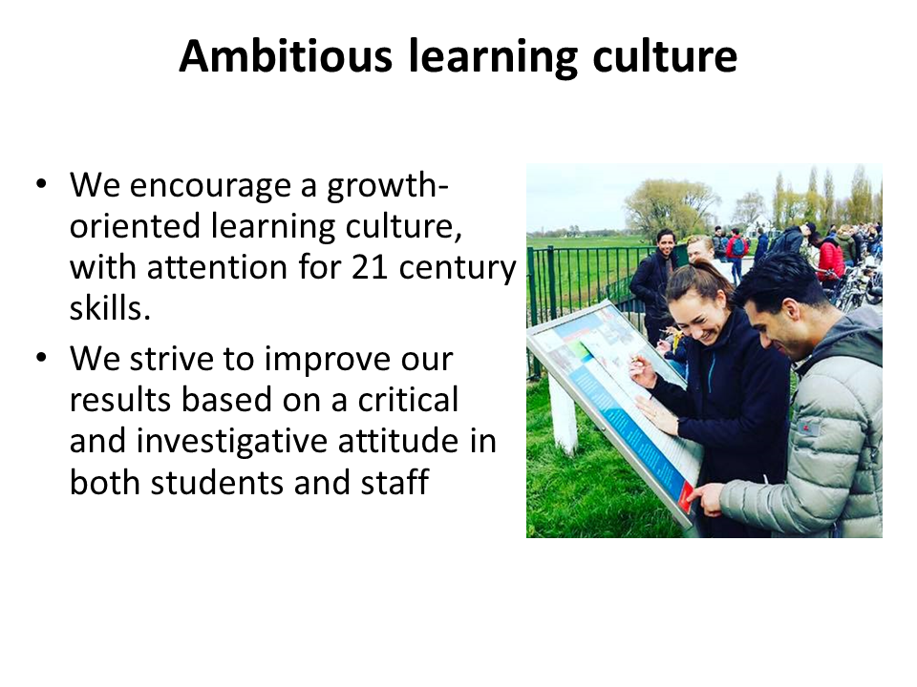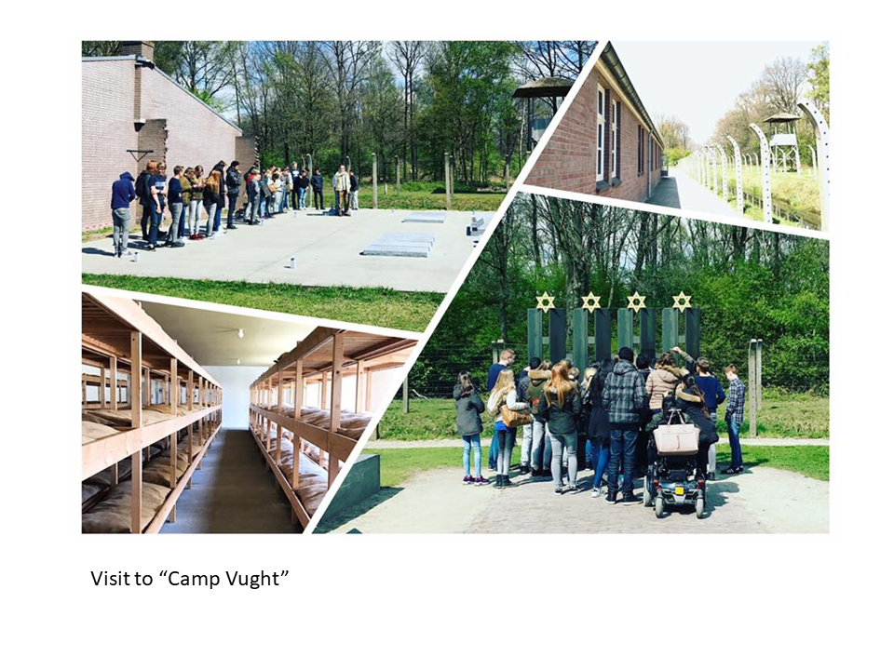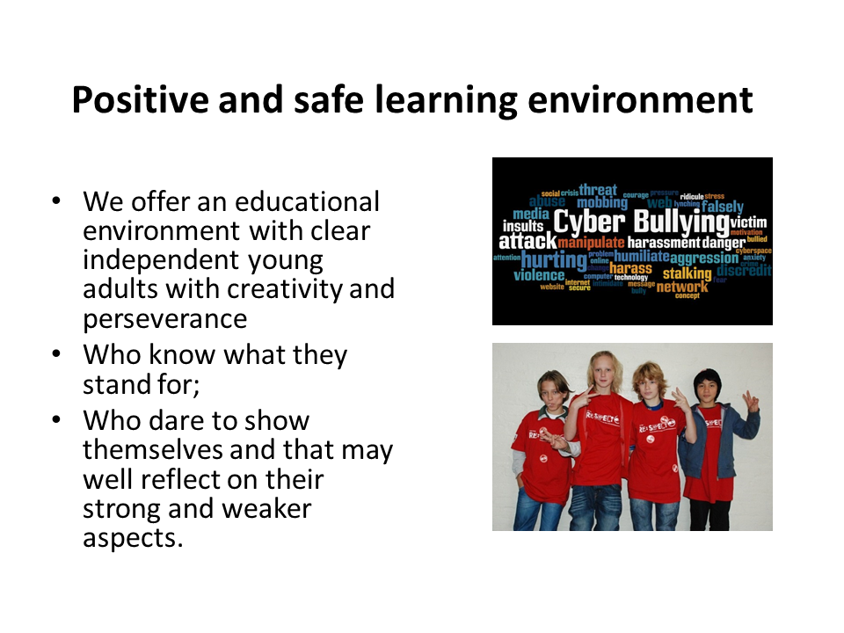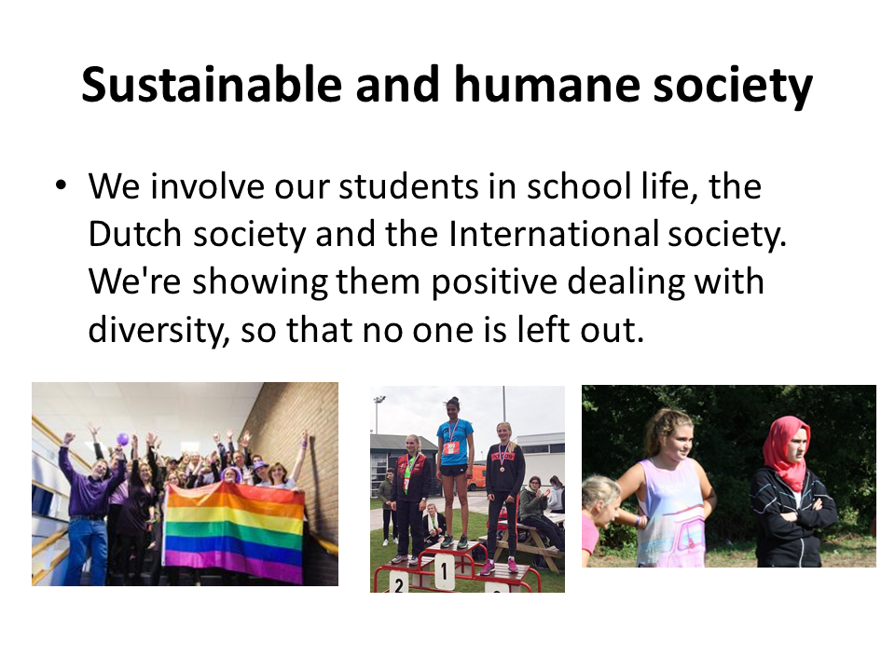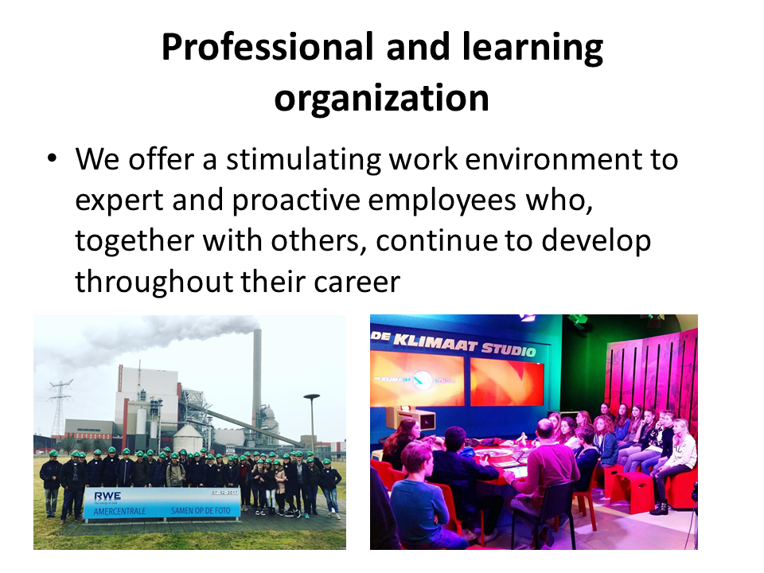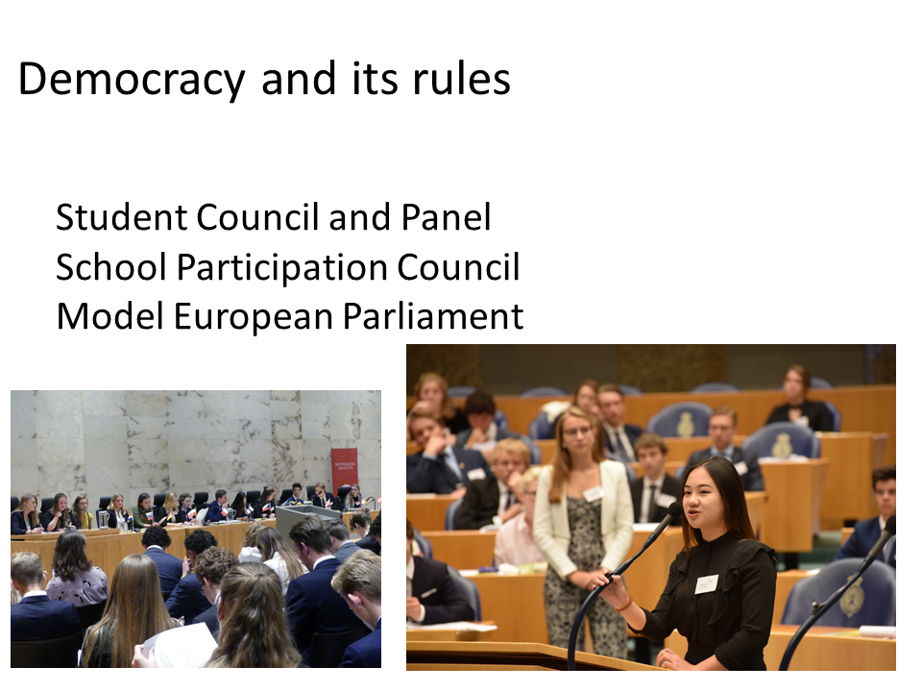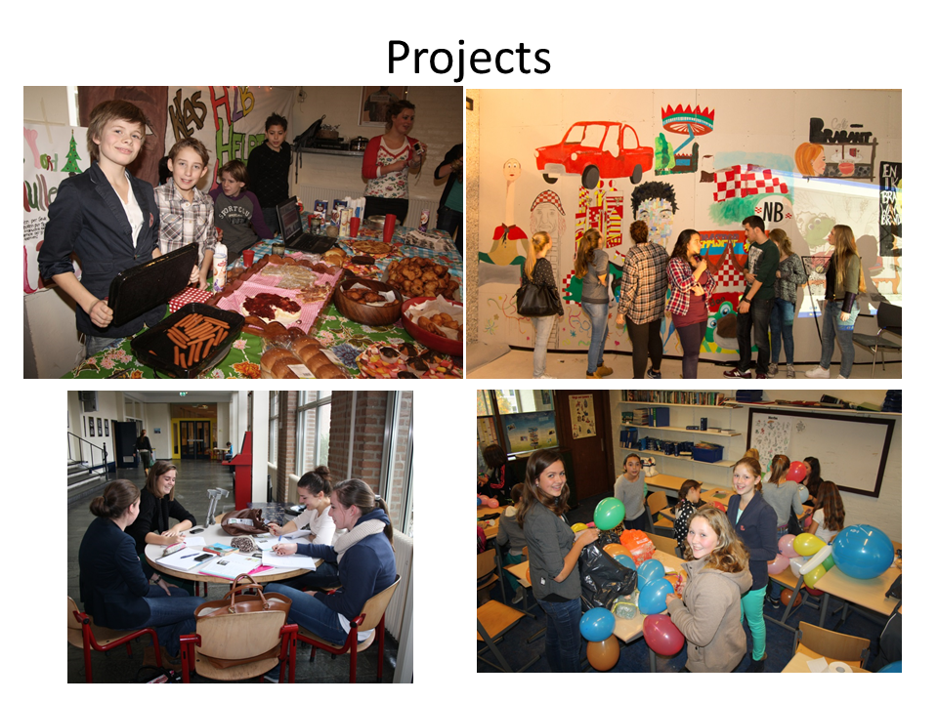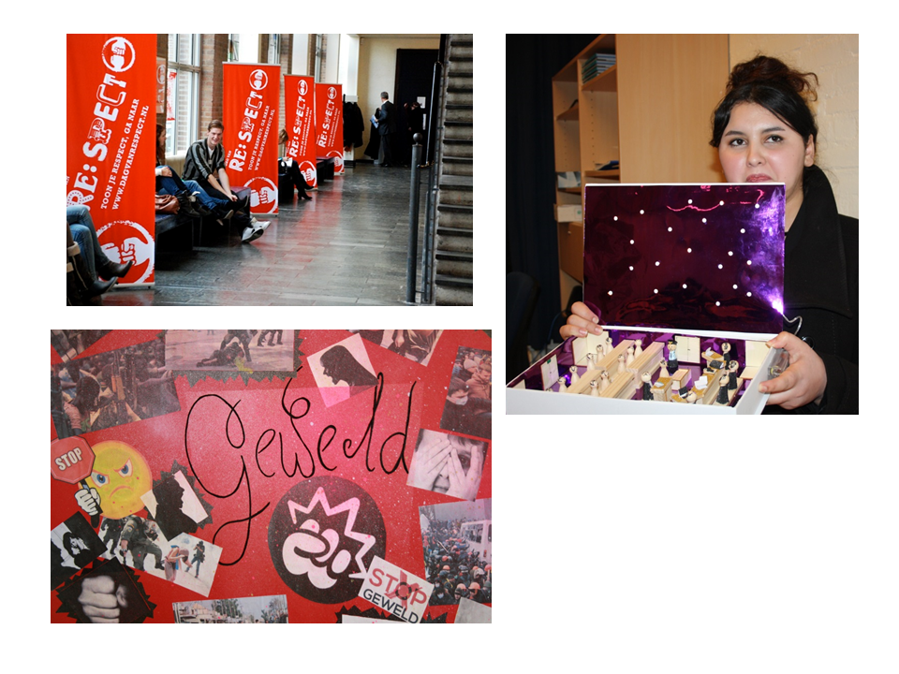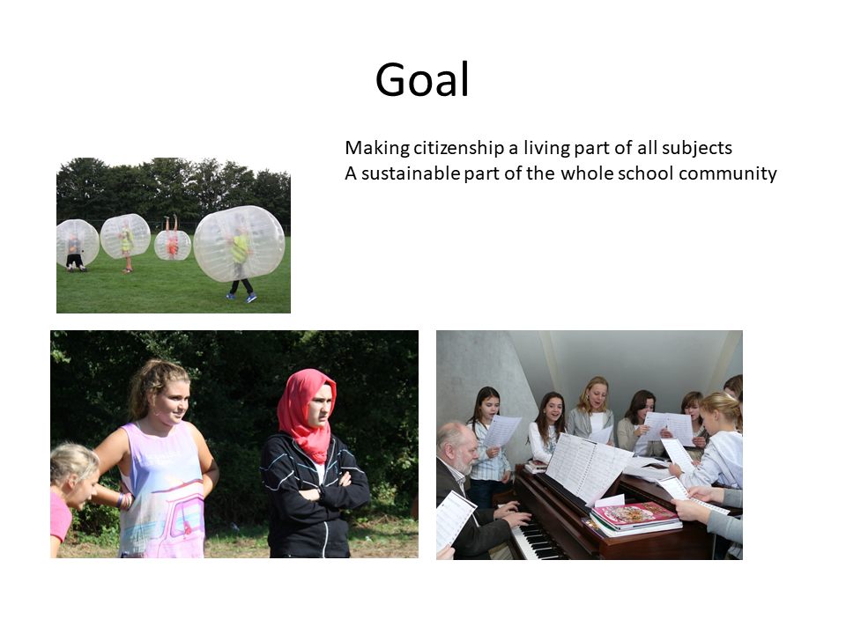

I Spoleczne Liceum Ogolnoksztalcace im Unii Europejskiej w Zamosciu – Poland
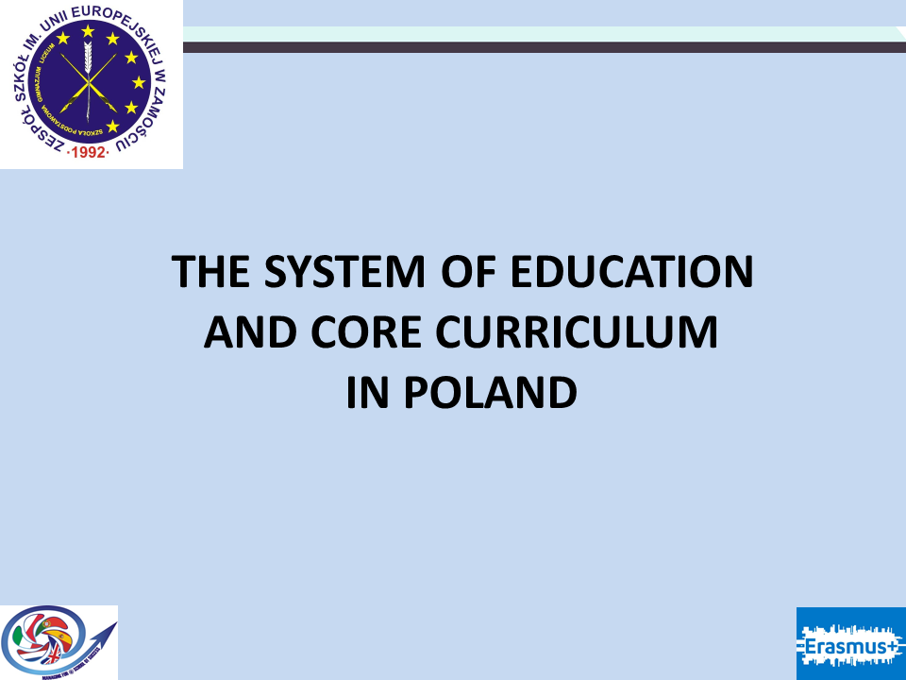
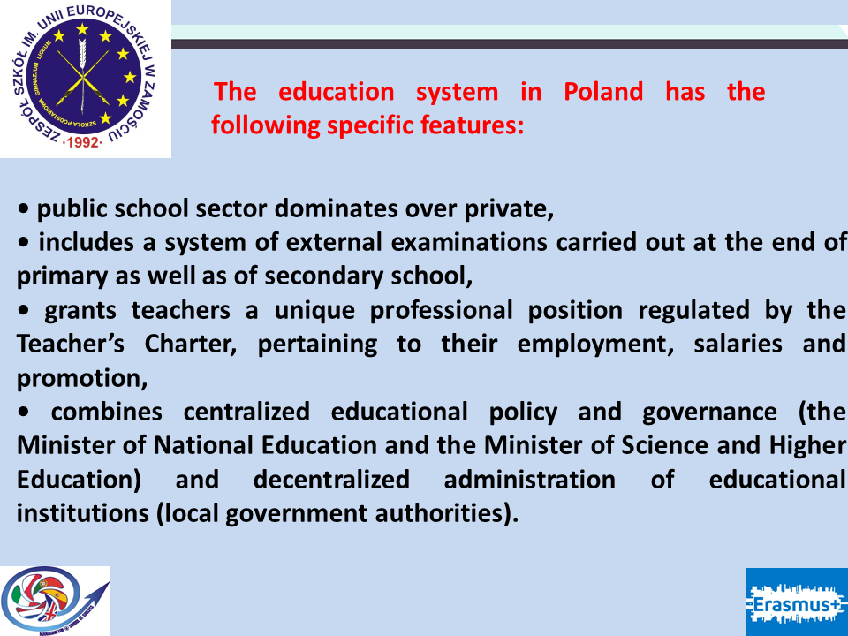
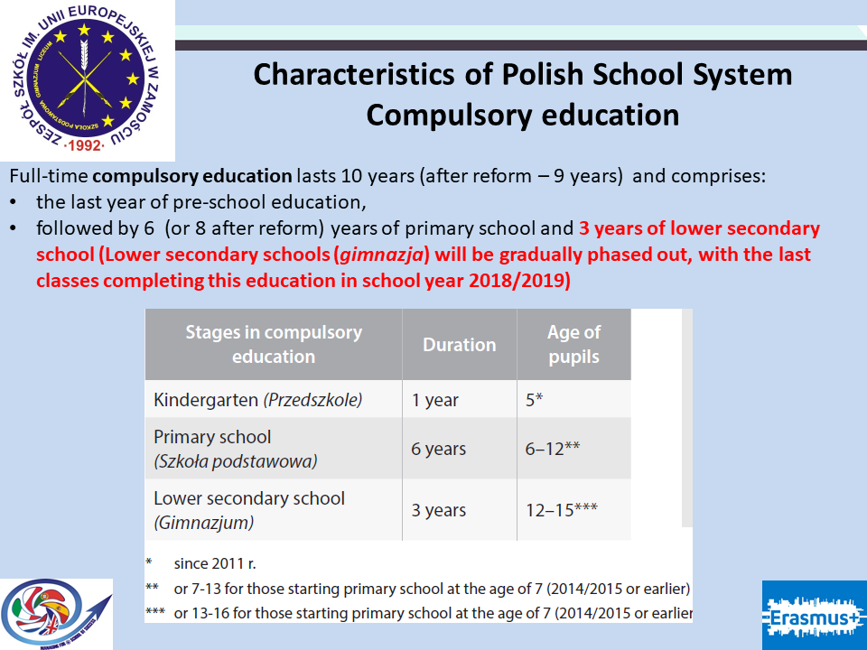
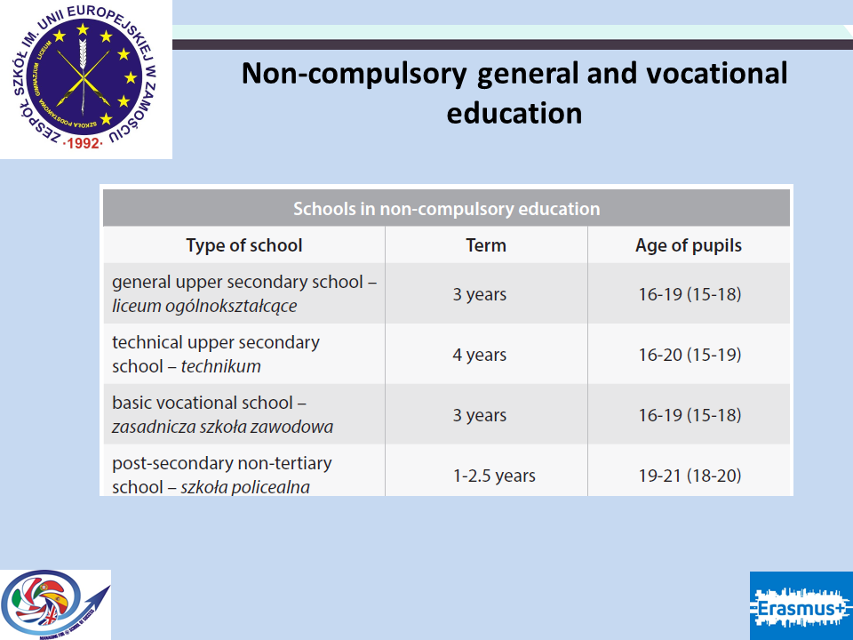
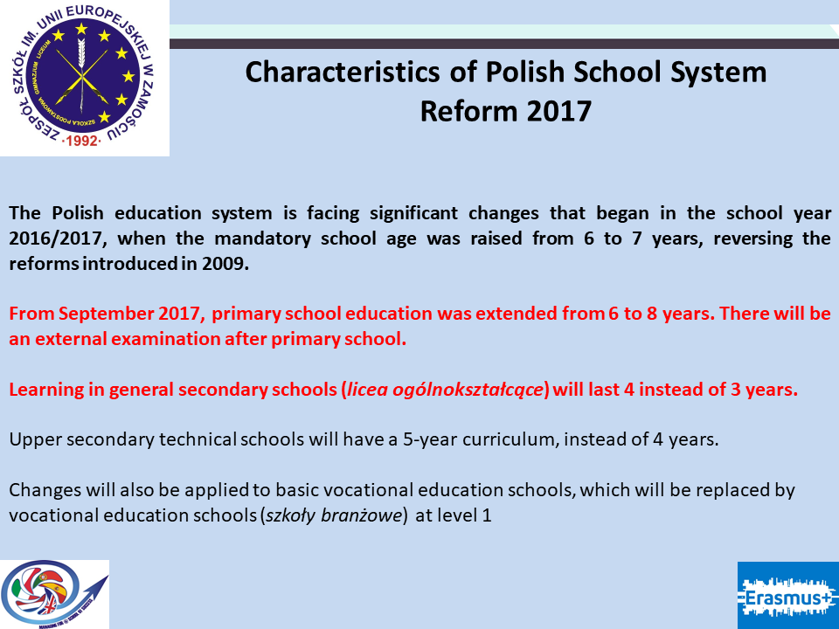
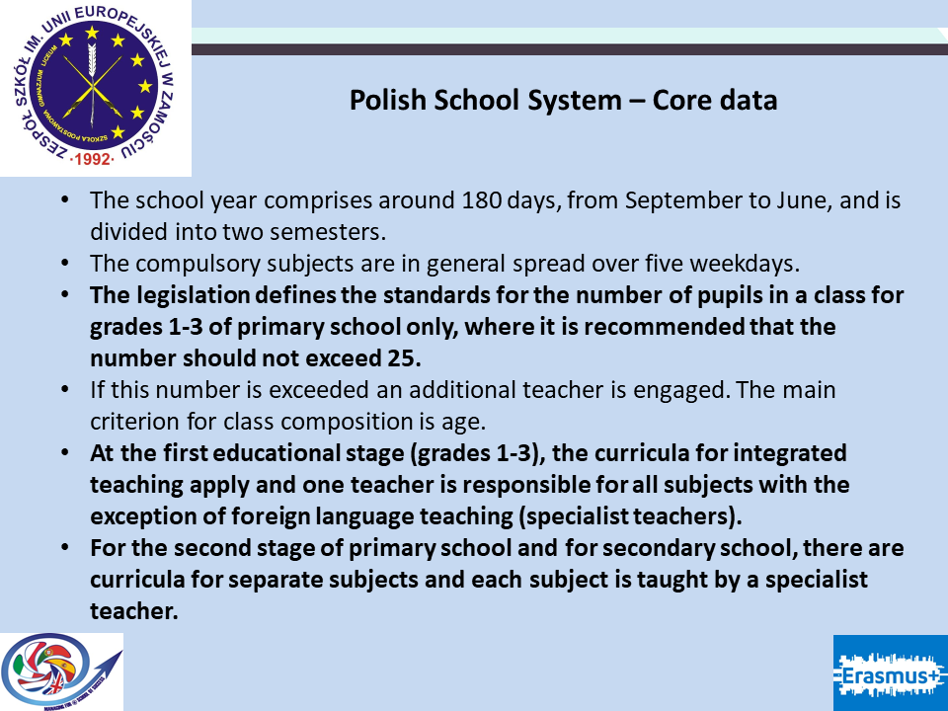
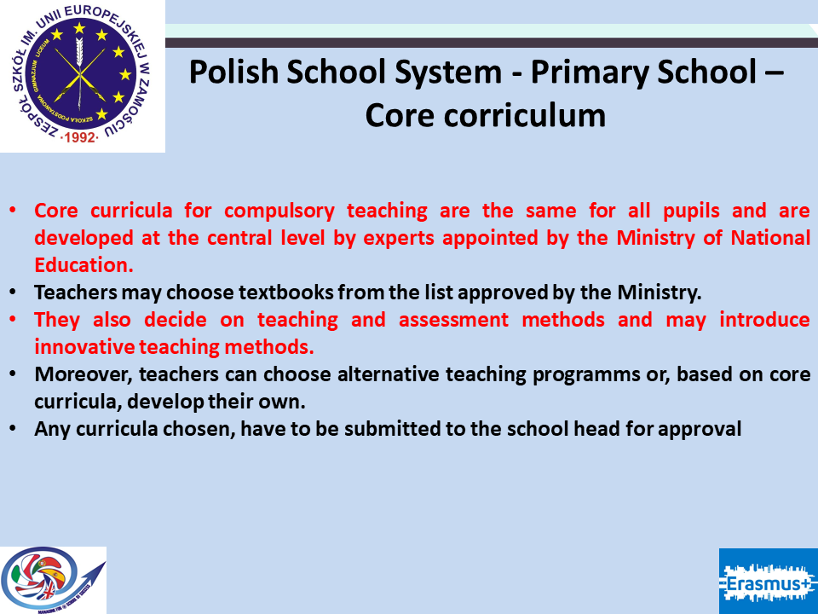
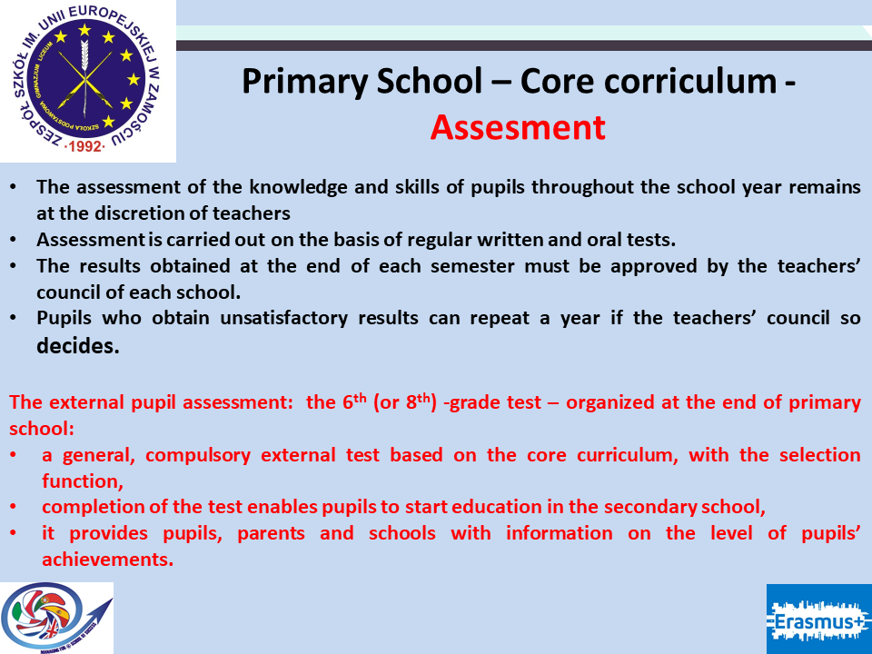
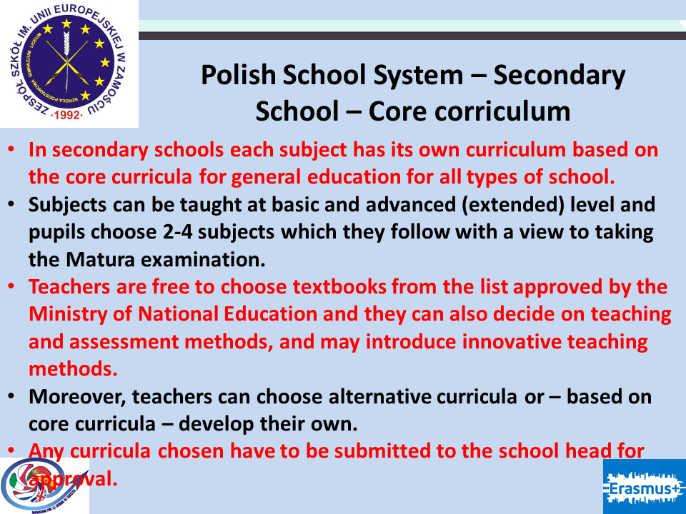
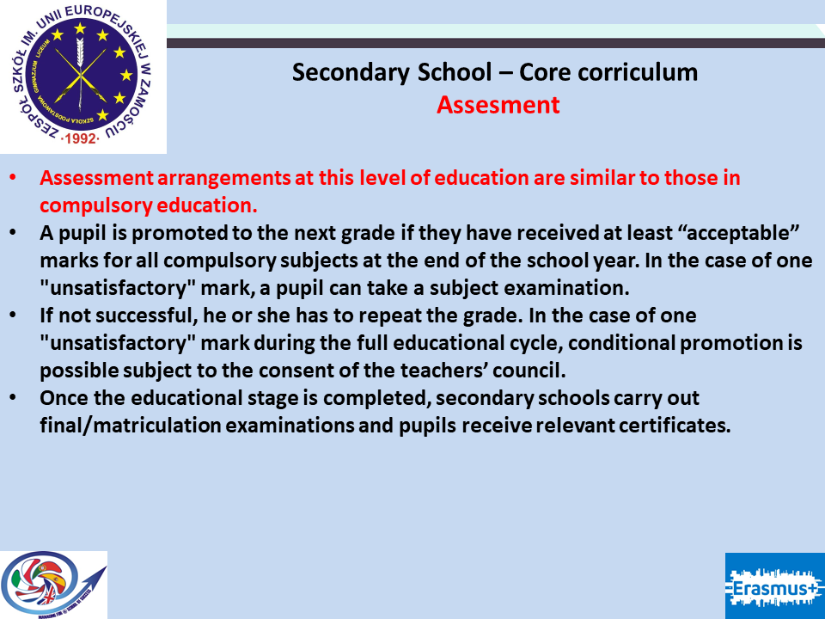
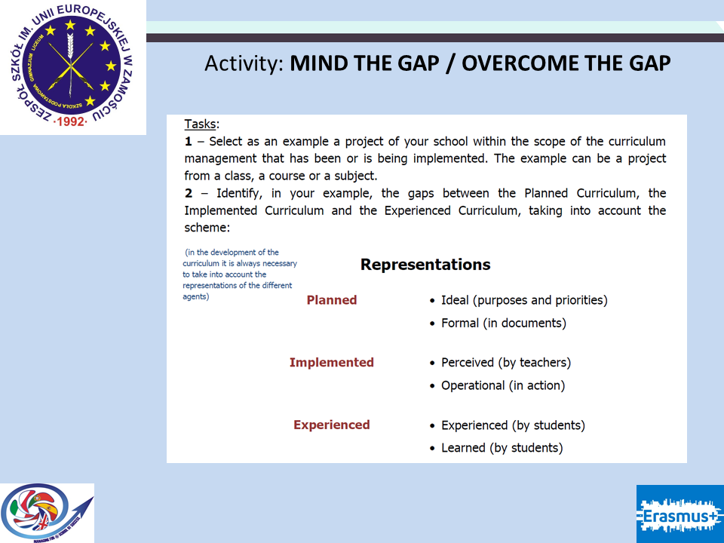
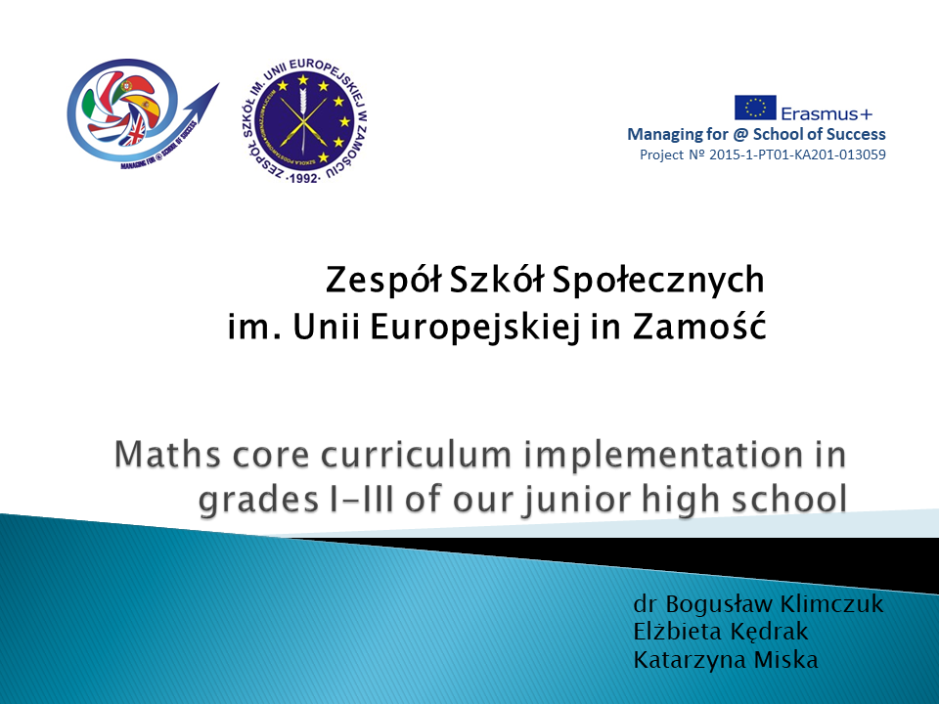
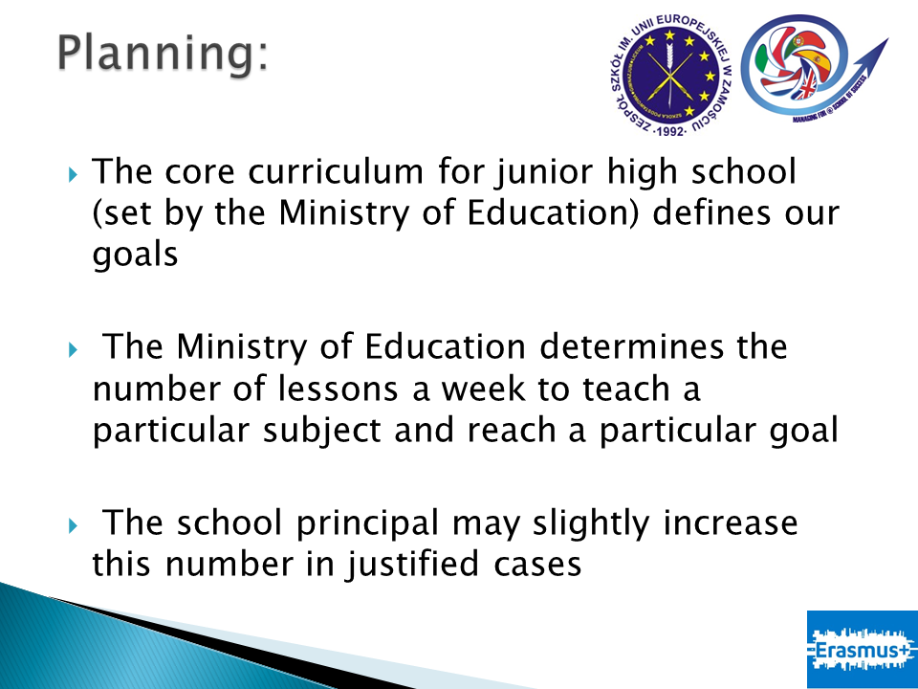
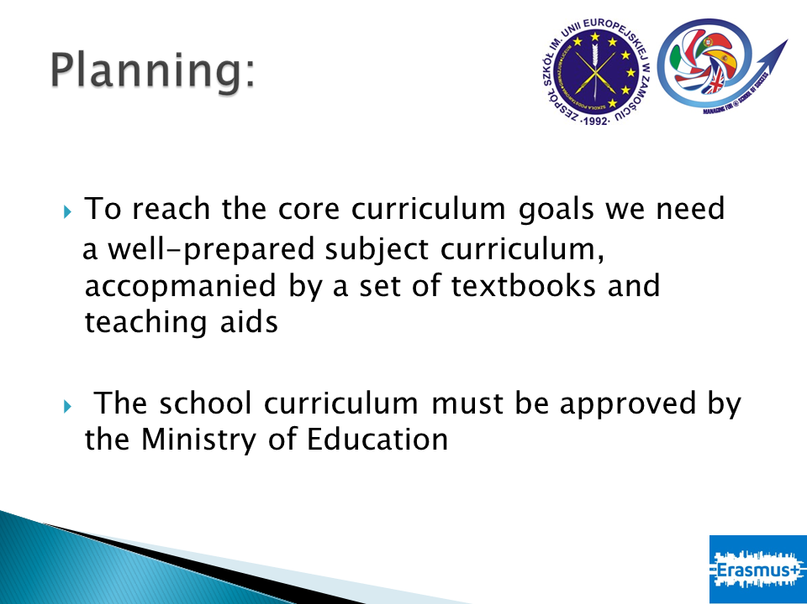
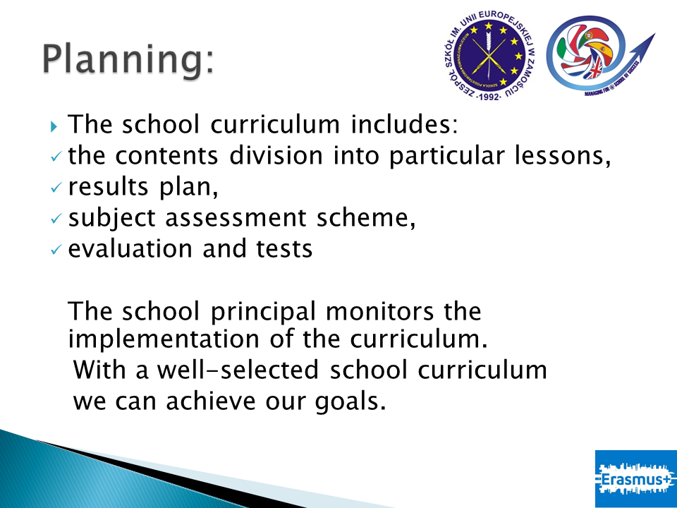
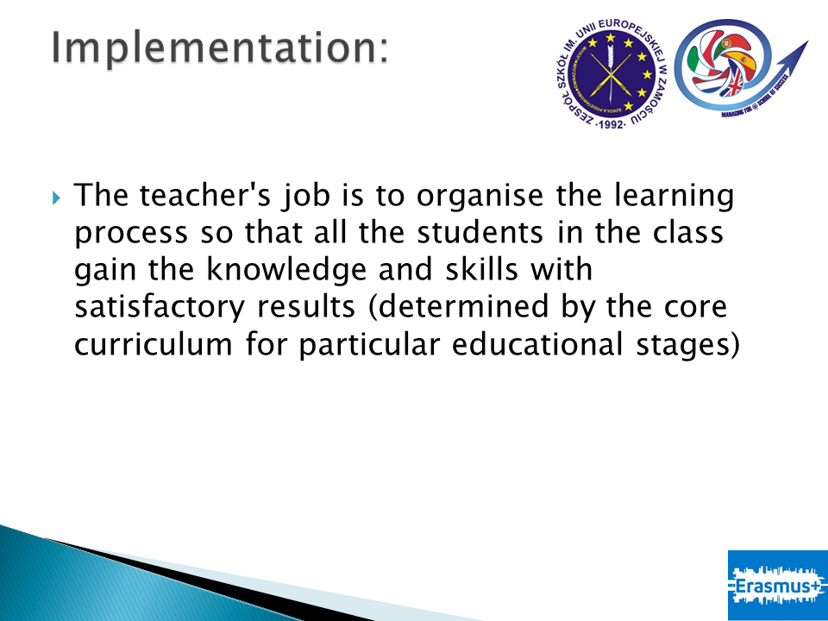
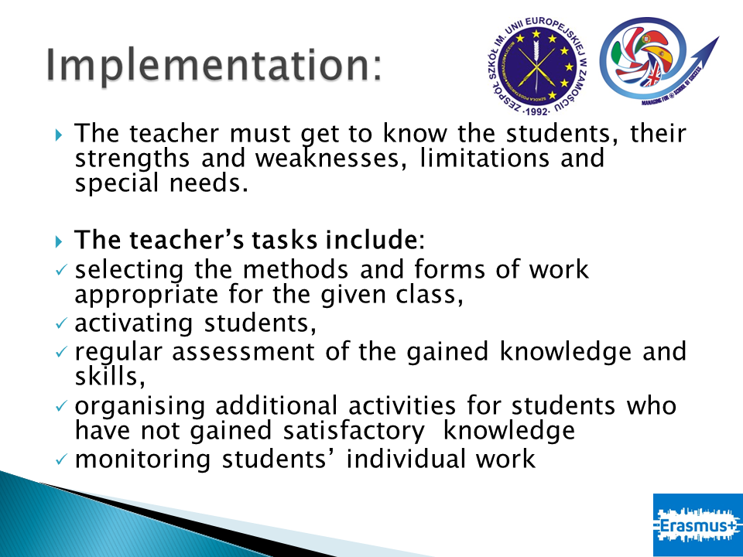
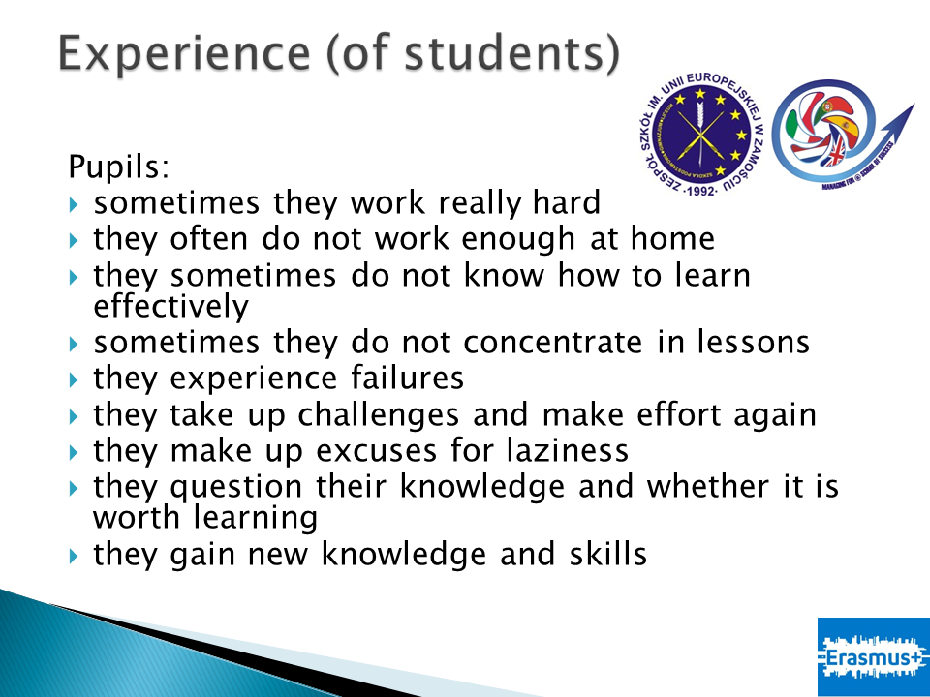
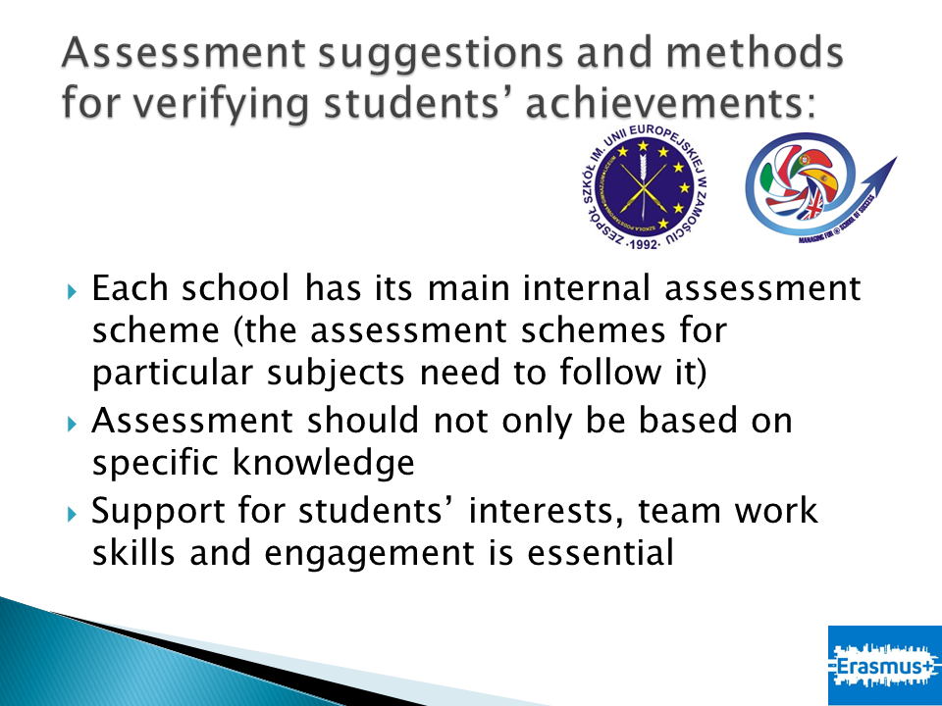
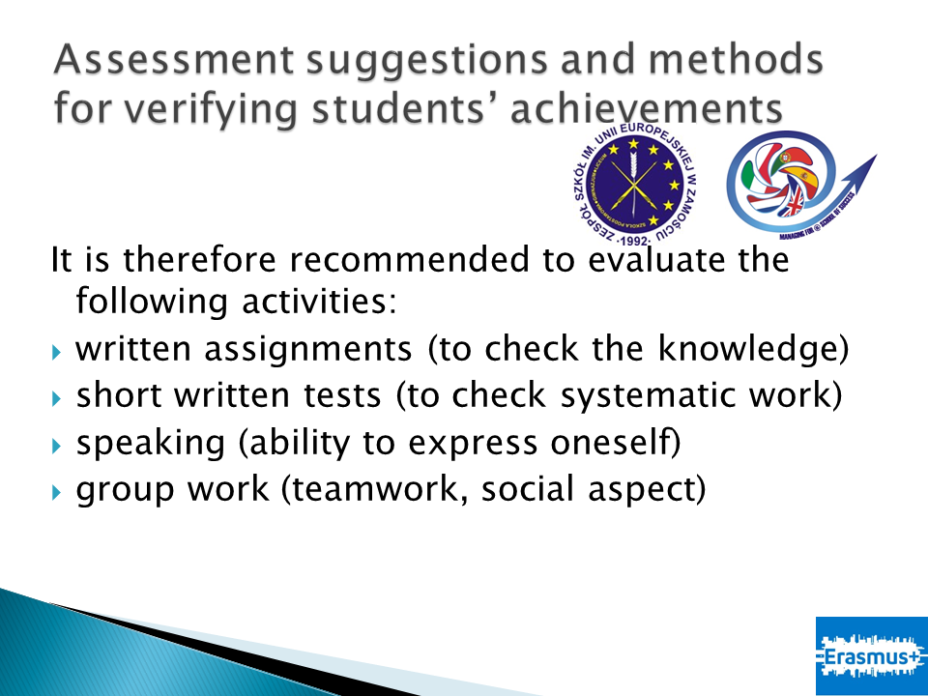
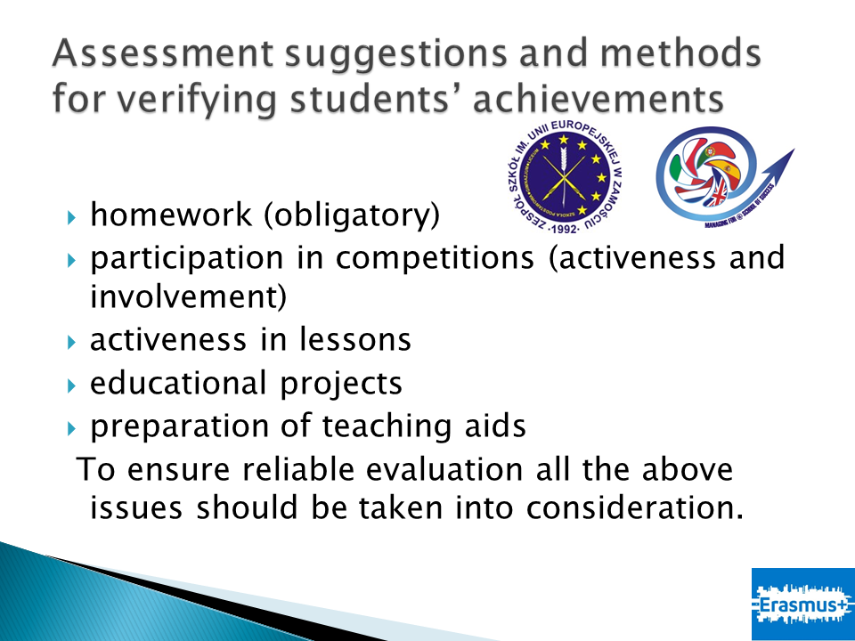
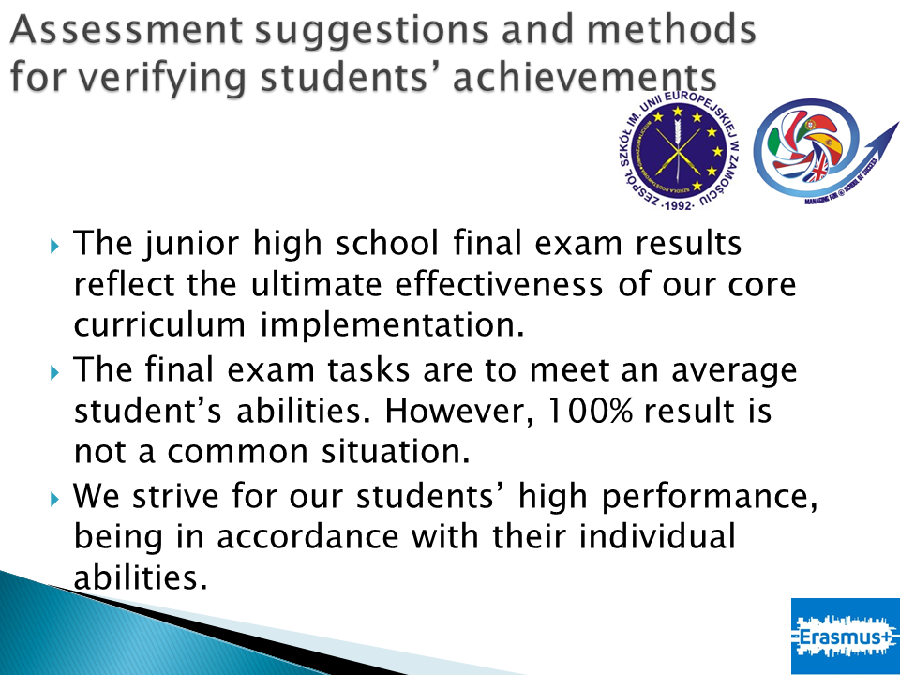
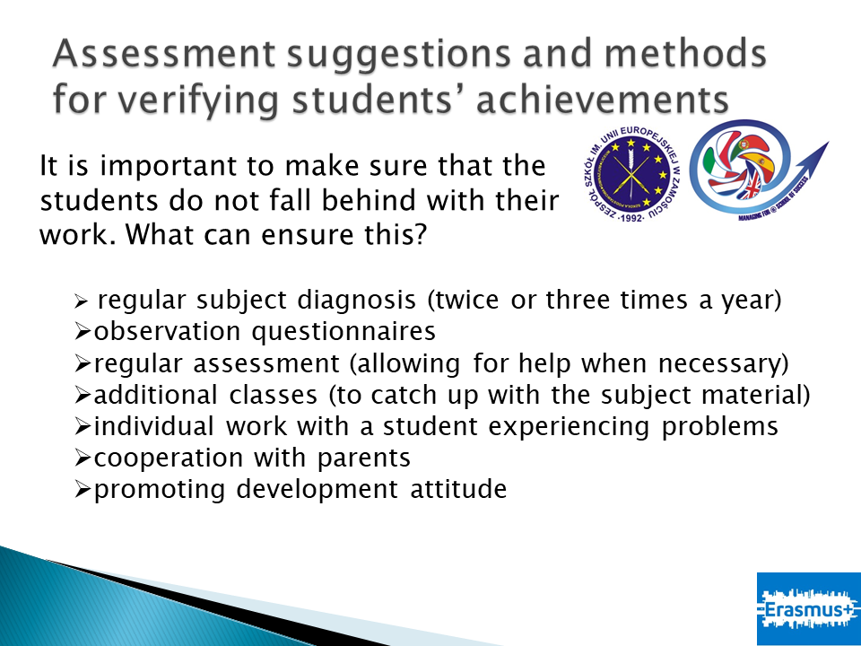
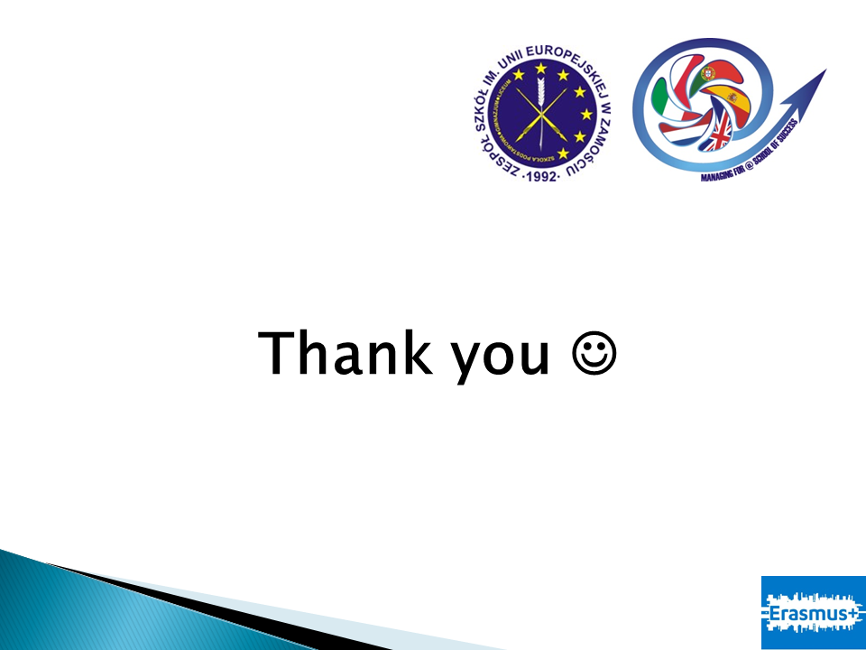

Sátão Group of Schools

Istituto Omicomprensivo "Ridolfi- Zimarino" – Italy
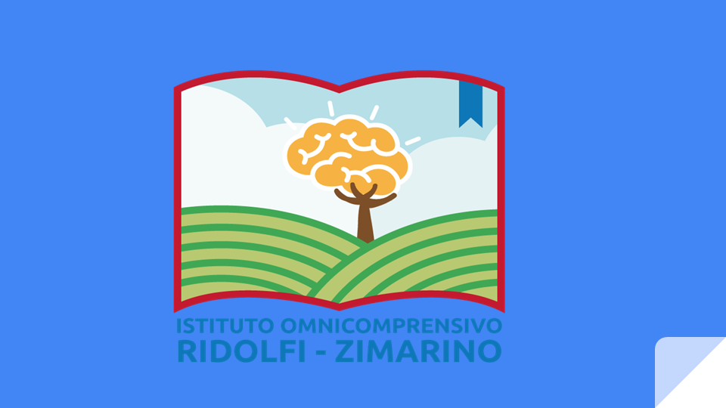
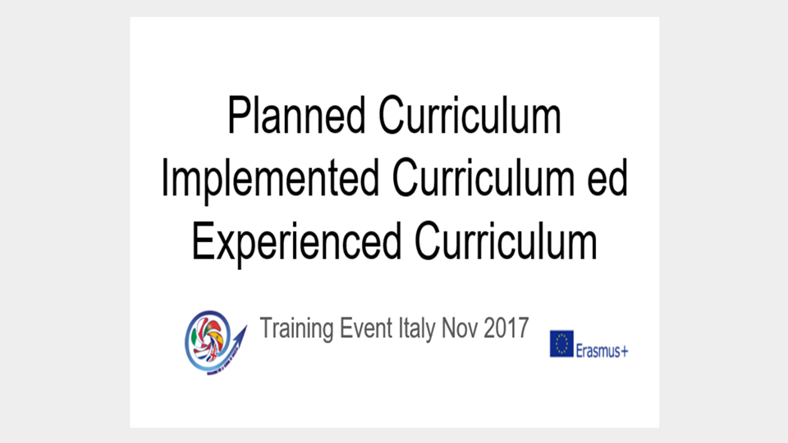
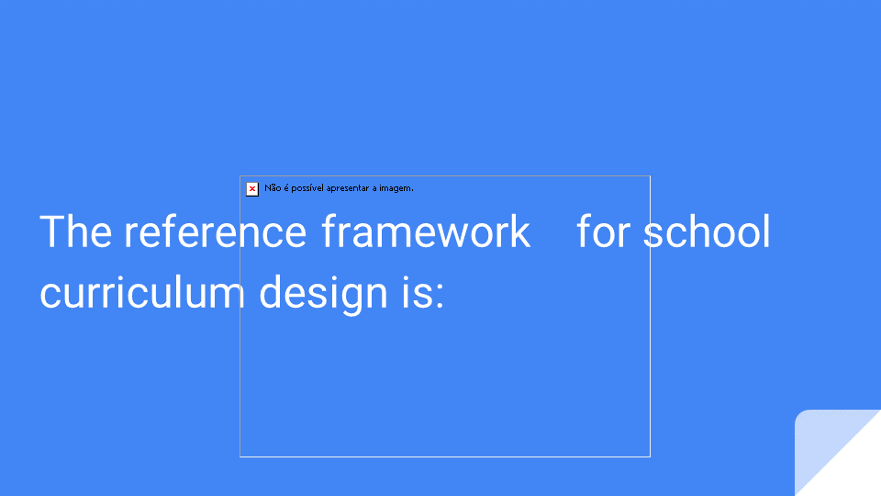
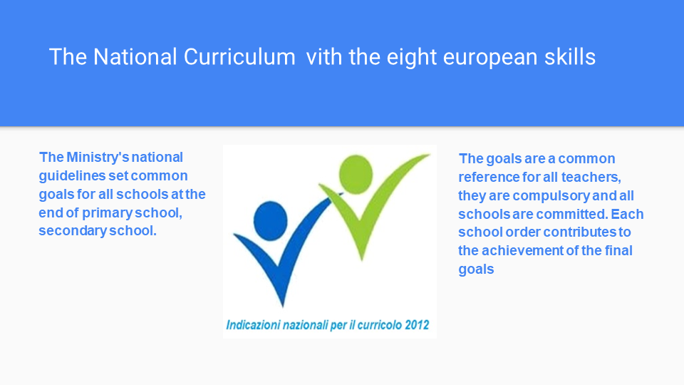
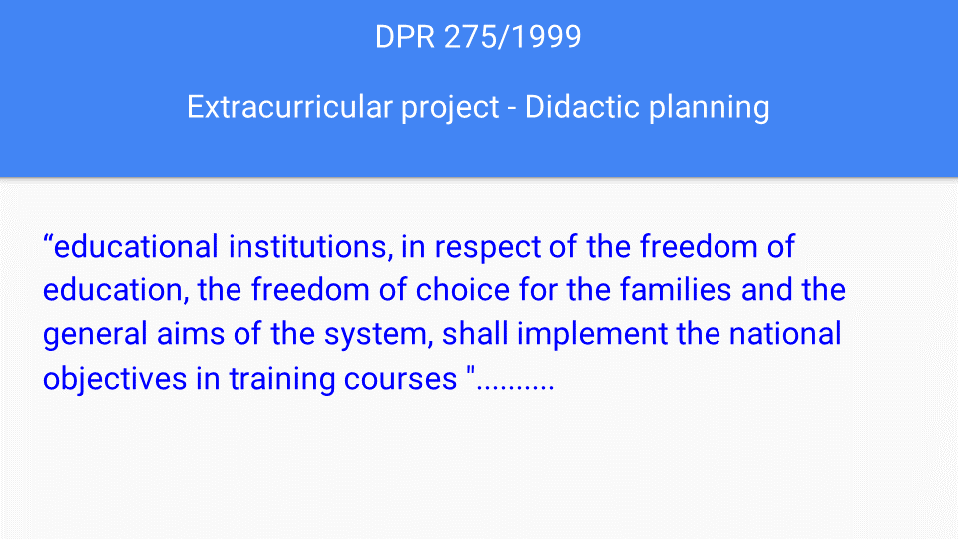
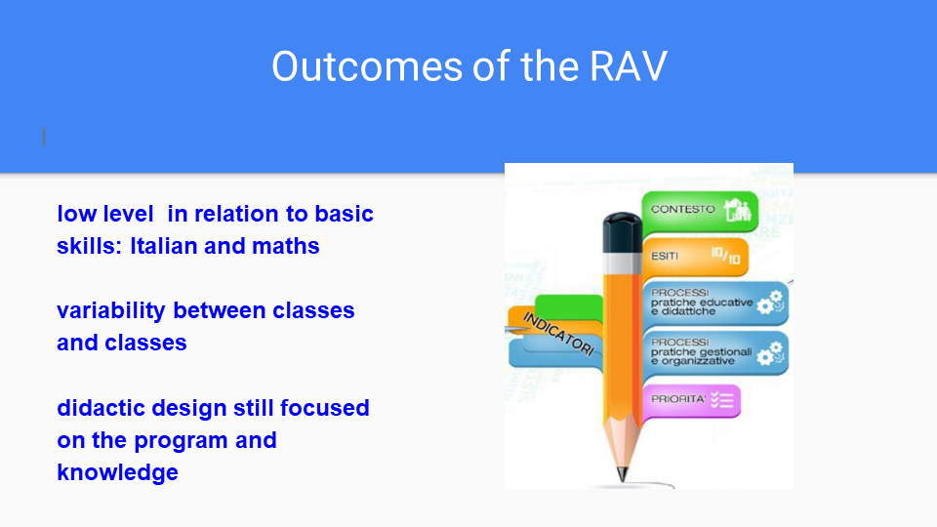
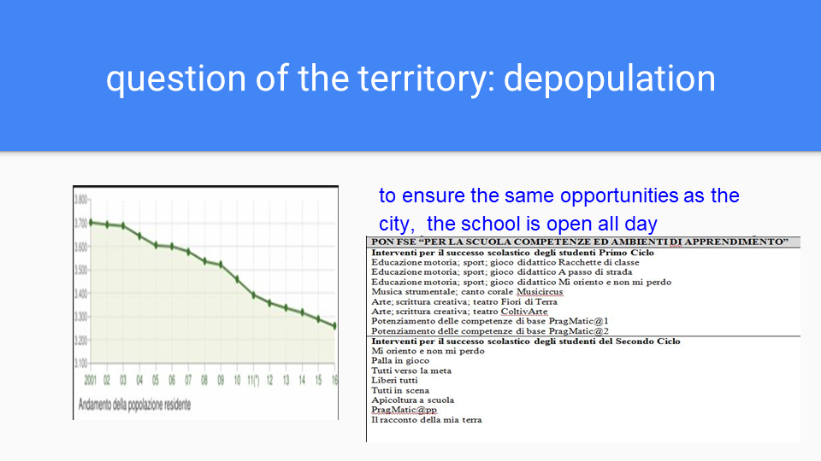
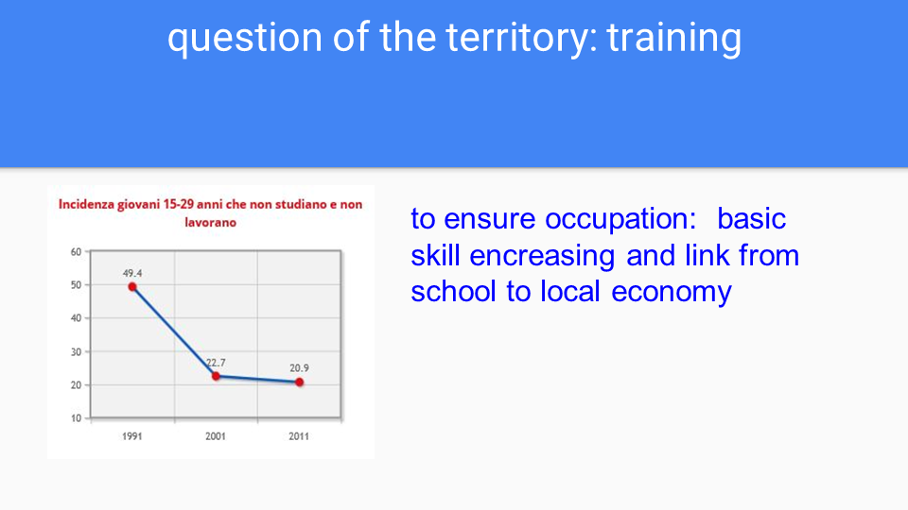
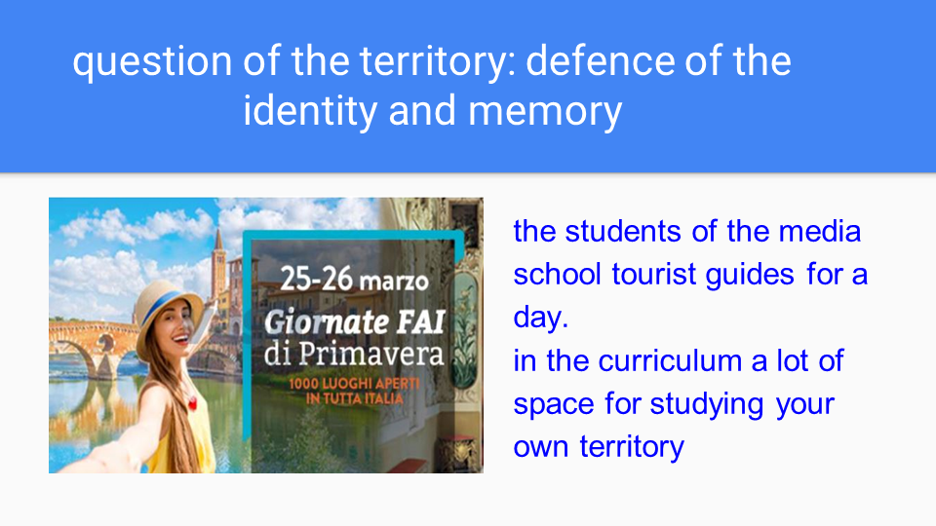
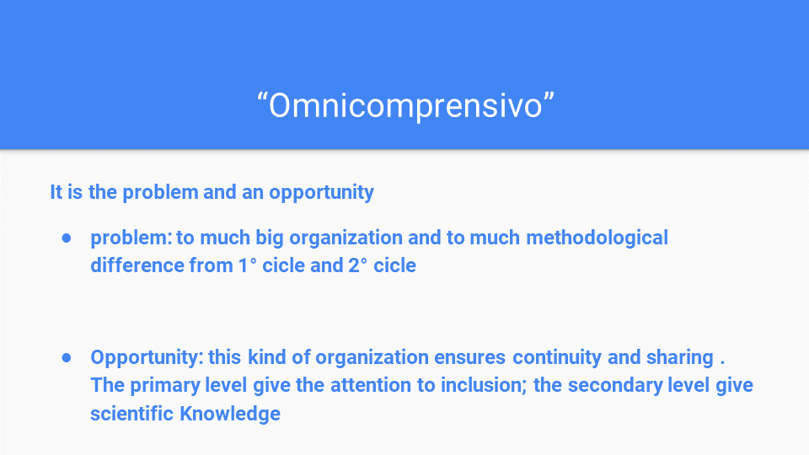
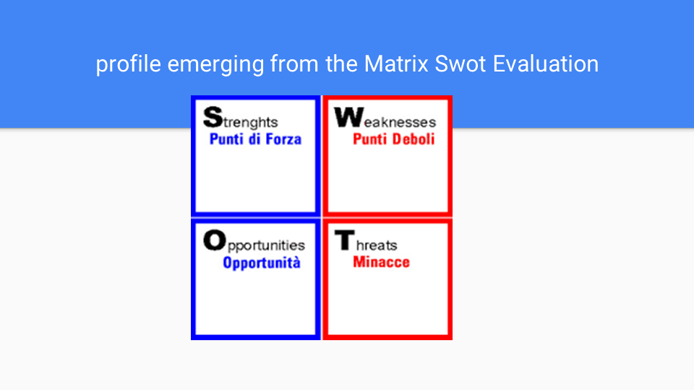
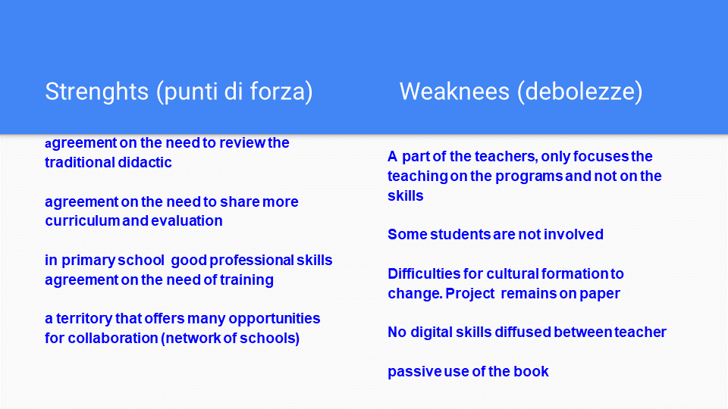
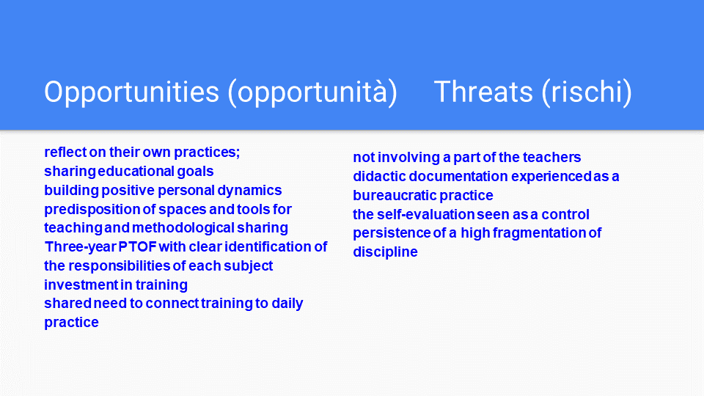
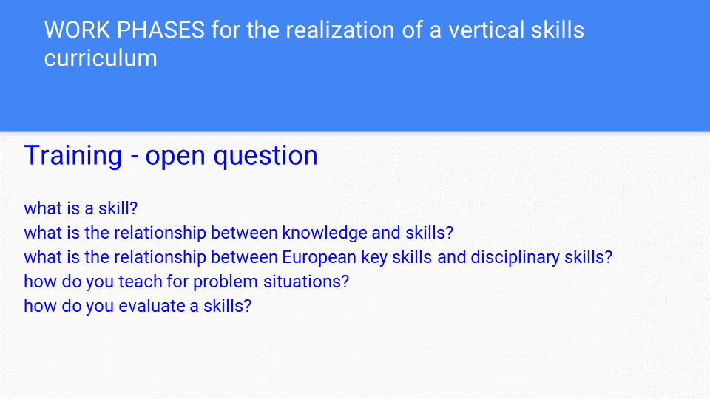
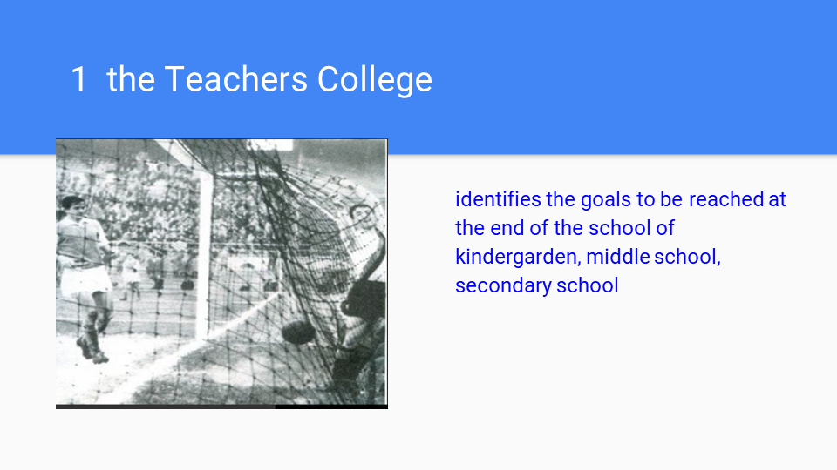
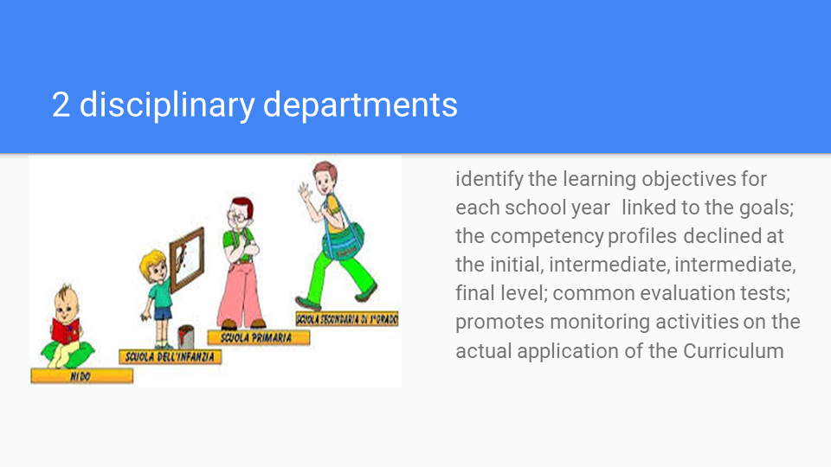
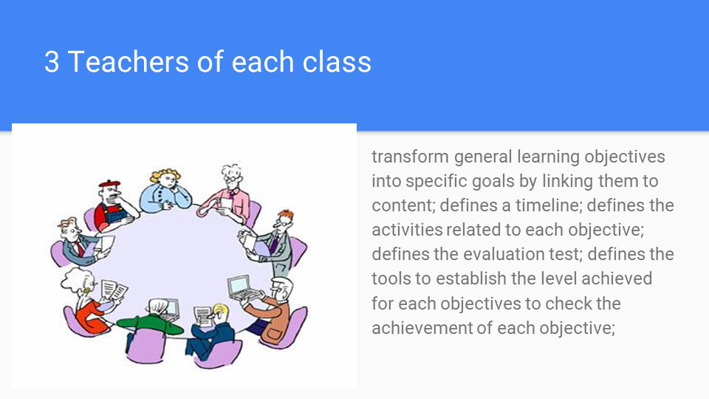
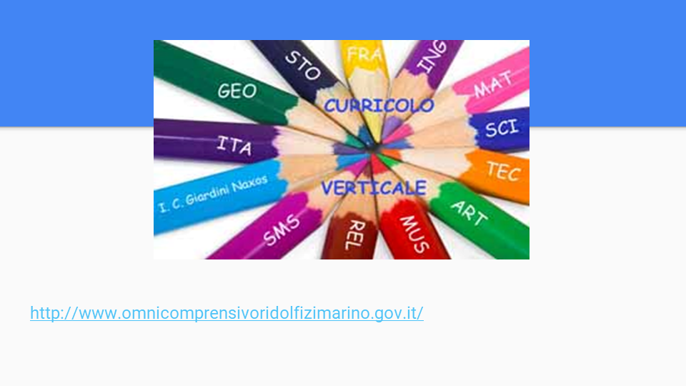

Nelas Group of Schools

Confederacion Espanola de Centros de Ensenanza Asociacion C.E.C.E. – Spain
MIND THE GAP / OVERCOME THE GAP
Goals:
• Become aware of the gaps between Planned Curriculum, Implemented Curriculum
and Experienced Curriculum.
• Identify practices or guidelines that reduce gaps.
• Find effective ways to improve students’ achievement.

Tasks:
1 – Select as an example a project of your school within the scope of the curriculum management that has been or is being implemented. The example can be a project from a class, a course or a subject.
2 – Identify, in your example, the gaps between the Planned Curriculum, the
Implemented Curriculum and the Experienced Curriculum.

PROJECT DESCRIPTION
The most visible gap is in our knowledge of curriculum and pedagogical issues as they arise in relation to multi-year sequences of study. While there is considerable knowledge of curriculum and pedagogy at the course or individual unit of study level, there is very little properly conceptualised, empirically informed knowledge about student learning (and teaching).

The project we have chosen is our Science Project.
We have programmed from 1st. to 6th. level of the science subject, which is supposed to be an enjoyable learning experience. It is based on the 5E’s teaching and learning model and takes into account the multiple intelligences theory.
The 5E’s teaching and learning is a constructivist model (developed by Bybee the 1997) that help students to develop investigations skills and an understanding of the nature of science. It includes 5 phases; Engage, Explore, Explain, Elaborate and Evaluate.
We strongly based our project on the multiple intelligences theory (created by Gardner the 1983) which also supports the constructivist learning. It is a theory that defends that there are eight ways to learn something, each one related to one intelligence (linguistic, logical mathematical, musical, bodily kinaesthetic, visual special, intrapersonal, interpersonal and naturalist). Because the lessons that we have planned are varied, we will try to arrive to all the intelligences in every topic, in order to make the kids learn in a meaningful way.
In this subject, we are going to strengthen the English language. English will be the
working language in science, so the teachers will use only English and will try to strengthen the production among the students with meaningful and motivating activities.

In conclusion, science subject will take the best from the 5E’s model and from the multiple intelligences theory to make of the science learning a motivating activity with encourages the English learning in a meaningful context.

PLANEED CURRICULUM

Ideal: Purposes and priorities

-Engage (session 1): This phase has the purpose of engaging the children with a motivating question about a topic, to speak about what they know about it and make connections with past learning experiences. In this case the teacher will introduce the science topic through a video that shows all contents they will learn during the different lessons. After watching the video students and teacher will discuss about the most important features of the topic and also about what they are expected and what they want to learn.

-Explore (session 2): In this phase students try to find an answer to their question. They have the opportunity to get directly involved with phenomena and materials, to experiment. The teacher acts as a facilitator, providing materials and guiding the students’ focus.

-Explain (session 3): In this stage learners communicate what they have learned, with the help and guide of the teacher if it is necessary. The significant aspect of this phase is that explanation follows experience.
We are going to use this stage to remind and stress the main vocabulary of the topic.
-Elaborate (session 4): In this session, the group check what they have learnt about the topic, do connections and finally create a mind map with the most relevant aspects of the topic.

-Evaluate (session 5): Students will do a test to check their knowledge about the topic. Evaluation is an important phase not only for the students, but for the teachers too, because it is an opportunity to see if the learning has taken place.
Even so, teachers will evaluate the kids during all the lessons, not only in the final one.

Formal (in documents)
Attached document 1: Topic charts for years
Attached document 2: Sample of programmation of one topic semester
Attached document 3: Evaluation of the project

Cr eati n g a “cr eati ve ” cu rr i cul u m
A creative curriculum is one that incorporates big ideas, varied and engaging activities, and a sense of continuity as a way to stimulate students, teachers, and even families. Making the knowledge, skills and concepts become innovation, enthusiasm and individuality is often quite complicated to avoid curricular gaps.
In case of our science project and its gaps, we tried to focus on big concepts and ideas.

For example, working on a science curriculum about plants and how they grow. It's important for students to learn the stages of photosynthesis. Depending on their age range, you may want students to memorize things such as what a plant needs to survive, or even different types of plants, or plant reproduction. But our project isn’t really about that. Our project plan or curriculum is one that is oriented toward what is conceptually important. Take a few minutes to jot down what concepts about plants you think might be important to the age group you work with. Some examples of big ideas might be things like:

• Plants have things they need in order to survive.
• Different plants grow in different places, and this happens for a reason.
• There are different categories of plants.

Once you have pinpointed three to five big, abstract ideas that outline your curriculum, you will be better prepared to get creative with specific activities.

IMPLEMENTED CURRICULUM

Perceived (by teachers)
Teachers usually develop a hard and important work to implement the curriculum contents and objectives in their classes, specially when they are strongly concerned about the importance of adding other resources or objectives that the curriculum does not talk about.
The curriculum considers different aspects which at the moment of operating in daily lessons teachers have to change and a gap is created:

• Diversity in class: The school curriculum establishes that education must be inclusive and answer to each student’s needs. Education must guarantee a balance of the diversity and the progress.
Teachers have to take into account all students’ needs in all the activities planned and
sometimes it makes advance students not to progress on their proper level and sometimes to slow down the general class rhythm.

• Timetable distribution: Most of times, the hours that the curriculum indicates or marks for each subject does not consider other important areas or contents that each teacher thinks are important to work. F.e:

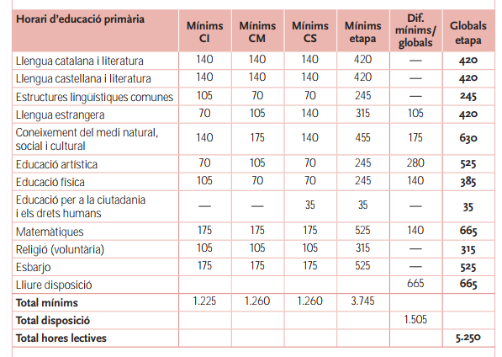

This chart represents the timetable the curriculum establishes. In Catalonia, due to the center autonomy we can add sometime to work on other aspects, but in other Spanish communities, what about working other aspects such as emotional education, Science in English, reading comprehension…?

Distinguish general vS measurable
Because of this belief of our responsibility as teachers in students’ achievement it is important to focus on creating measurable learning objectives as opposed to general learning objectives. I want to be able to measure a student's performance or their understanding of the topic, in order to measure our overall success.

Operational (in action) related to our Science project
In our school we have decided to spend this free hours of autonomy to create a Science project which aims to work Science concepts using English as a vehicular language. The idea is that students experiment and manipulate at the same time that they learn.

Science curriculum establishes some features that create an important gap at the moment of operating with the subject:

“It is important to strengthen the direct knowledge of the reality and grant a privilege of
the evidences identification which confirm or create questions about the ideas”

“ Evaluation has to be directed exclusively to the students knowledge improvement”

“Students have to participate actively in group work, having a responsible and caring
attitude; being able to argue and to respect others’ ideas and opinions”

EXPERIENCED CURRICULUM

Experienced (by students)
We strongly opine that the experience that students have and keep from the curriculum is the most important thing in the teaching and learning process.
On our way of teaching and considering the curriculum we take into account some important items to make this experience absolutely useful and lasting:
• Students role in learning process: Students self- centered methodology where curriculum is presented whole to part, with an emphasis on big concepts. The curricular activities rely heavily on primary sources of data and manipulative materials and students questions are listened and highly valued.

• Teachers role in learning process: Teachers are basically guides and mediators; intermediaries between the students and the knowledge. They develop interactive roles and the assesment they do considers observation and participation; viewing students as “thinkers” of the world which work in group.

• Distinguish satisfaction and dissatisfaction of students: We think it is important to keep students motivated and satisfied through learning.

• Be able to change whenever necessary

Learned (by students)

To make sure that students have achieved the objectives we have proposed without any learning gap is one of the most difficult tasks we have as teachers.
Obviously, in the “trip” of creating, developing and evaluating, some concepts are left
behind. In this part is when we realize exactly which gaps have been forgoten.

Attached documents:

ANNEX 1: TOPICS FOR SCIENCE YEAR 2015-2016

ANNEX 2: 6TH GRADERS MINDMAPS

ANNEX 3: SESSIONS EVALUATION

1st | 2nd | 3rd | 4th | 5th | 6th
Plants (Parts and cycle, seeds) | Plants  (What does it need to survive) | Plants  (Parts and cycle, seeds) | Plants  (Parts and cycle, seeds) | Web of life  (Food chains, changing environments and evolution) | States of matter  (Solid, liquids, gas and matter changes)
Seasonal changes | Seasonal changes | Seasonal changes | Seasonal changes | Mixing and making  (Using materials, mixtures and new materials) | Lights  (How do we see, shandows)
Animals and humans | Animals and humans | Animals and humans | Animals and humans | Space  (Solar system, days and nights, reality and fiction) | Forces  (moving surfaces, gravity and magnets and simple machines)
Healthy life | Healthy life | Humans and  Healthy life | Humans and  Healthy life | Growing and changing (Life cycles and reproduction) | Earth  (Rocks and soil)
Materials | Materials | Materials and their properties | Materials and their properties

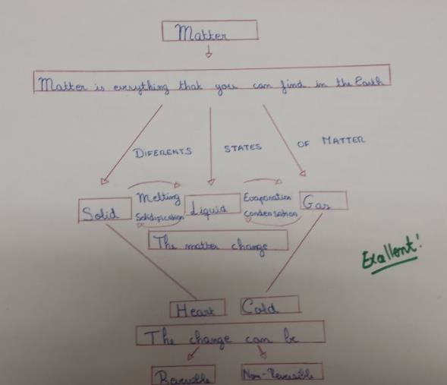

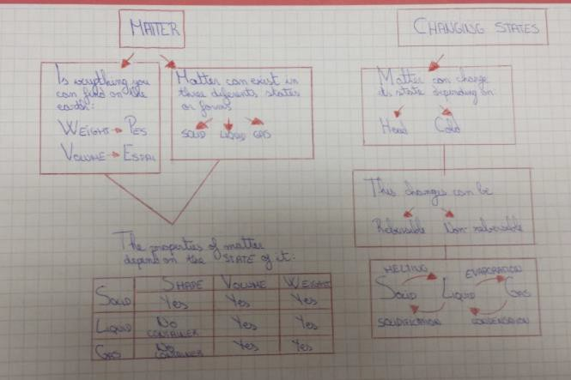

Session1: Topic presentation | Session 2: Experimentation | Session 3: Vocabulary presentation | Session 4: Mind Map | Session 5: Eva uation
Date:  Valoration:  We watched a vídeo anda timelapse about how the plants feed and líve. The student:s were motivated and we speak about plants topie.  Igave one plant for the class,and they should take care. They were super motivated but unfortunately another teacher decided to plant out the plant. | Date:  Valorat on:  We take someand some colorant.We put the flowers ín a jar wíth the colorant. The objective was tint the petaIs.  Unfortunately the experiment wasn't works.  on halloween we did another experíment usi ng a bottle, soda and one balloon.They enjoyed alot. | Date:  Valorat on:  We spent more days that we expected. Because we miss one lesson.They wrote  down on their notebooks the vocabulary. We mix the explanation with draws. The most dífficult part to understood for them was the pollination and the  plants reproduction. For this reason we vvatched two vídeos which explained and represented these concepts. | Date:  Valorat on:  We díd the mínd map together, becauseit was the first time that they díd it. lt was simple and easy to understand.Then, they  represented the mind map  in groups.  Some groups dedicated time to made a good work, but not everybody. | Date:  Valorat on:  They díd an a,b,c test. At the first time they felt unconfident,but the 90% of the class past the test.

I 1st TERM EVALUATION 5th GRADERS
I TOPIC 1: Web of life (Food chains,changing environments and evolution)
Session 1:  I Topic presentation | Session z:  Experimentation | Sessoi n3: Vocabual ry presentation | Session 4: Mind Map | Session 5: Evaluatoi n
Date: 22nd September  Valoration:  Students watched a vídeo about weblife and we talked about íin the class.So níce. | Date:29th September  Valoration:  The exper mentation was to create their ownfggç!chajo with plastic glasses and represent it withthe group.So amazing but too much preparation for so little explanation. | Date: 6th October  Valoration:  Very good.A little bit bor ng but important and necessary. | Date:13th October  Valoration:  lnstead of doing a Mind Map we representa summary usíng power poínt presentation. | Date:20th October  27 th October  Valoration:  The evaluation session has been changed by an Englísh  lesson due to management of the class.

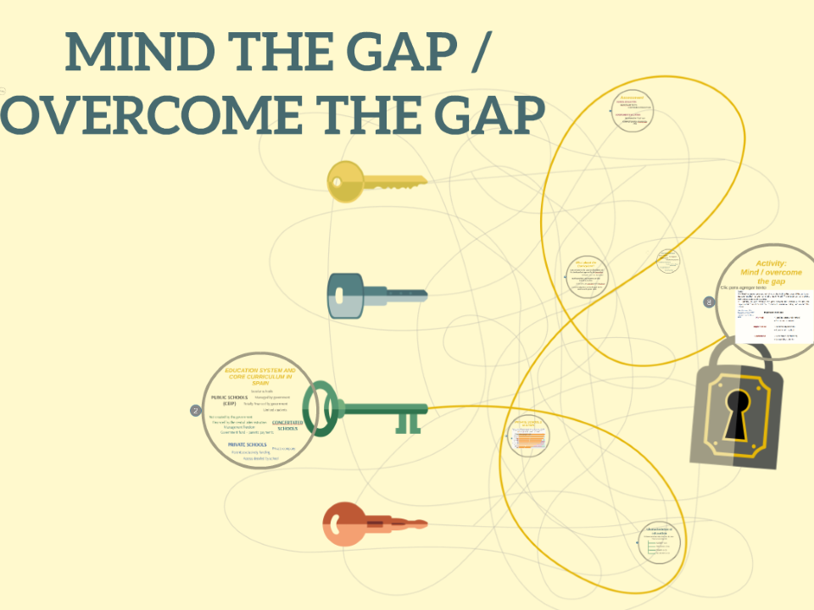
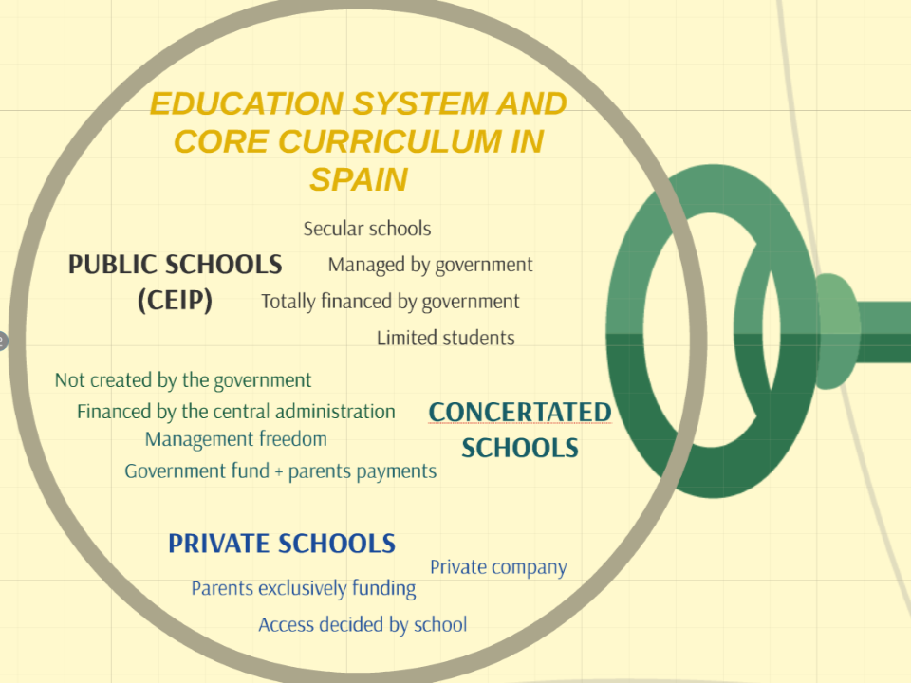
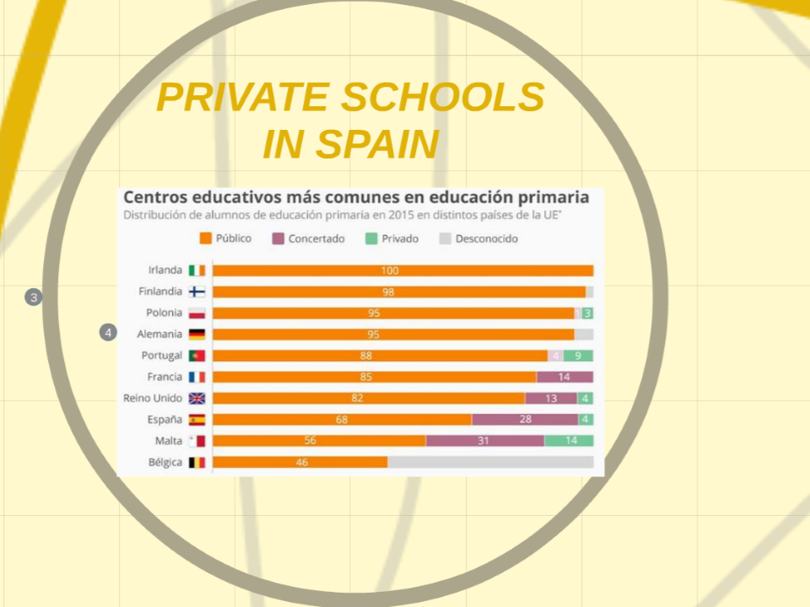
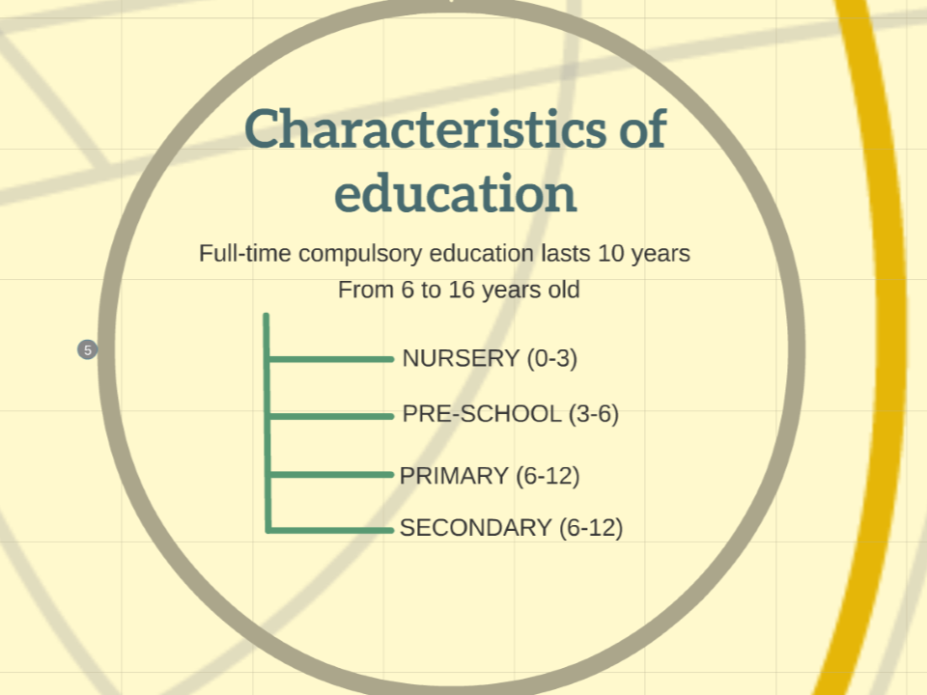
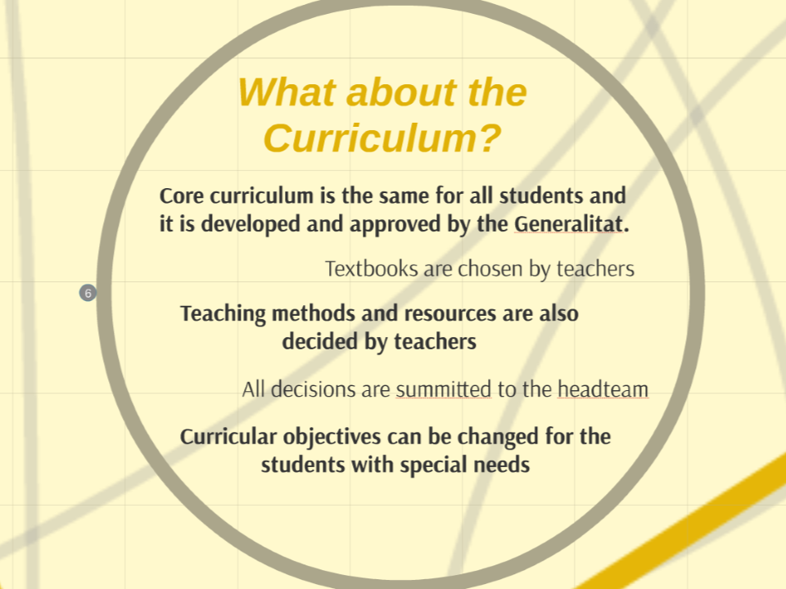
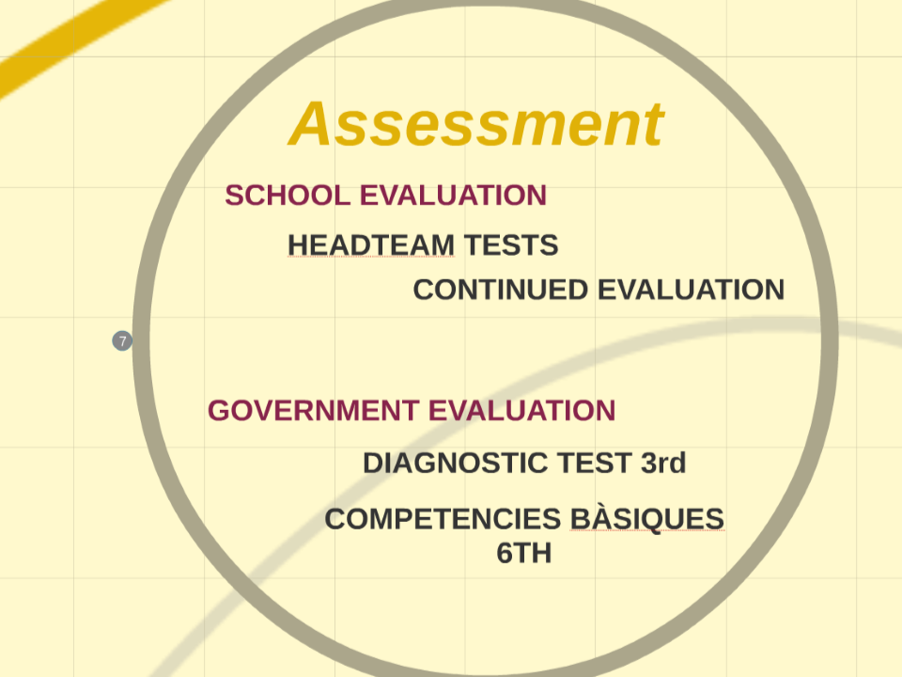
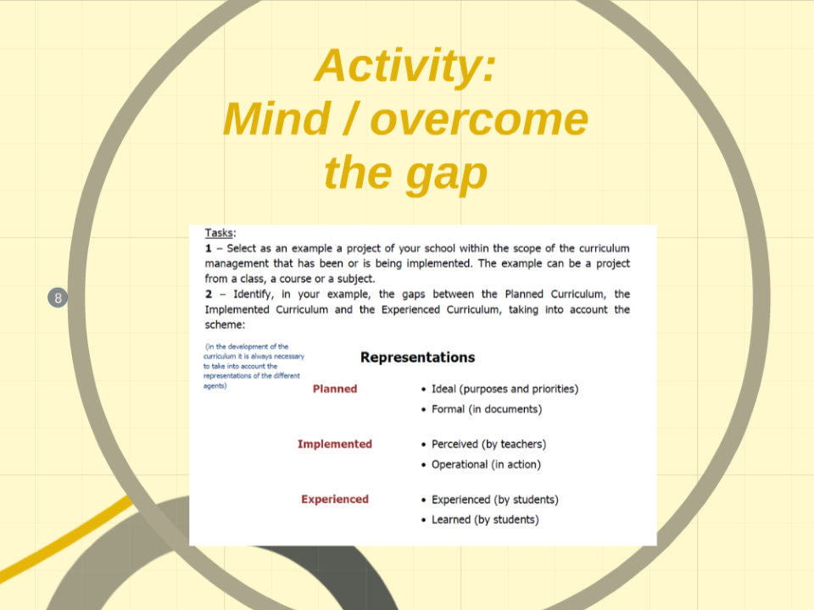
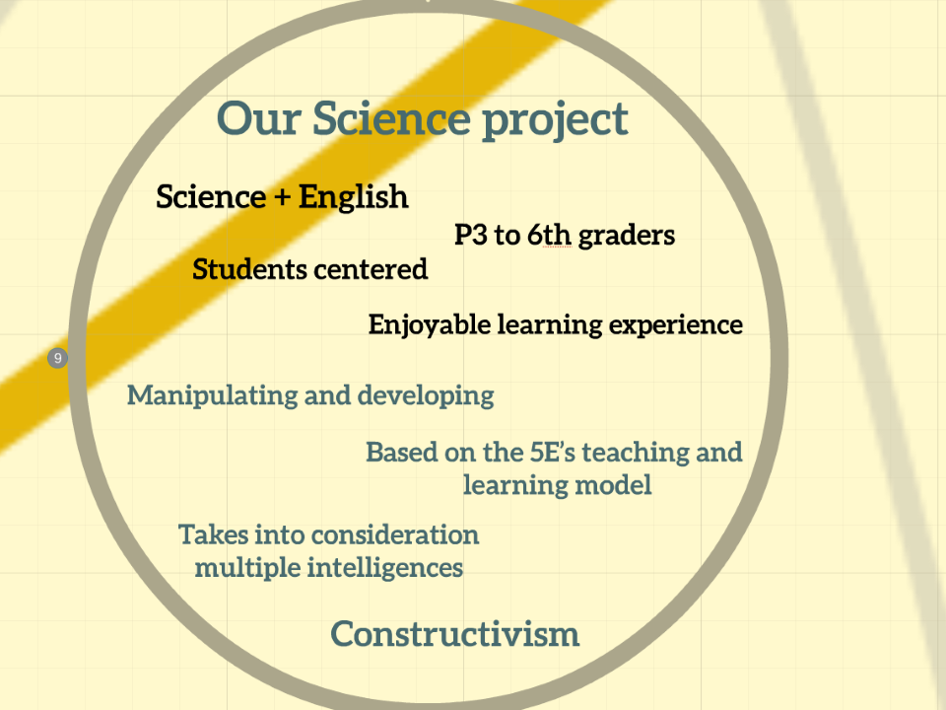
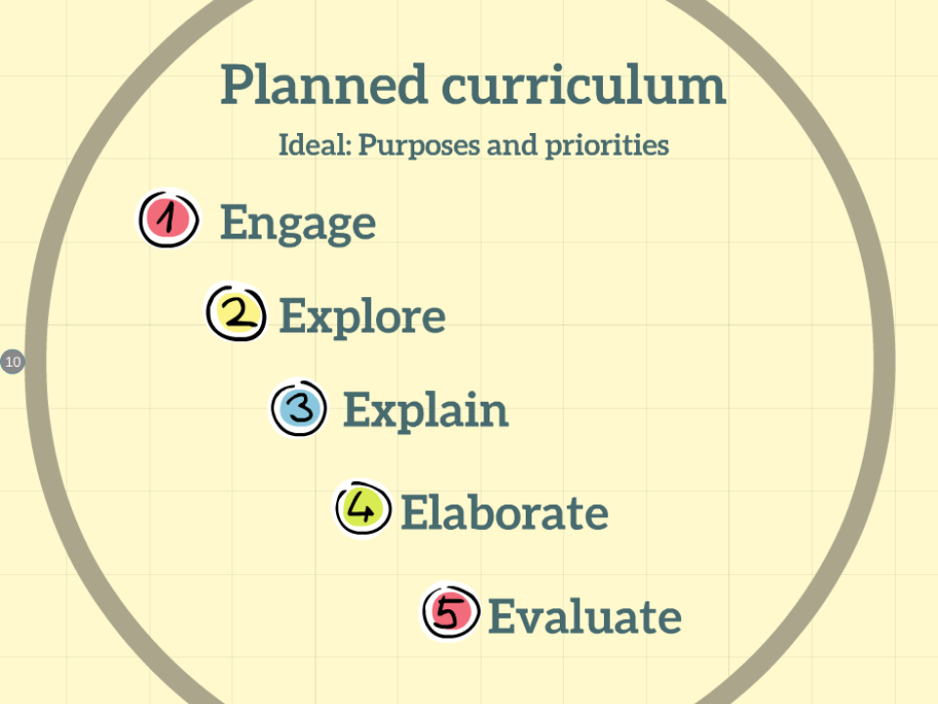
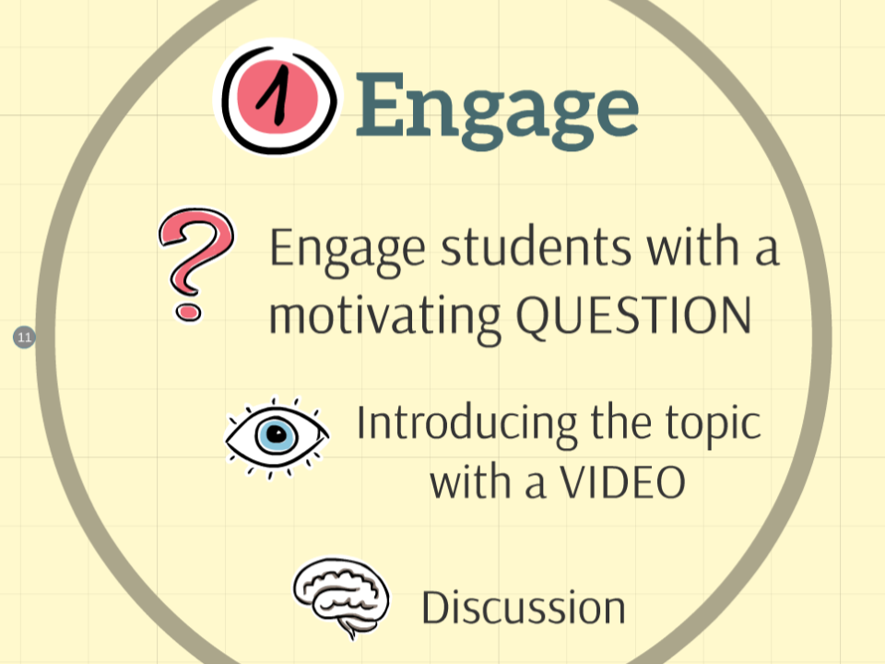
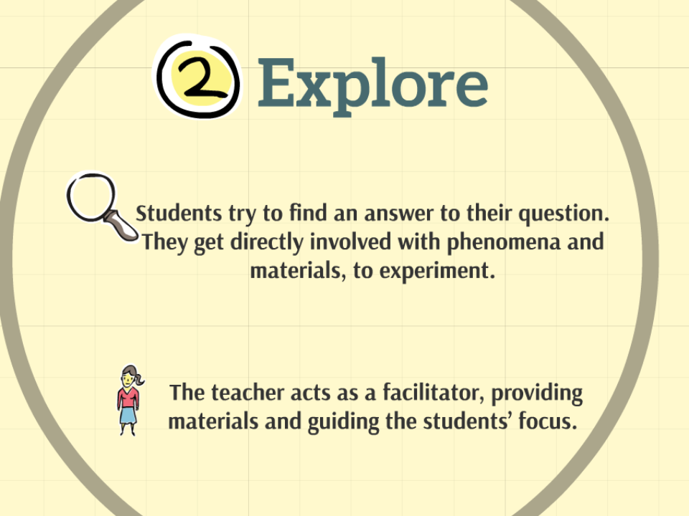
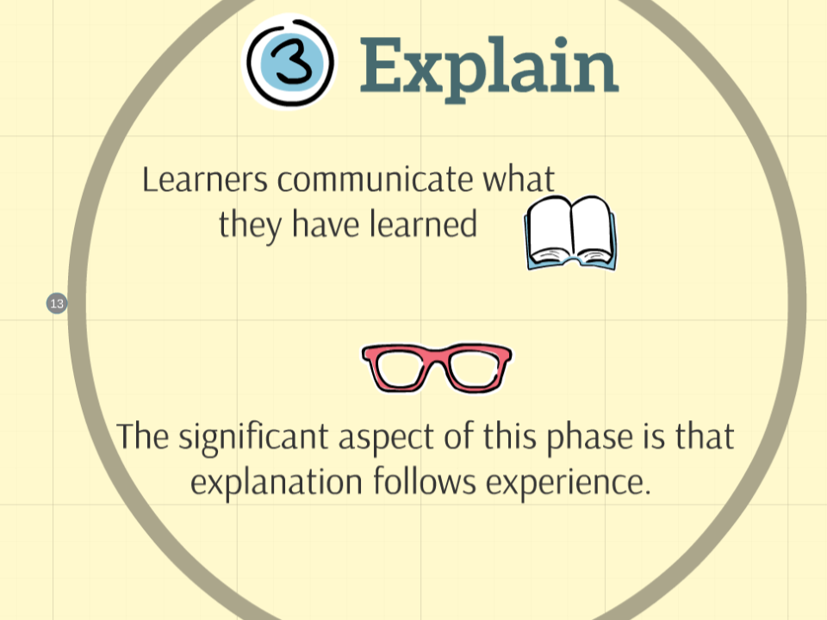
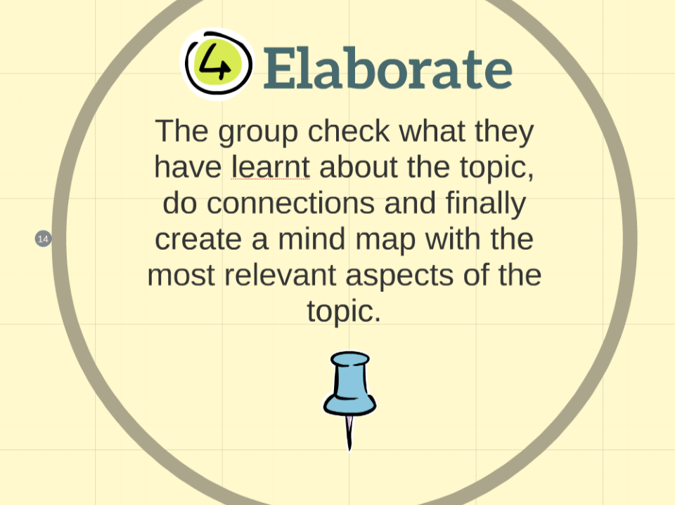
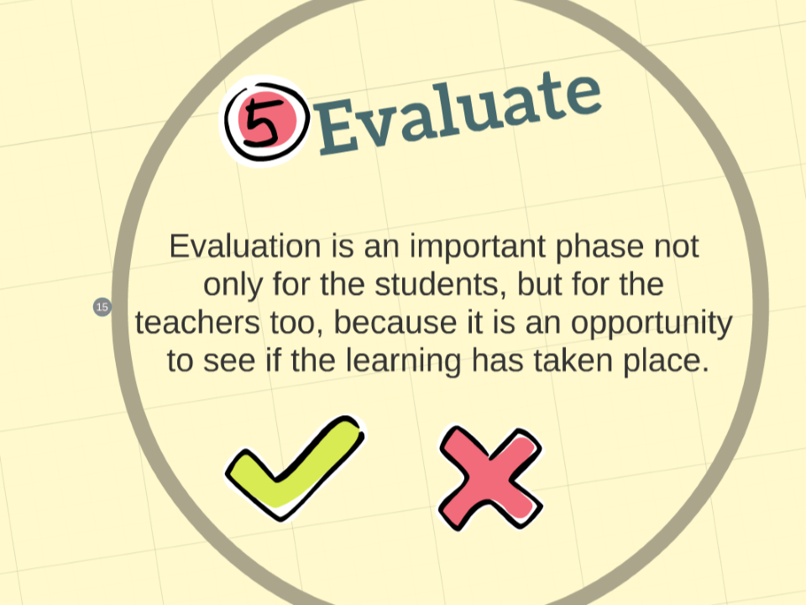
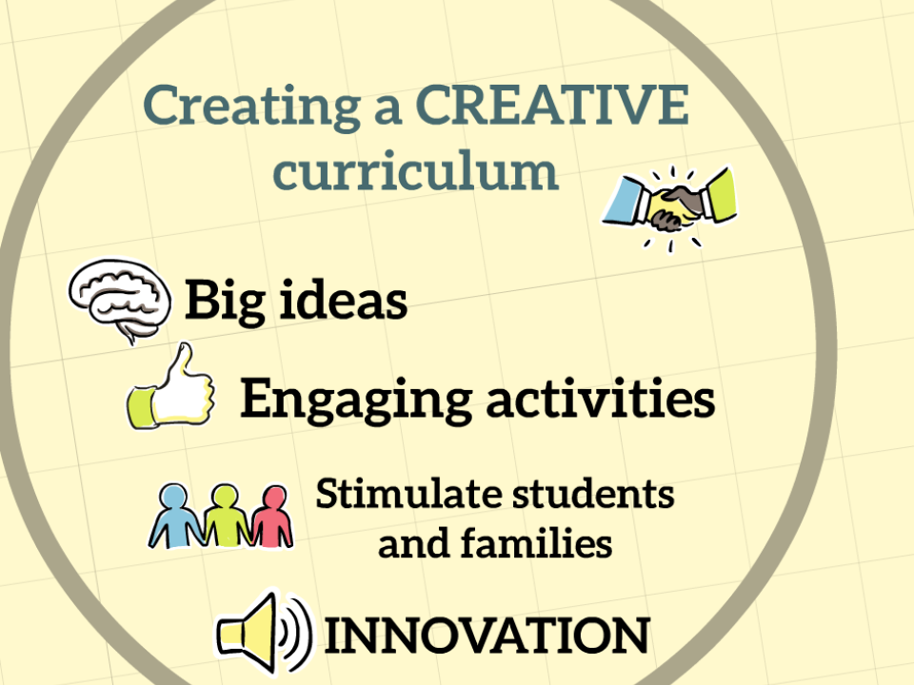
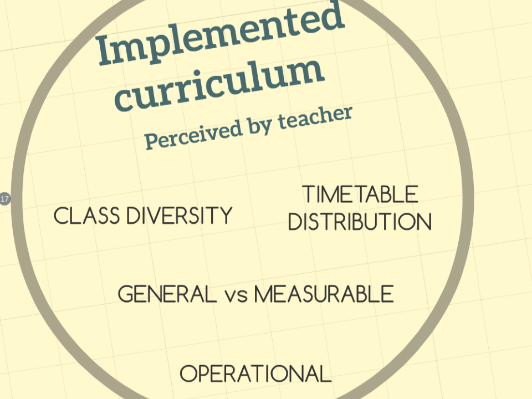
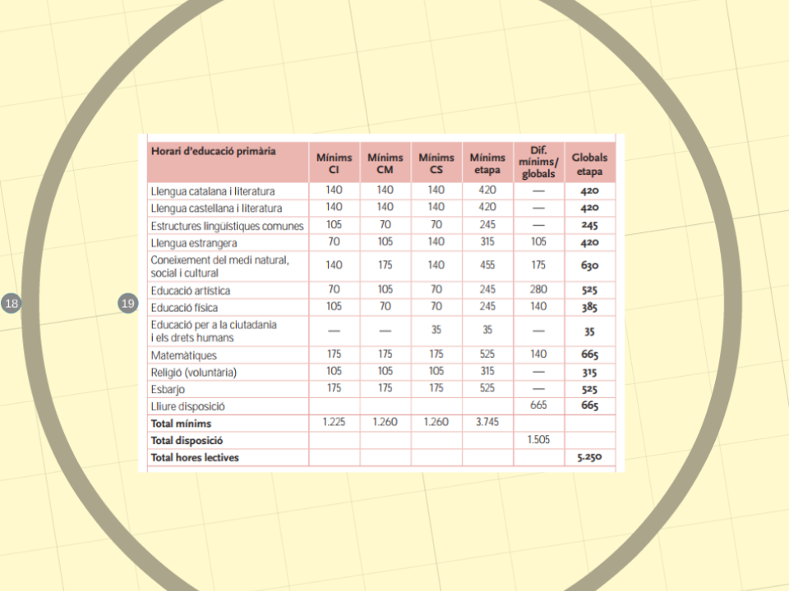
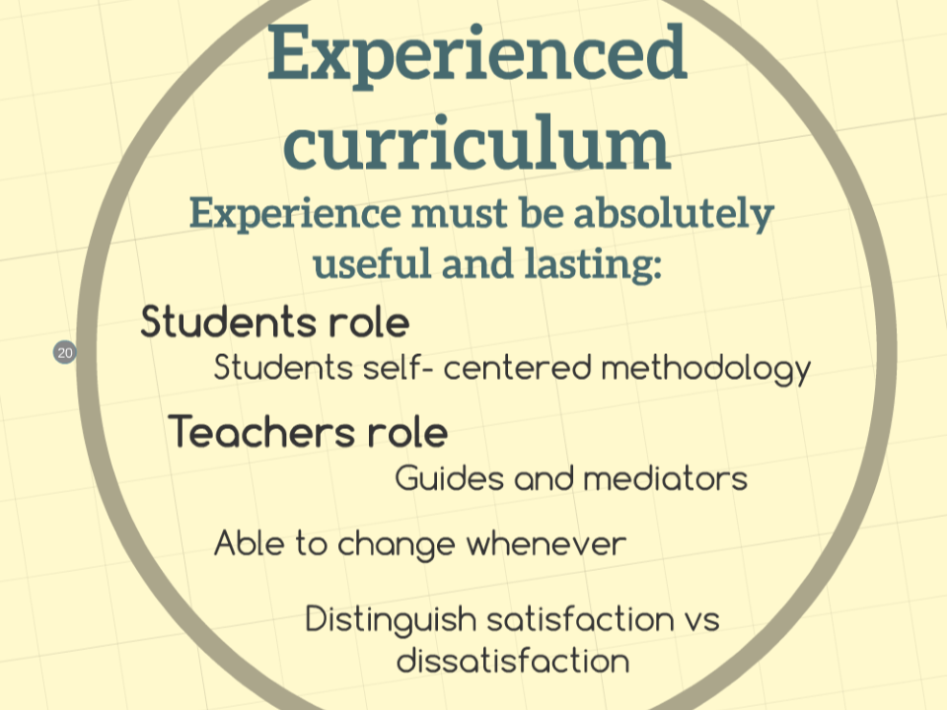
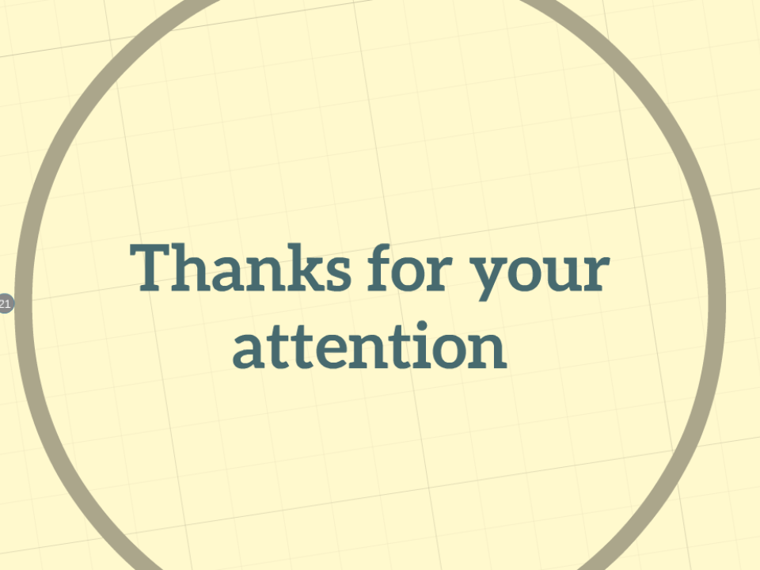


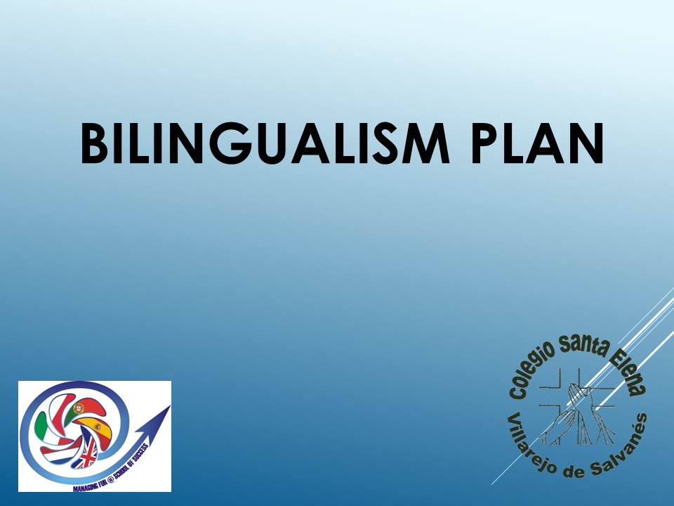
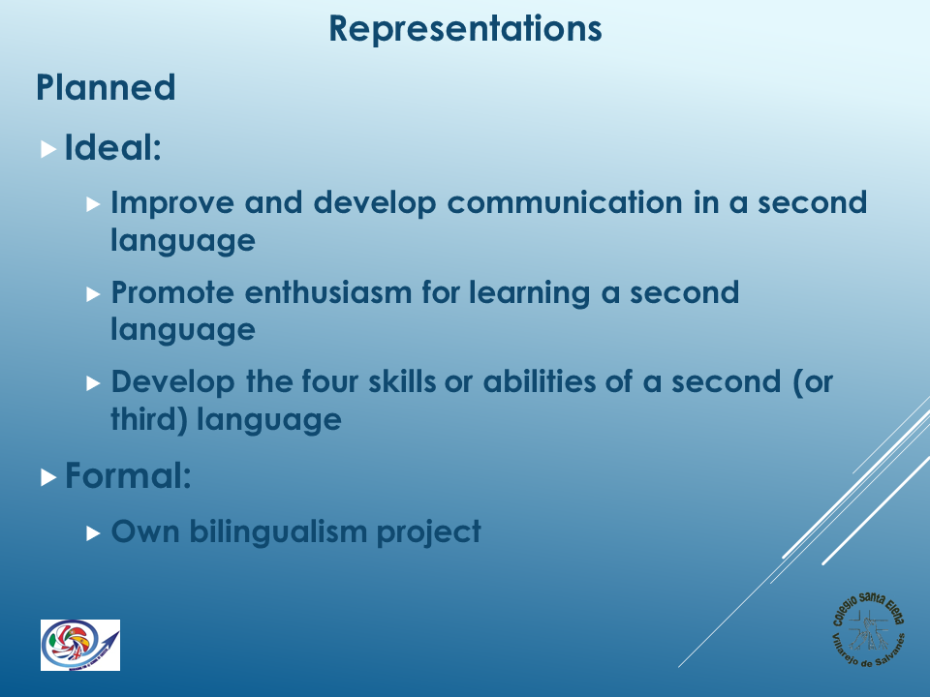
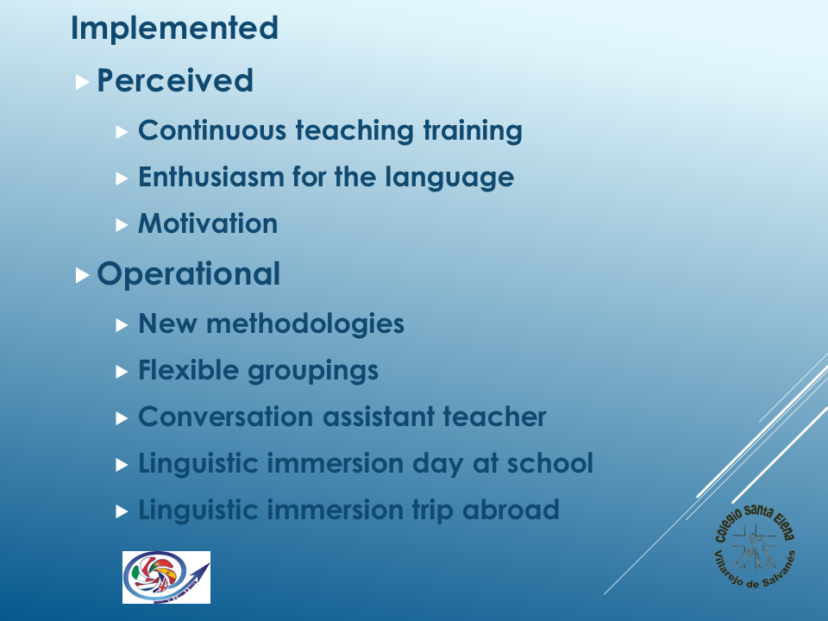
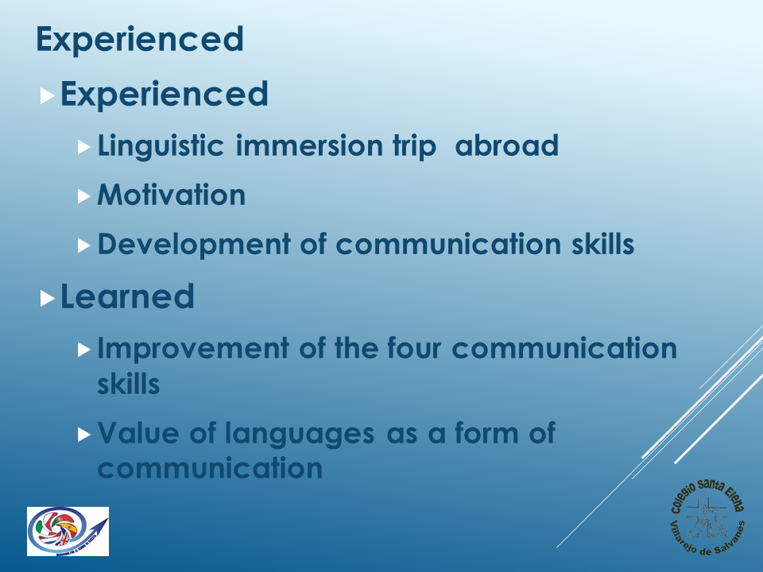

Penalva do Castelo Group of Schools

Mangualde Group of Schools
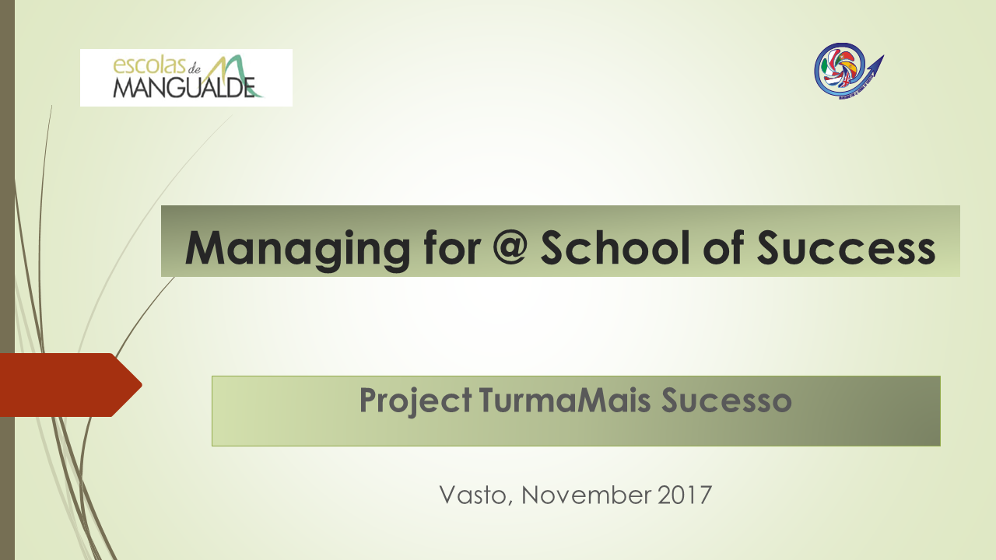
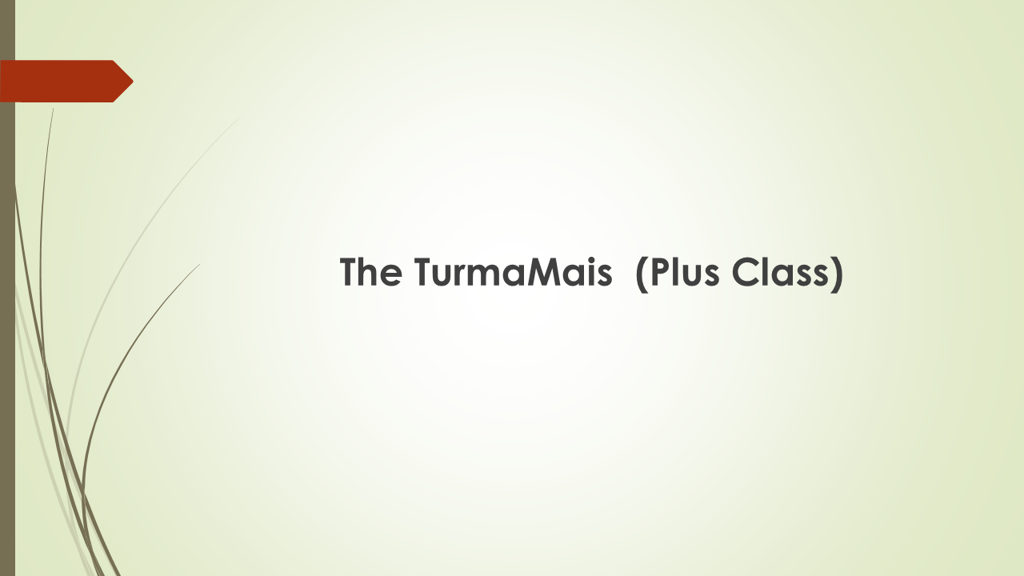
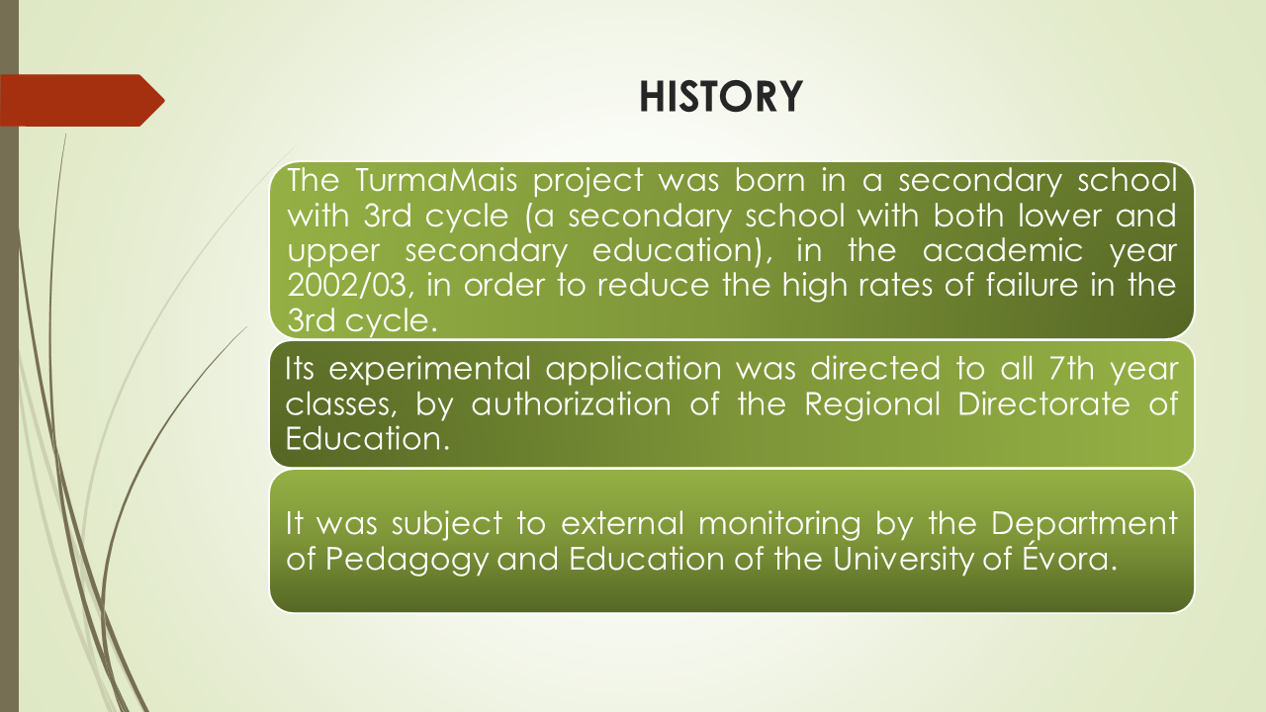
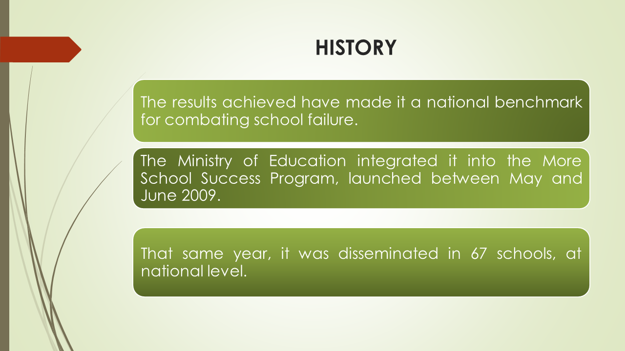
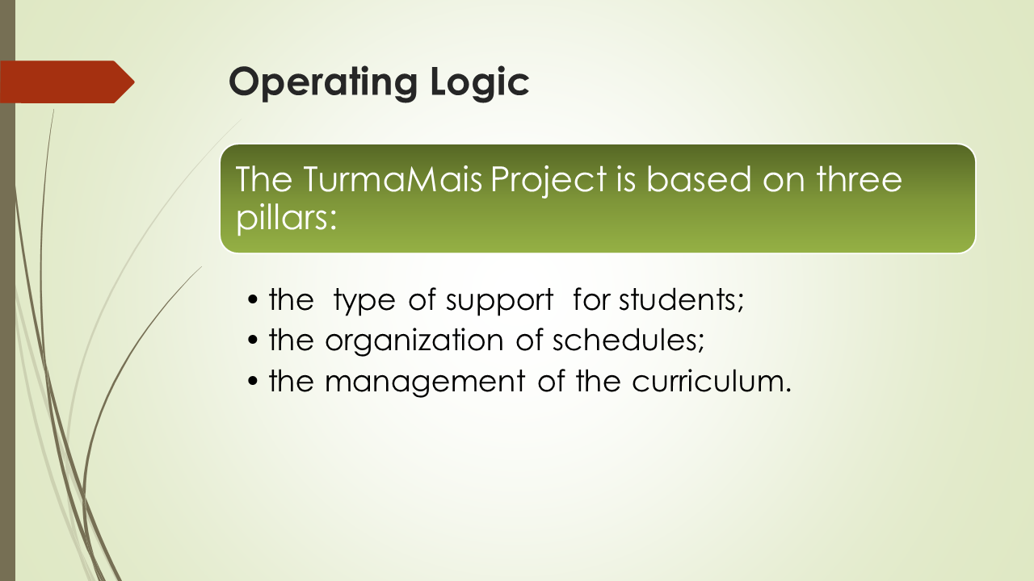
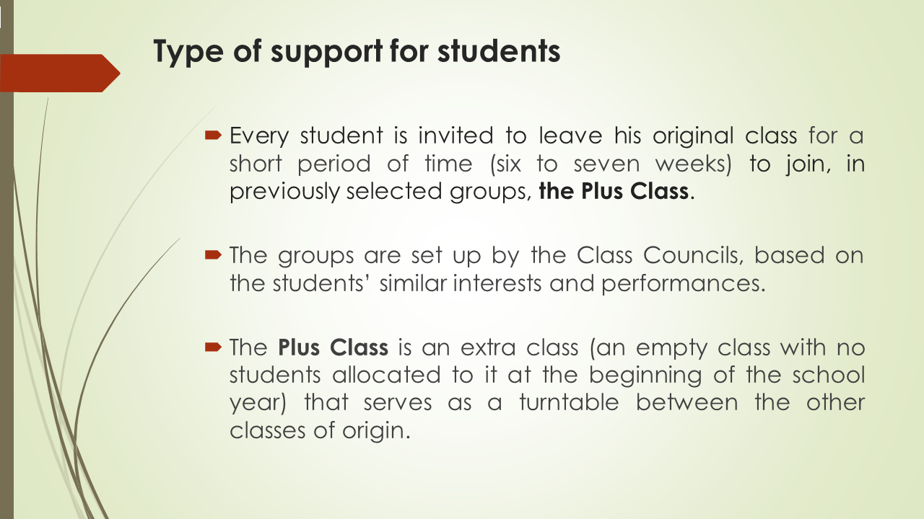
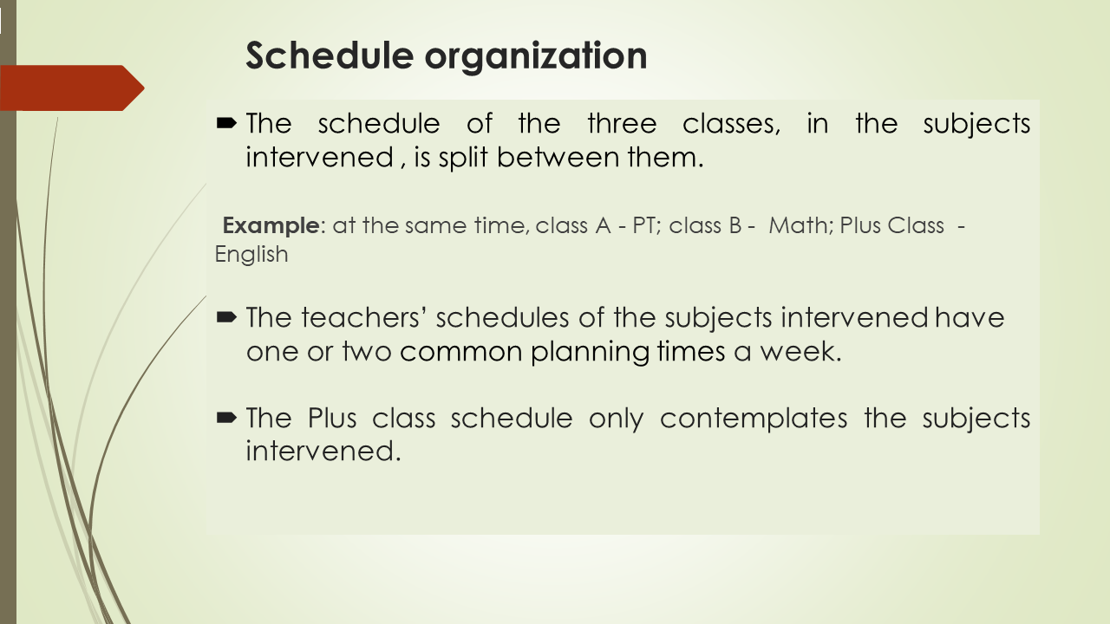
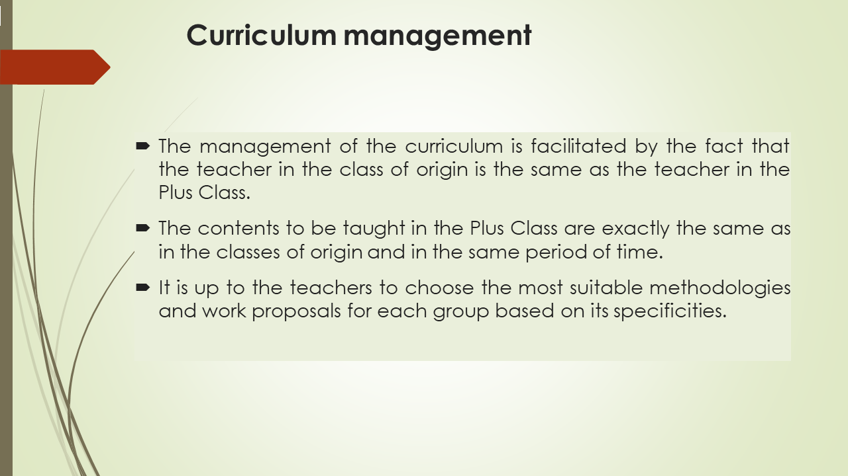
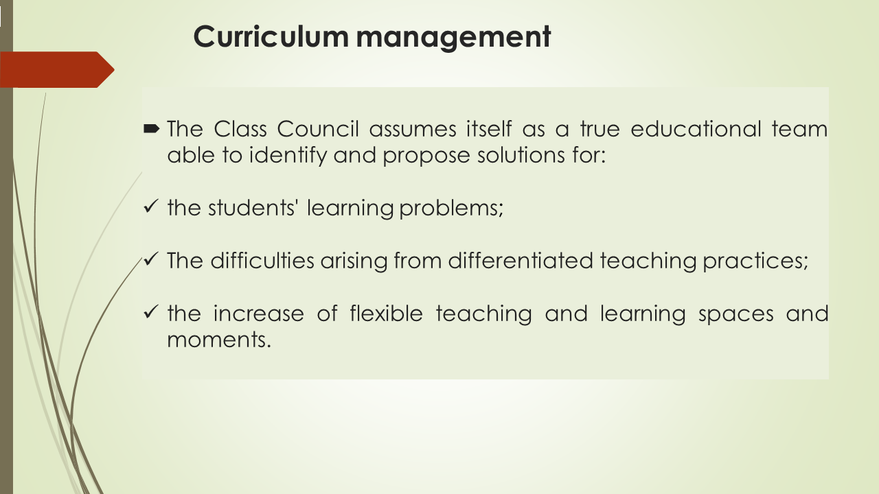
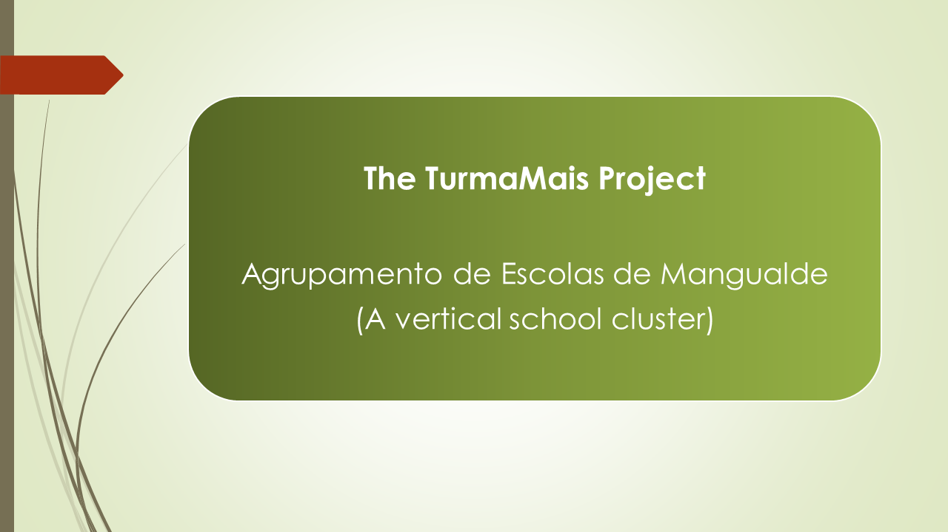
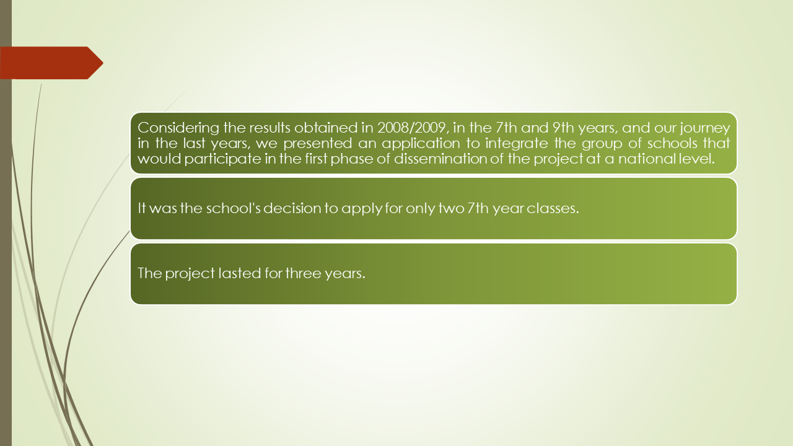
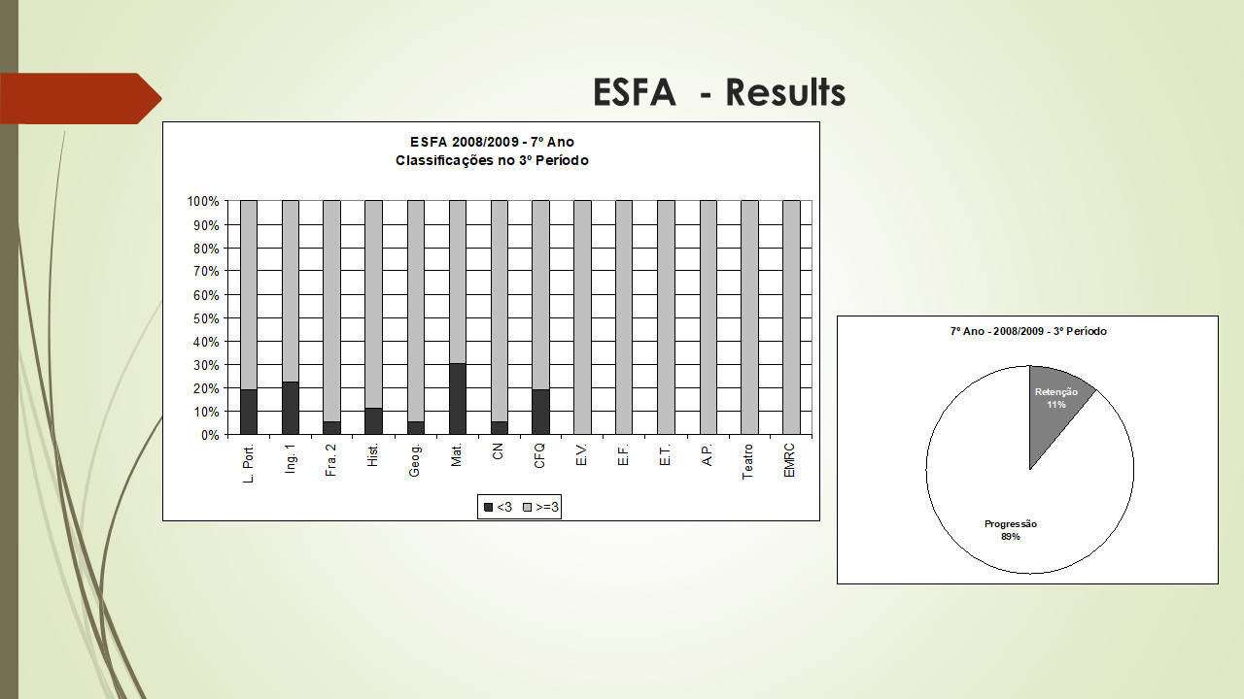
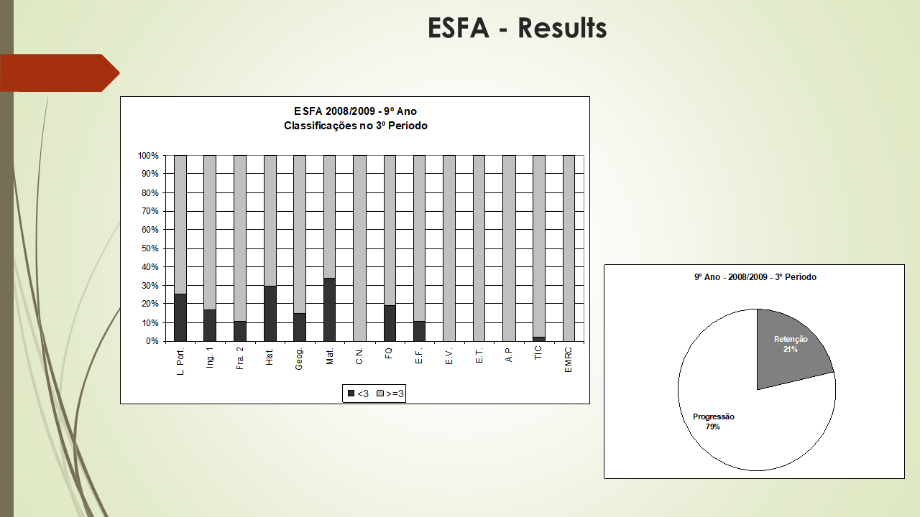
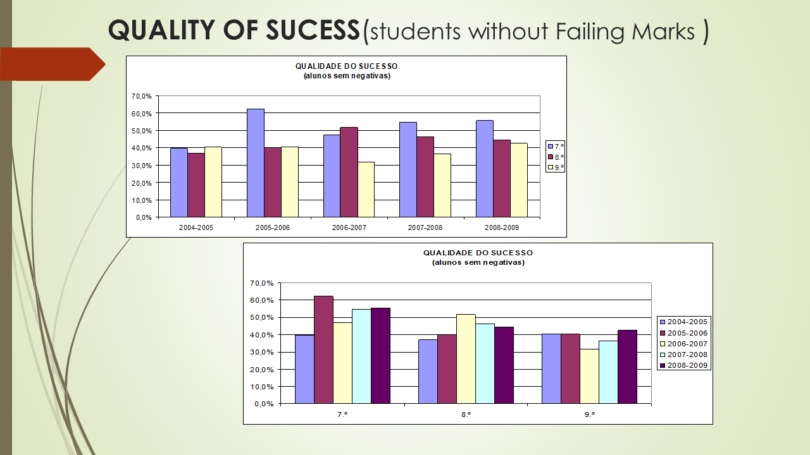
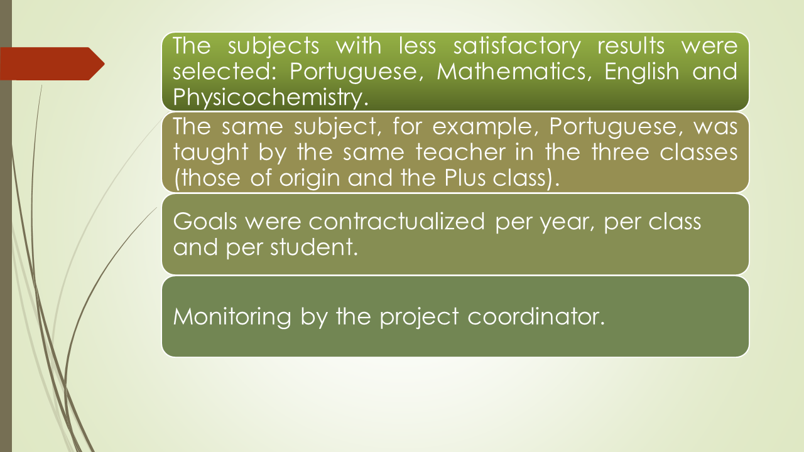
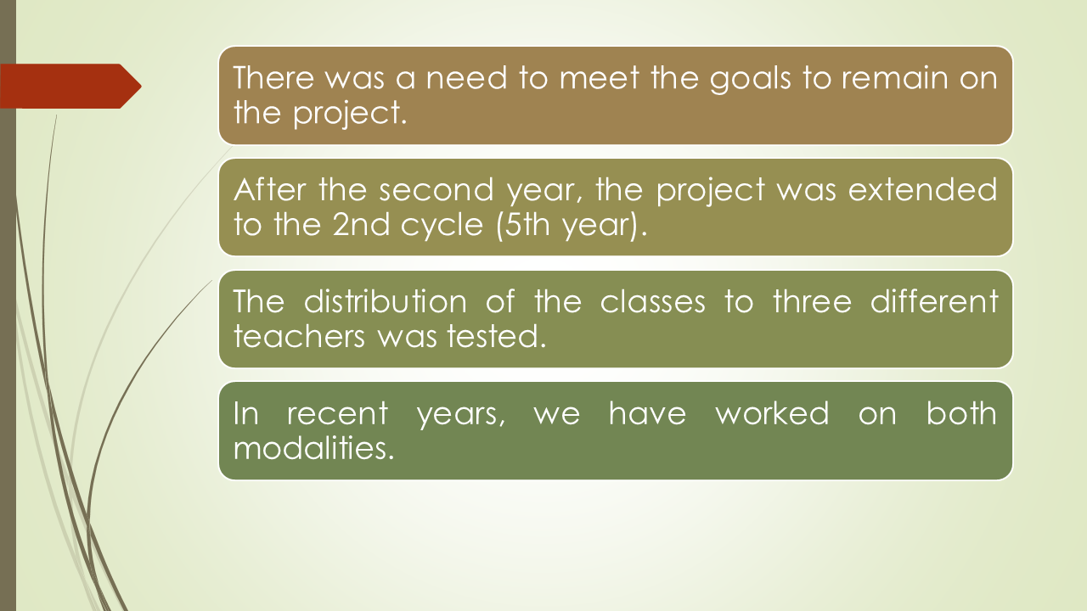
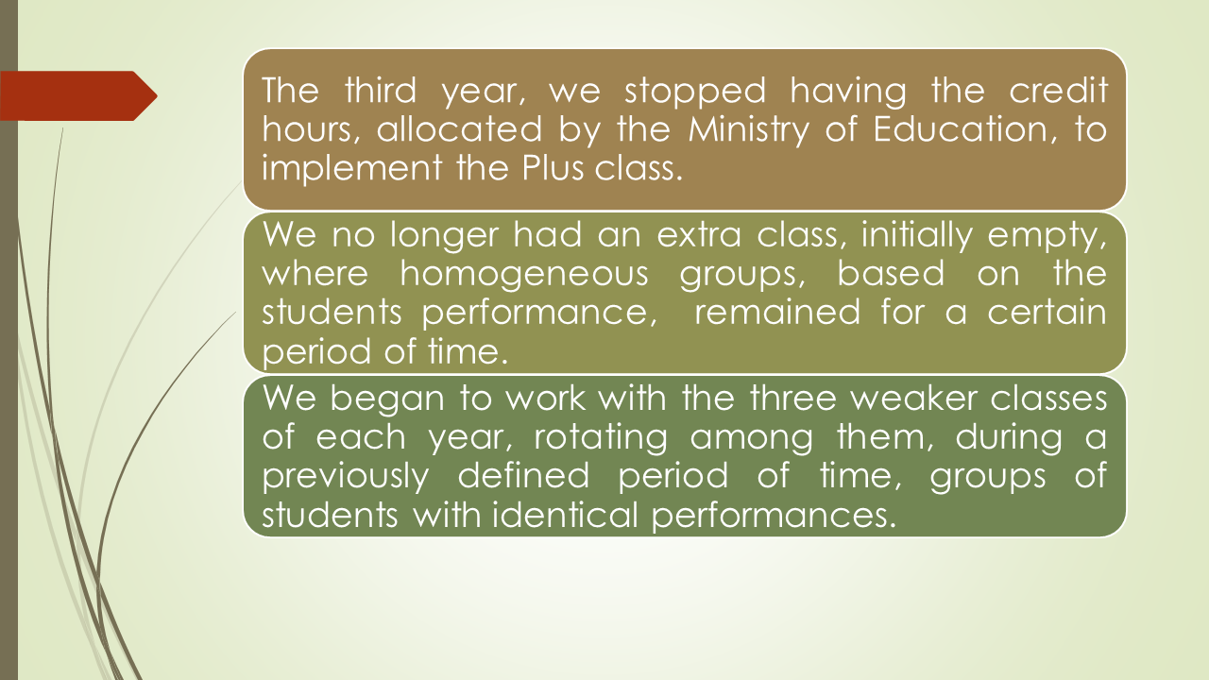
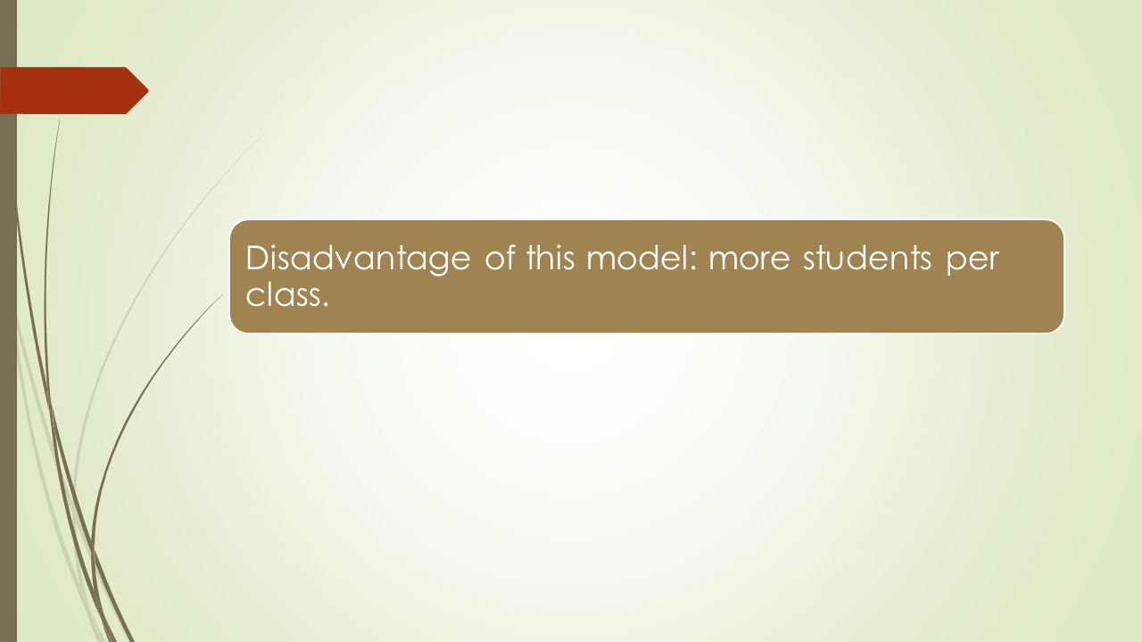
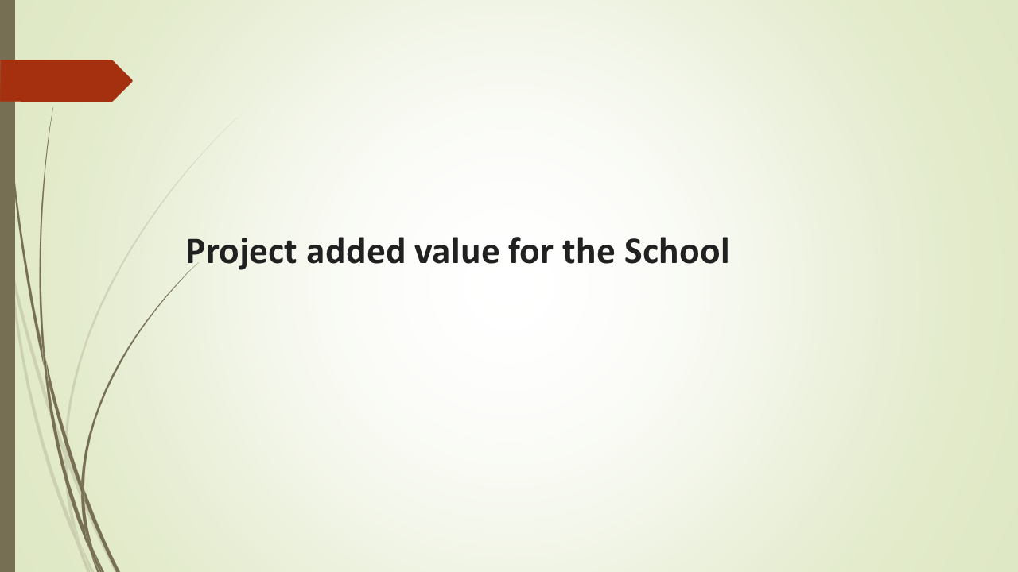
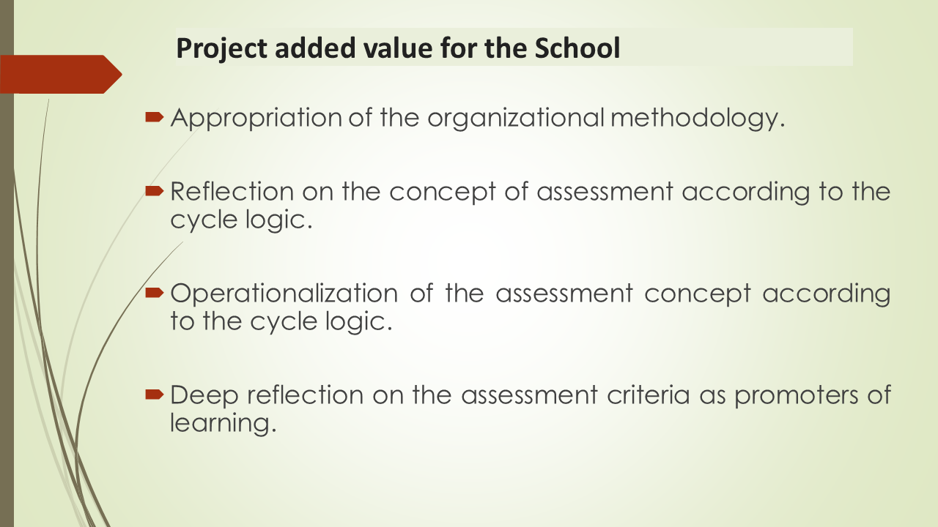
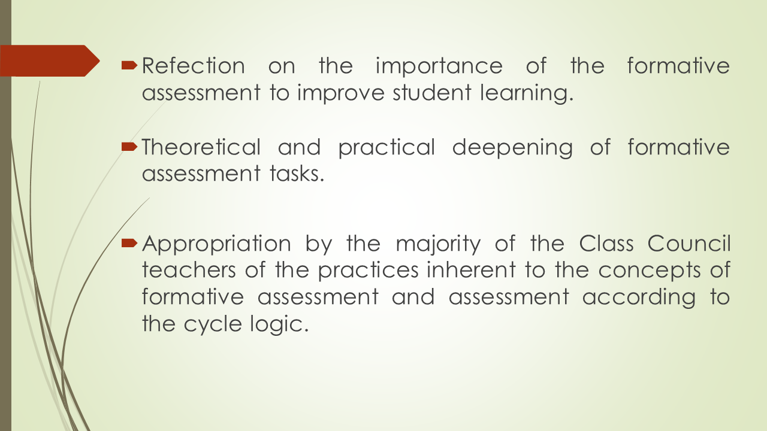
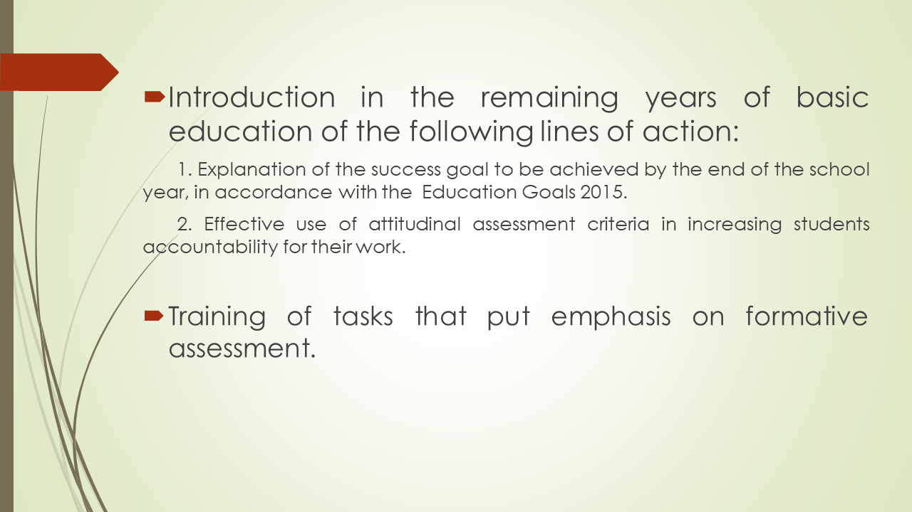
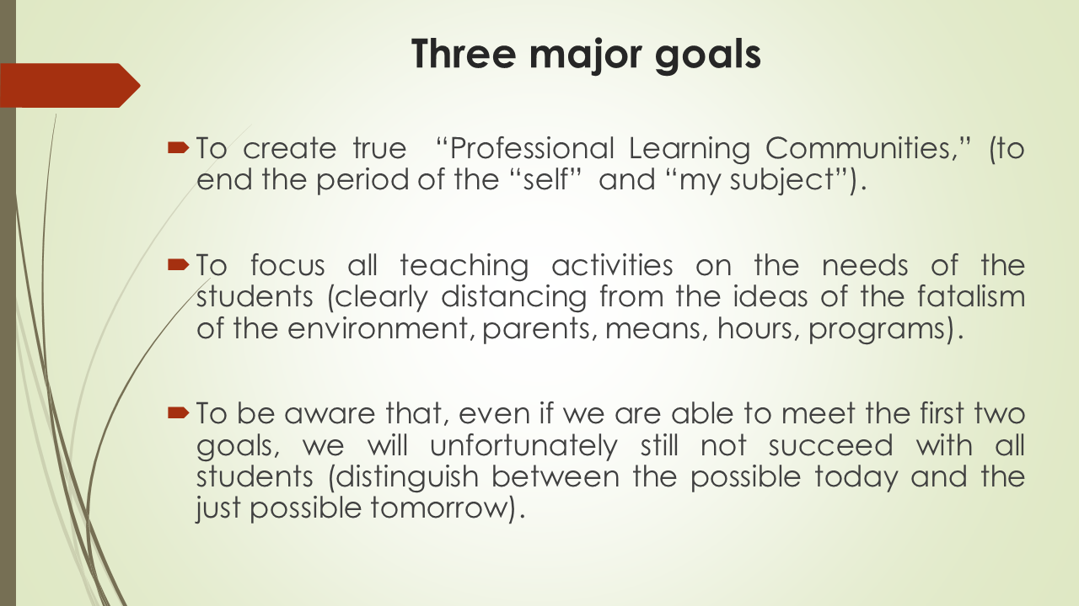
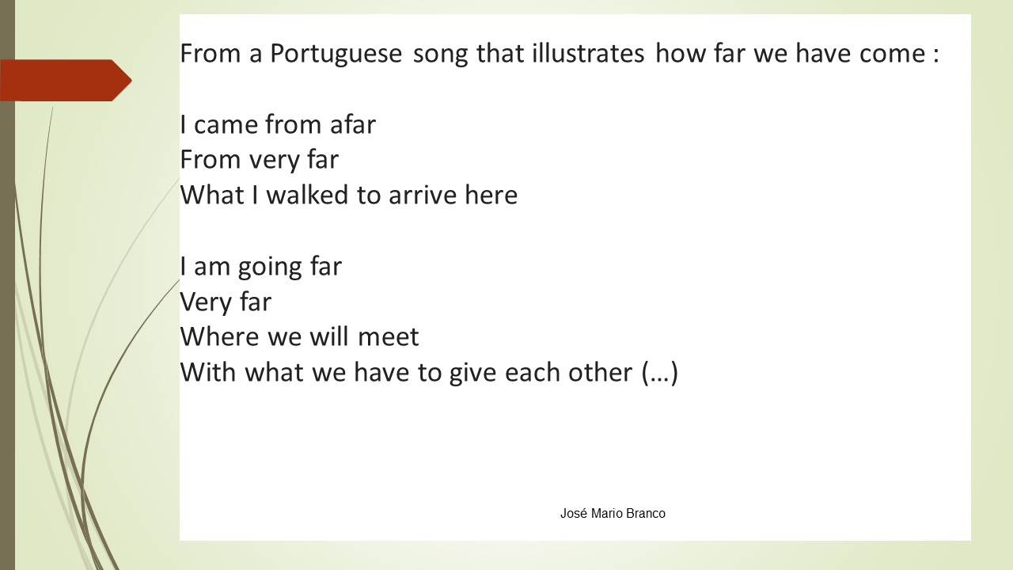

This work is licensed under a Creative Commons Attribution-NonCommercial 4.0 International License.

