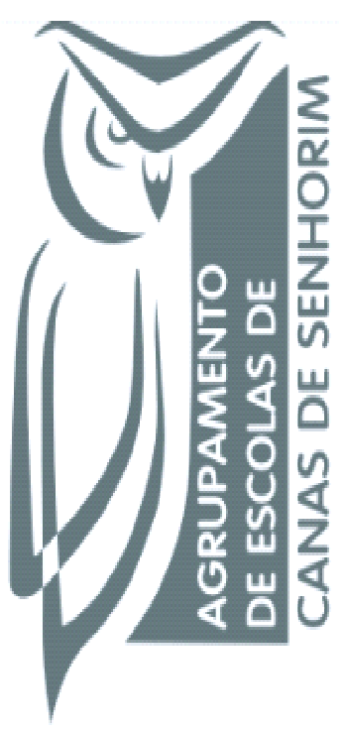
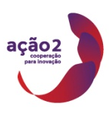
Managing for @ School of Success

TRAINING EVENT NR. 3
SCHOOLS’SELF EVALUATION

Main topics:
1 Referential; school self-evaluation and external evaluation by the national administration. Each school have their own referential ejm, Rachel school referential is to be happy
2 Actors, should they include parents, the community, what is expecting that this particular person perform, who is the team? What training the team have to do?
3- Objects, methodologies and instruments; what the evaluation is looking for, what is evidence?, what kind of evidence?.....instruments that what performance at national level ( Pisa test….) how they compare and discuss the national data’s. …
4 – Dissemination and improvement plans. To whom communicate the report, the other staff, how to use the data to improve the plan for the next year in the school, after I get it the information what should the school do?

SELF-EVALUATION OF SCHOOLS
AIM | QUESTIONS/KEY TOPICS
- Understand the schools self-evaluation process in the countries of the project and its origin. | - What policy recommendations originated the need of SE process in the countries of the project?  - Self-evaluation overview in each partner country. (Introduction)  - Which are the national strategies to develop school quality/ school improvement?  - The SE process is legally defined in the countries of the project?  - Is the SE process internally or externally driven? If so, by whom? What entity is responsible for the SE process at a national level?  - What is expected from the SE process?  - Main characteristics of schools self-evaluation process in the countries of the project: Who? When? How?  - SE policies, models, instruments, descriptors and indicators;  - SE model: SE framework, tools and implementation;  - Participants in school SE;  - Data collection and analysis;  - Schools responsibilities;  - SWOT analysis: until now, can you identify the main strengths, weaknesses, opportunities and threats of the SE process implemented in your country?

This work is licensed under a Creative Commons Attribution-NonCommercial 4.0 International License.

