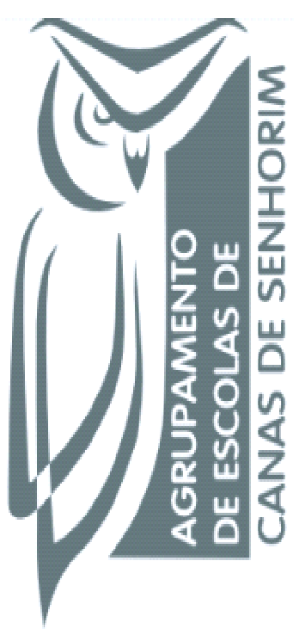
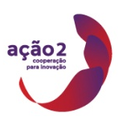
Managing for @ School of Success
1st Short Term Joint Staff Training Event - “School Autonomy”
11th to 15th April, 2016 - Portugal

This work is licensed under a Creative Commons Attribution-NonCommercial 4.0 International License.

