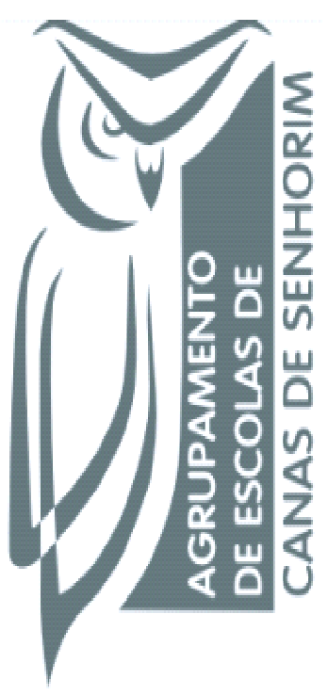
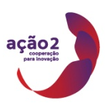
Managing for @ School of Success
1st Short Term Joint Staff Training Event - “School Autonomy”
11th to 15th April, 2016 - Portugal

Schools’ autonomy is a struggling issue within European educational systems. If national systems have different traditions concerning schools’ power to define, decide and act by themselves, globalization and international agencies have been contributing to change and shape differently schools’ autonomy concept and practices. The most relevant decisions concerning schools’ autonomy are linked with educational offer; pedagogical main strategies; teachers and staff selection; financial and material resources management.
The training event that will be included within the project Managing @ School of Success is an opportunity to discuss and share some of these issues, both among project partners and with experts that were invited to participate.
Training event objectives are:
. To share concerns and practices of partners regarding autonomy;
. To deep and foster questions concerning innovation within school management;
. To share and discuss with other educational actors and stakeholders new possibilities of networking regarding educational issues.
. Share experience and best practices;
. To promote knowledge built and shared by the partner countries;
. Create a frame of reference levels and degrees of different autonomies;
. To develop, transfer and implement communication platforms;

This work is licensed under a Creative Commons Attribution-NonCommercial 4.0 International License.

